**Financial Markets Project**

*2023-2024*

***Prepared By* :**  - Azza Karchoud

- Emna Megdiche

- Jihene Gazzeh

- Takoua Hmidi

***Under the assistance of* :** - Professor Eymen Errais

- The Teaching Assistants

* **The Outline**

1. *Introduction*
2. *Brokers’ List*
3. *Strategy Explanation*
4. *Macroeconomic factors*
5. *Sectors Analysis*
6. *20 Companies Analysis*
7. *Description*
8. *Macroeconomic Factors*
9. *Stock Performance*
10. *SWOT Analysis*
11. *Financial Statements Analysis*
12. *Conclusion*
13. *Behavioral Analysis*
14. *Risk Profile*
15. *Markowitz Strategy Explanation*
16. *Portfolio Rebalance Discussion*
17. *Comparison to benchmarks*
18. *To Tunindex*
19. *To Sectors*
20. *MWR VS TWR Strategy Explanation*
21. *Risk Analysis*
22. *KPIs and KRIs*
23. *Attribution Analysis*
24. *Conclusion*

*Remark : The resources can be found by clicking on each paragraph*

## Introduction

This document holds the comprehensive analysis conducted within the framework of the Financial Markets project, under the guidance of **Professor Eymen Erraies** and the help of the **Teaching Assistants**. This analysis is backed by the knowledge that we got equipped with in this course : Technical Analysis, Markowitz model, Times series analysis , Risk analysis , etc .

The work methodology can be presented as follows :

The analysis process has started with a thorough understanding of the stock market in Tunisia : stock exchange , key players , rules and regulations , etc .

Then , a macroeconomic analysis was conducted on 58 companies listed in the Tunis stock exchange to determine the ones that represent potential growth and investment opportunities .

After selecting 20 firms , a more in-depth analysis was made on their financial strength through the financial statements analysis , as well as , an analysis on their stock performance over the course of 10 years . This step was conducted in hand with the technical analysis , in which multiple indicators were constructed such as daily return , Bollinger Bands , MACD , etc. This multi-faceted approach aimed to unravel the nuanced behavior of each company's stocks over the specified timeframe.

Informed by the insights collected, the selection was refined to the top 10 companies, upon which the Markowitz model was applied. This strategic modeling identified six companies with the potential for profitable investment.

The actual investment, through the broker on which a thorough analysis was made as well , was performed after determining the right entry point to the market.

Finally , the results of the investment phase were analyzed by performing risk analysis , benchmark comparisons , KRIs and KPIs analysis , attribution analysis , etc .

## **Brokers’ List**

| ***Broker*** | ***Fees*** | ***Competitive advantage*** | ***CFA’s ethical and professional standards*** |
| --- | --- | --- | --- |
| **Amen Invest** | [1%](https://www.cmf.tn/sites/default/files/pdfs/epargne/prospectus/prospectus_fcp_amen_selection_fr.pdf) per annum of the fund's net asset value | [-High expertise allowing it to have International partners](http://www.ameninvest.com/index.jsp?view=quote) | In their website , they mentioned the following: “We operate in full compliance with current regulations and recommendations dictated by the nature of our business.” |
| **Attijari Intermédiation** | [0.6%](https://ati.attijaribourse.com.tn/AttijariBourse/assets/documents/CONVENTION_ORDINAIRE_LIBRE.pdf) | [-A facility of accessibility thanks to their large number of agencies (exceeding 207)](https://ati.attijaribourse.com.tn/AttijariBourse/notre-soc)  [-They have a publication section where they constantly share information about the financial market](https://ati.attijaribourse.com.tn/AttijariBourse/morning-brief) | In their website , they mentioned the following: “Attijari Intermédiation is a stock market intermediation company offering a secure trading environment that respects professional ethics and is suitable for all investor profiles.” |
| **BH INVEST intermédiaire en bourse** | [0.45%](https://www.cmf.tn/sites/default/files/pdfs/epargne/prospectus/prospectus_sicav_bh_capitalisationf.pdf) | It is following ESG aspects which makes it a socially responsible firm | In their website , they mentioned the following: “It also closely monitors the development of the various securities listed on the Tunis Stock Exchange, to provide investors with access to key information that sheds light on the reality of companies, to help them in their decision-making.” |
| **BMCE capital securities** | [0.6%](https://www.lavieeco.com/argent/bourse-attention-aux-commissions-qui-peuvent-plomber-votre-plus-value-6255/#:~:text=Tandis%20que%20BMCE%20Capital%20Bourse,Bourse%20un%20taux%20plus%20%C3%A9lev%C3%A9.) | [-International existence (in 5 countries)](https://www.bmcecapital.com/solutions/intermediation-boursiere)  [-Personalized services](https://www.bmcecapital.com/solutions/intermediation-boursiere)  [-Unique information systems knowns as “Front to Back”](https://www.bmcecapital.com/solutions/intermediation-boursiere) | It follows a quality approach which obliges it comply with certain ethical and professional standards |
| **STB Bank** | [0.8%](http://tarif-general-2016.pdf) | [-Their website includes dashboards that summarizes key indicators of the stock market as well as important other information of the local and international stock markets](https://www.stbfinance.com.tn/dashboard) (the information is provided for any website visitor) | In their website , they mentioned the following:”Building on its strengths and evolving in an increasingly competitive environment geared towards an increasingly demanding clientele, Société Tunisienne de Banque has taken the necessary steps to consolidate its businesses, diversify its products, optimize its commercial base, modernize its operating network and open up to new business lines.” |
| **MAC SA** | 1% | -[They have a winning portfolio that has been outperforming tunindex from January until August 2023 . This is an indication of their high expertise](https://www.ilboursa.com/marches/l-intermediaire-en-bourse-mac-sa-devoile-la-nouvelle-composition-de-son-portefeuille_42276)  [-Innovation : They have a mobile application through which trading is allowed](https://www.macsa.com.tn/#/expertises/brokerage).  [-They have a section where users can simulate their tax savings based on your investment amount automatically](https://www.macsa.com.tn/#/warrants/cea-simulator) | In their website , they mentioned the following:”Building, with our customers, a better future by providing responsible and innovative financial solutions" |
| **MENA CAPITAL PARTNERS** | 0.6% | [It has been referenced by big companies such as Kia Motors](http://www.menacp.net/site/fr/references.58.html) | In their website , they mentioned the following:”MENA Capital Partners has developed a robust brokerage business thanks to its team of highly experienced professionals and superior systems. This has enabled us to attract major regional and global investors.” |
| **Arab Financial Consultants** | [0.8%](https://www.cmf.tn/sites/default/files/pdfs/epargne/prospectus/prospectus_maj_fcp_salamett_plus_fr.pdf) per annum of the fund's net asset value | [-Diversified services to include engineering and financial structuring activities](https://www.afc.com.tn/qui-sommes-nous?menu=0#content)  -They have a press release section where they share important information about the firm | AFC didn’t share about their CFA’s ethical and professional standards . |
| **SOCIÉTÉ MAXULA BOURSE** | 0.6% | [They regularly provide a detailed analysis about the financial state and performance of each listed company](http://www.maxulabourse.com.tn/notes-valeur) | In their website , they mentioned that their business ethics is based on transparency and responsibility , which makes it part of their genetic code. |
| **Union Financière** | 0,9% | -High quality services which are certified by ISO9001  [-It is a socially responsible firm as it follows a CSR approach](http://www.ufigroup.com.tn/actualites.html) | [It is certified by ISO9001 which obliges it to meet specific CFA’s ethical and professional standards](http://www.ufigroup.com.tn/financeb51f.html?IDArticle=14). |
| **UIB Finance** | 0.8% | Innovation : it allows to open an account online | In their website , they mentioned the following:”[Responsibility and ethics mean meeting the diverse needs of our customers while safeguarding the long-term interests of all our stakeholders. Our responsibility is also expressed through the courage to take responsibility for our actions and to express our opinions transparently.](https://www.uib.com.tn/carriere/nos-valeurs)” |
| **UBCI Bourse** | [0,9%](https://www.ubci.tn/wp-content/blogs.dir/2022/10/UBCI-Rapport-D%C3%A9finitif-2021-Pages.pdf) | [-Rewarded the label of “Committed to CSR Confirmed” delivered by AFNOR Certification](https://www.ubci.tn/wp-content/blogs.dir/2023/07/UBCI-2022.pdf) | l’UBCI a fait de la Responsabilité Sociétale de l’Entreprise un pilier de son éthique et de son action au quotidien. |
| **Tunisie Valeurs** | 0.8% | [-They provide a thorough guide on how to use the account and how to solve encountered problems](https://www.tunisievaleurs.com/faq/) | [-Transparency : They have detailed confidentiality , legislation , and security polic](https://www.tunisievaleurs.com/nos-outils/tval-mobile/politique-de-confidentialite/)ies which are also shared on their website. |

**Conclusion:** The thorough research on brokers in Tunisia, considering factors such as fees and ethical and professional standards, have led to choosing **MAC SA**.

This broker is distinguished for its high level of professionalism and quality work, earning recognition from both traders and institutions. We are confident that MAC SA will be instrumental in developing a successful trading strategy.

## Strategy Explanation

**Top- down Strategy**

1. *Sector Analysis*

* Conduct a comprehensive analysis on all sectors of the listed companies.
* Assess the current market conditions, economic trends, and potential opportunities and challenges in each sector. (macroeconomic factors)

1. *Narrowing Down the List*

* Based on the sector analysis, the ones that have represented strength over the period and for which optimistic forecasts have been chosen , while taking into consideration the specific profitability opportunities during December (the month of purchase).
* In this analysis, the following factors have been considered : seasonality, market trends, and any specific events or catalysts that might impact sectors differently.

1. *Company Analysis within Chosen Sectors*

* After detecting the potential sectors , an analysis over the companies was performed in order to detect the strength, challenges that each one faces, and how it is interacting with its sector (for which the characteristics were drawn)

This analysis have considered financial performance, market position, growth prospects, and any other relevant factors for each firm

**Note: As part of our strategy , we have decided to not include Délice and Sotuver (which represent highly profitable opportunities) due to ethical beliefs and considerations.**

1. *Choosing the Most Profitable Companies: (20 companies)*

* Based on the selection criterias listed below , 20 companies have been identified.
* To further narrow this list to include 10 companies, the following was performed
* Swot analysis / Financial Statement Analysis / Technical Analysis with Excel / Time series with Python

1. *Finalizing Investment Decisions: (12 companies)*

* Having a list of 12 companies , Markowitz model was used to determine the weight of each stock .
* After determining the companies selected by Markowitz (as some weights were 0), an identification of weights has been performed due to the possibility of inaccuracy of the model , as well as the budget constraint.

## Macroeconomic factors

[In 2022](https://www.tunisievaleurs.com/fr/revues/20221201.pdf), the global economy, already strained by the pandemic, faced multiple shocks. The repercussions of the Ukraine war, combined with an unforeseen deceleration in China due to Covid-19 outbreaks and lockdowns, led to a surge in global inflation. This, in turn, prompted worldwide adjustments in monetary policies and financing conditions. The International Monetary Fund's latest projections indicate a decline in global economic growth from 6.1% in 2021 to 3.2% in 2022, 0.4 percentage points lower than anticipated in the April 2022 edition of the World Economic Outlook.

Similar to the global scenario, the Tunisian economy experienced adverse effects from the Russian-Ukrainian war, resulting in sluggish growth, rampant inflation, an expanding trade deficit, diminishing foreign currency reserves, and a record-high public debt. The challenges in financing the budget deficit are exacerbated by delays in securing external resources. [IMF staff and the Tunisian authorities have reached a staff-level agreement to support Tunisia's economic policies with a 48-month arrangement under the Extended Fund Facility (EFF) of about US$1.9 billion.](https://www.imf.org/en/News/Articles/2022/10/15/pr22353-tunisia-imf-staff-reaches-staff-level-agreement-on-an-extended-fund-facility-with-tunisia)

[In 2023, the day after the outbreak of Israeli oppression forces genocide, oil prices skyrocketed to $139 a barrel. Wheat prices also rose sharply.](https://news.gnet.tn/consequences-economiques-du-conflit-en-palestine-sur-le-monde-et-la-tunisie/#:~:text=En%20effet%2C%20au%20lendemain%20du,engendr%C3%A9%20un%20v%C3%A9ritable%20choc%20%C3%A9conomique.) The second consequence, linked to energy prices, concerns inflation. There is a risk of higher inflation and a deterioration in purchasing power.

It should be noted that Tunisia's growth forecasts for 2023 were revised downwards by the government itself in the supplementary finance law, from an estimated 1.8% to 0.9%, i.e. a 50% drop. And according to Hamza Meddeb (researcher), it is highly likely that levels will be even lower at the end of the year, with zero growth and a real stagnation of the economy.

"In recent years, there have been shocks on the energy and food markets, and on interest rates," he tells us. A slowdown in the global economy therefore means a slowdown in Europe. In this respect, Meddeb points out that the European Union is Tunisia's leading economic partner. As such, the impact on the country will be indirect, due to the drop in European demand.

"In Tunisia, tourism will suffer, not only in terms of demand, but also because of the geopolitical situation and the climate of polarization in the world. Some European tourists are likely to avoid the Arab world as a whole", he points out.

Meddeb also points to a possible drop in remittances from Tunisians living abroad, as well as the failure to improve investment. "Tunisia's economic, social and political instability, coupled with geopolitical instability, is unlikely to encourage potential investors in Tunisia and the wider region", warns the researcher.

The year 2024 therefore promises to be a difficult one for the world and for Tunisia, whose economy is settling into stagnation. Indeed, the geopolitical environment has a significant economic cost, leading to uncertainty about the country's ability to maintain this level of spending, not forgetting in this context that 2024 will be a year of major debt repayments.

1. ***Sluggish economic growth***

The gross domestic product [(GDP) increased by 0.6%](https://www.ins.tn/publication/la-croissance-economique-au-deuxieme-trimestre-2023) in the second quarter of the current year (April to June 2023) compared to the same quarter in 2022. However, when considering the quarter-on-quarter variations in relation to the first quarter of 2023, real GDP showed a contraction of -1.3%. The cumulative GDP growth for the first half of 2023 is estimated at 1.2%.

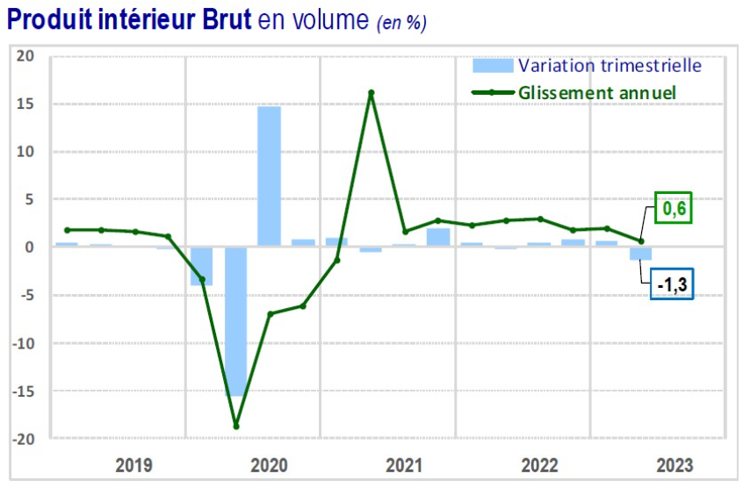

1. ***Escalating Inflation***

In August 2023, the annual inflation rate in Tunisia increased to 9.3%, breaking a trend of five consecutive months of decline. However, by October 2023, the inflation rate decreased again, [reaching 8.7%](https://tradingeconomics.com/tunisia/inflation-cpi#:~:text=The%20annual%20inflation%20rate%20eased,vs%2015.3%25%20in%20August).).This fluctuation suggests a certain level of volatility in the inflationary environment during this period.

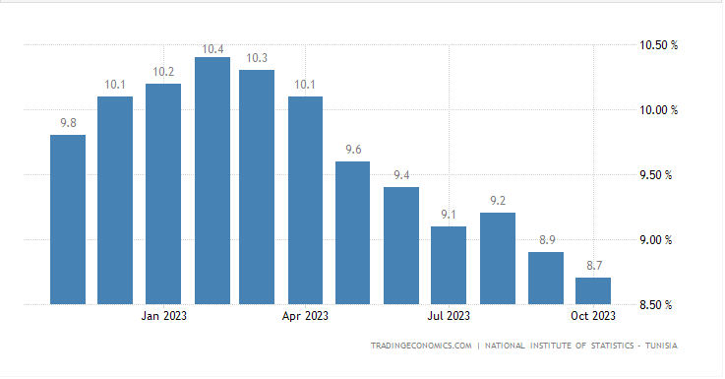

1. ***Depreciation of the tunisian dinar***

According to the note on economic and monetary developments published by the Central Bank of Tunisia (BCT), in September 2023 the dinar depreciated by 4.3% against the euro and appreciated by 3.3% against the US dollar compared with the same period last year.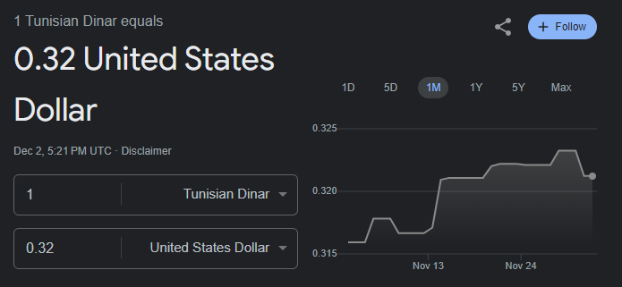

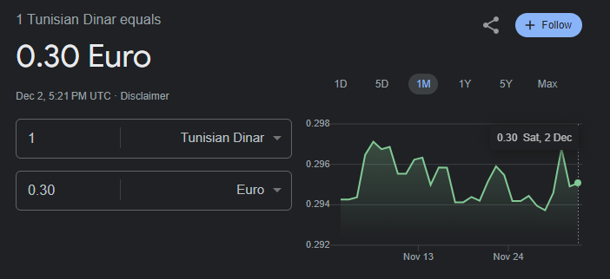

1. ***P***[***erformance of Tunindex***](https://www.webmanagercenter.com/2023/11/06/516272/bourse-de-tunis-performance-des-indices-sectoriels-au-3e-trimestre-2023/)

The TUNINDEX, the Tunis Stock Exchange's benchmark index, rose by 4.30% on September 30, 2023, compared with 18.12% over the same period in 2022.

Over the same period, the TUNINDEX20 index showed a similar trend, up 2.92% versus 21.95% over the same period in 2022.

Six of the twelve sector indices published by the Tunis Stock Exchange recorded positive performances at the close of the third quarter of 2023. The best performers were the Financial Services index (+31.38%) and the Industry index (+13.13%).

By contrast, **6 sector indices posted negative performances.** The Household and Personal Care Products index saw the biggest decline (-11.11%), followed by the Consumer Goods index (-6.06%).

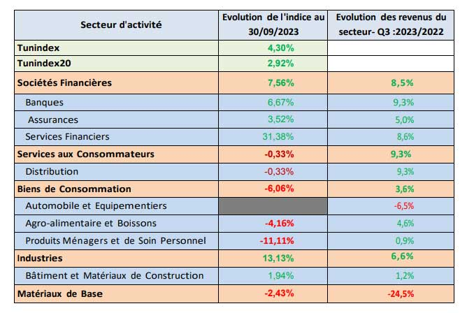

## Sectors Analysis

## The Financial Sector

* In the first half of 2023, earnings for the financial sector as a whole - the largest market capitalization on the Côte d'Azur, comprising 28 companies - **rose by 3.5%** compared with the same period in 2022, to **948 million versus 916 million.**
* The 12 listed ***banks*** achieved an overall half-year **profit of 788MD, up slightly (1.2%)** on the same period in 2022. The increase in half-yearly earnings affected only 5 banks.
* The best performance was achieved by **AMEN BANK** with **33.9%**.
* The 6 listed***insurance*** companies posted an **11.5% increase in overall half-year profit to 91MD**, compared with 81MD for the first half of 2022. The insurance companies saw total written premiums rise by 4.6%, from 723 million to 757 million.
* For the 7 listed **leasing** companies, **overall earnings were up 37%** in the same period of 2022, reaching **46MD versus 34MD**.

The overall net income of the 7 listed leasing companies **rose by 6.9% in the first half of 2023** compared with the same period in 2022, to 253MD versus 236MD.

* The financial sector as a whole, comprising 28 listed companies, posted **total revenues of 4,363 million versus 3,968 million, an increase of 9.9%.**

1. **Banks**

* It is crucial to emphasize the significant lack of visibility regarding the anticipated cost of risk in 2023,2024. This uncertainty is expected to persist, influenced by the worsening economic conditions in the post-Covid era, strained cash flows for both businesses and households, and the expiration of the moratorium from September 2021 (as per BCT circular n°2020-2021). The lifting of the moratorium is poised to unveil the quality of each bank's portfolio.
* The visibility challenge extends to the potential effects of the migration to IFRS (International Financial Reporting Standards) on banks' consolidated financial statements, particularly concerning the adoption of IFRS 9. This new accounting standard for financial instruments introduces changes to the current rules governing the classification and measurement of financial assets, as well as the impairment model.
* Despite the uncertainties, banks have accumulated solvency reserves over the past three years through robust earnings growth, subordinated debt, and additional provisioning requirements for collective provisions. These measures, combined with distribution conditions set by the BCT, aim to maintain a solvency cushion. Consequently, these solvency reserves are expected to empower banks to absorb the shock of the transition to IFRS 9 and mitigate the impact of this accounting standard change.

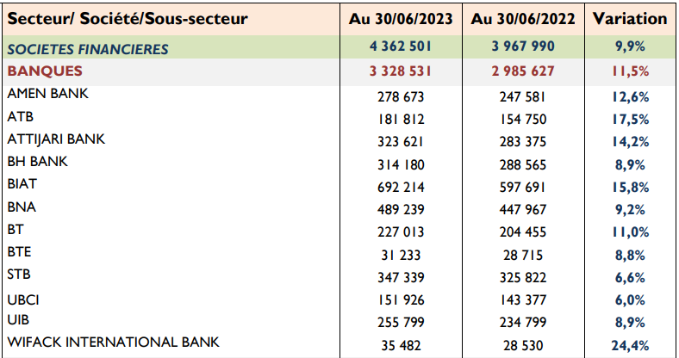

[(BVMT)](https://www.bvmt.com.tn/sites/default/files/actualites/evolution-des-revenus-des-societes-cotees-au-30-juin-2023.pdf?fbclid=IwAR0g2-qYLuO7h-Zox1Eznqyris2SJPGTll0mUyrKFI6VPvfmIpX885n5DOk)

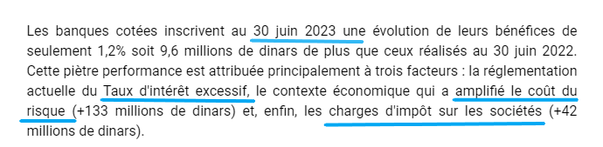[(ilboursa)](https://www.ilboursa.com/marches/classement-des-banques-cotees-par-benefices-nets-au-premier-semestre-2023_42884)

1. **Leasing and insurance**

* [The mobilization, structure, and cost of resources pose significant challenges for the leasing sector. Unlike banks, leasing companies lack direct financing from the Central Bank of Tunisia (BCT). As a result, there is more risk](https://www.ilboursa.com/docs/noterelativeausecteurduleasing-fvrier2023.pdf).

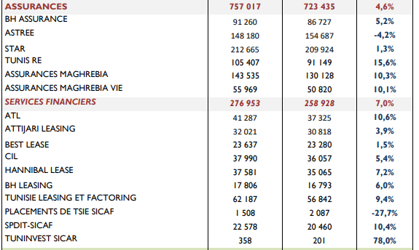

## The Consumer Services Sector

1. **Distribution**

* Overall earnings in the consumer services sector **rose by 17.3%**.
* In the same vein, the overall half-year results of the 2 listed ***supermarket chains*** (Monoprix and Magasin General) were **negative** at (**-12.2MD**), compared with a larger loss of (**-21.1MD**) during the same period in 2022.
* Overall half-year results for the 4 listed ***car dealerships*** (excluding UADH, which did not publish) **fell slightly (-2.7%) to 47MD**, compared with 48MD for the same period in 2022.
* This sector of car dealerships is grappling with various challenges. In addition to the economic aftermath of the post-revolution period, the industry has borne the weight of the local currency's decline, a decrease in Tunisian purchasing power, and a restrictive regulatory and fiscal framework. This framework promotes the voluntary restriction of quotas, higher consumption taxes, and corporate income tax, further contributing to the sector's difficulties.

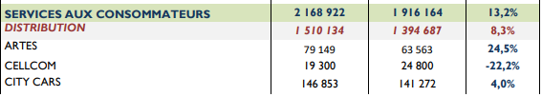

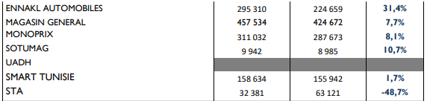

* For the group’s holding company (UADH), the latest balance sheet dates from 2017, but showed a profit of TND 6.659 million, down sharply from TND 12 million in 2016, and only TND 365 thousand consolidated for the 2017 financial year. In any case, the group’s decline will become inevitable when the French manufacturer Citroën withdraws its dealer card in Tunisia.
* [UADH delisted from the TSE (Tunis Stock Exchange) due to its lack of transparency.](https://en.africanmanager.com/tunisair-just-as-guilty-as-loukil-and-hachicha-groups-but-still-untouchable/)

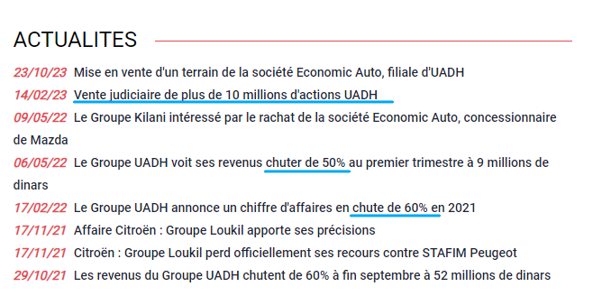([ilboursa](https://www.ilboursa.com/marches/cotation_UADH))

* [Cellcom has not yet published their financial statements for 2022.](https://kapitalis.com/tunisie/2023/10/13/bourse-de-tunis-16-societes-nont-pas-publie-leurs-comptes-semestriels/) ([ilboursa](https://www.ilboursa.com/marches/cotation_CELL))

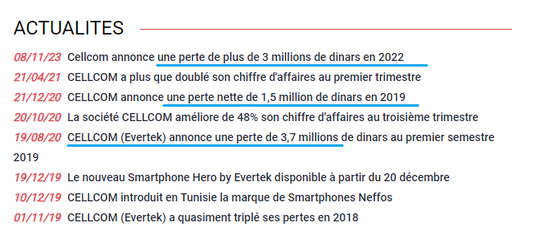

1. **Travel , Leisure & Media**

* The biggest increases were in Travel & Leisure (26.3%)

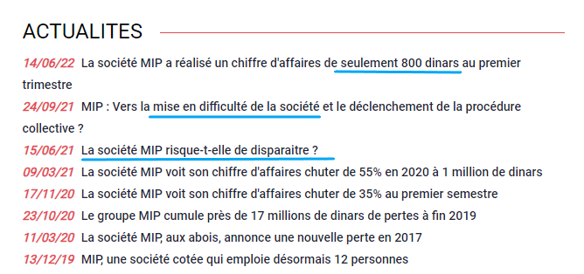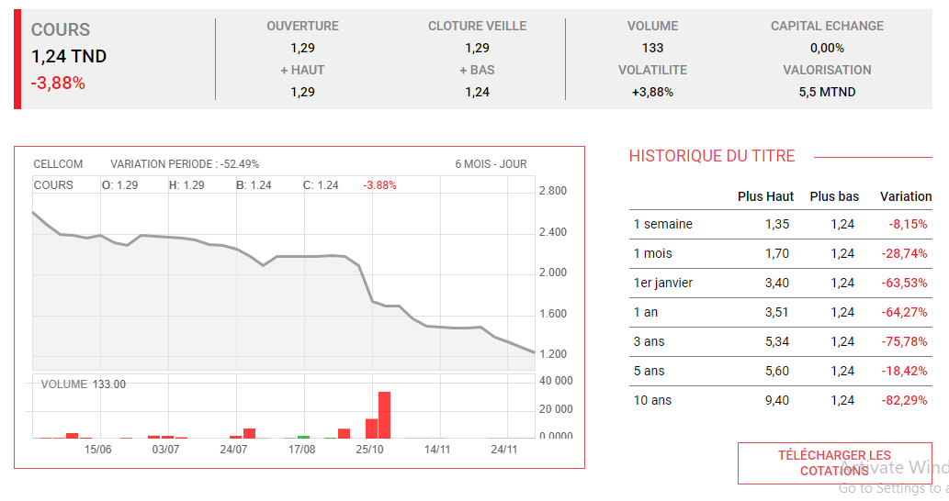

[(ilboursa)](https://www.ilboursa.com/marches/cotation_MIP)

* MIP did not publish its financial statements.
* [MIP shares will be suspended from Wednesday, October 19, 2016 to Thursday, October 20, 2016. MIP shares will resume trading on Friday, October 21, 2016.](https://bvmt.com.tn/fr/content/suspension-de-la-cotation-du-titre-%C2%AB-mip-%C2%BB)
* Tunisair, even if it achieved better results than last year, it is still not recommended due to numerous internal conflicts.
* [“Tunisair was one of the best public companies for years before it was hit hard by corruption, like other companies,” President Saïed lamented, holding those responsible for the decline accountable for their actions.](https://airspace-africa.com/2023/07/03/tunisair-rescue-plan-takes-center-stage-as-president-saied-summons-minister-of-transport-and-ceo/)
* Tunisair’s stock is currently trading at TND 0.420. When it went public, the 20% free float was worth more than TND 21.1 million. Today, that 20% is worth just TND 387,000. All this and the CMF still refuses to consider that Tunisair is just as ‘guilty’ as the 4 private companies (UADH, GIF FILTER, Loukil Group’s AMS and Fethi Hachicha Group’s Electrostar) and should also be subject to the application of Article 157 bis of the CMF.

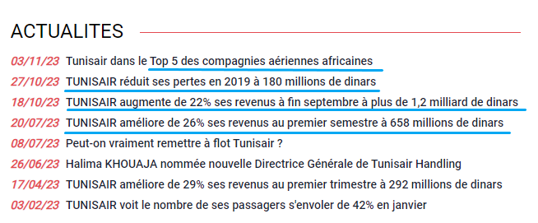

* [Tunisair and MIP have not yet published their accounts for the 2022 financial year. (lack of transparency)](https://en.africanmanager.com/tunisair-just-as-guilty-as-loukil-and-hachicha-groups-but-still-untouchable/)

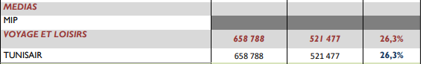

1. [**Healthcare sector**](https://www.agenceecofin.com/finance/2108-110981-bourse-de-tunis-les-entreprises-de-sante-ont-realise-la-plus-forte-progression-de-revenus-au-premier-semestre-2023)

* The healthcare sector, listed on the Tunis Stock Exchange, has demonstrated remarkable performance, achieving the highest revenue growth by the end of June 2023. **Companies within this sector collectively experienced a notable 44.2% increase in sales, surpassing other sectors, including consumer services (13.2%), financial companies (9.9%), and industries (8.7%).**
* Within the listed healthcare sector, two pharmaceutical companies, Siphat and Unimed, contribute to this impressive growth. Although Siphat's financial results were not available in a timely manner, Unimed's financial statements were considered. Specializing in the manufacture of pharmaceutical products, **Unimed reported a substantial 44.19% surge in revenues during the first half of 2023**, propelling the healthcare sector to the forefront. Notably, Unimed secured the third-highest increase in revenues among the 34 listed companies across all sectors by the end of June 2023.
* Throughout the current year, Unimed has consistently reported rising revenues, marking a positive contrast to the trend observed in 2022. In the first three months of 2023, Unimed's sales saw an impressive 37% increase, while Siphat's grew by 29%. These robust results have significantly contributed to the healthcare sector's overall performance, culminating in the sector **leading in revenue growth with an impressive 36.4% increase by the end of the first quarter.**



1. **The Consumer Goods sector**
2. **Automobiles And Equipment**

* ASSAD , STIP both showed a disappointing performance
* In the case of Gif-Filter, which it tried to rescue after the death of its original promoter, the last balance sheet dates back to 2020 and shows a deficit of more than TND 5 million; its auditors had already pointed out the “significant uncertainty regarding the continuity of operations” and the tax authorities were already on the spot for an in-depth audit.
* [Gif-Filter to delist from the TSE](https://en.africanmanager.com/tunisair-just-as-guilty-as-loukil-and-hachicha-groups-but-still-untouchable/)

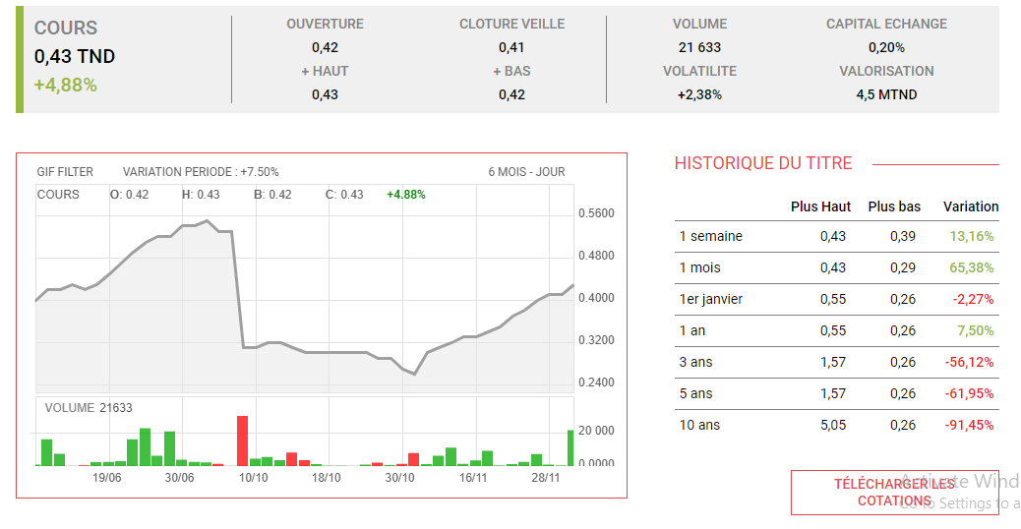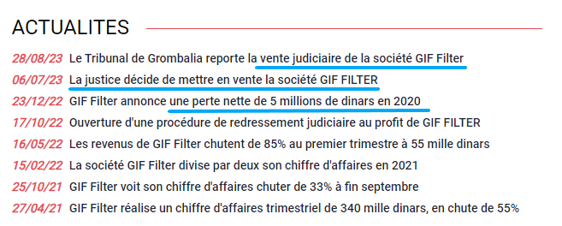

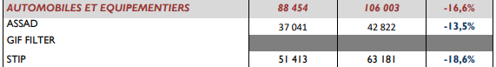

1. **Food And Beverages**

* The overall half-year result of the three large groups operating in the agri-food industry (Poulina Group Holding, Délice Holding and SFBT) **increased by 12.4%** to reach 230MD compared to 205MD during the first half of 2022.
* Total revenues for the three major agrifood groups (Poulina Group Holding, Délice Holding and SFBT) **rose by 5.6% from 2,909MD to 3,072MD.**

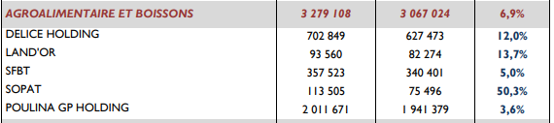

1. **Household and Personal Care Products**

* [This market is anticipated to experience **an annual growth rate of 3.30%** (CAGR 2023-2028)](https://www.statista.com/outlook/cmo/beauty-personal-care/tunisia)
* The [SAH Group](https://www.cmf.tn/sites/default/files/pdfs/emetteurs/informations/indicateurs/indic_1trim23_sah.pdf) (the largest company in this sector) is actively expanding its presence both locally and regionally. After the prosperous launch of its detergent business and the successful growth of its subsidiary, Azur Détergent, SAH is now pursuing a diversification strategy by entering the cosmetics market. In addition to its entry into the Saudi Arabian market in 2022, Lilas, a subsidiary of SAH, is further expanding its reach by entering the French market. In France, SAH is introducing its hygiene products under its own brand name in supermarkets.
* At the end of the first half of 2023, [Officeplast'](https://www.tustex.com/bourse-bilans/officeplast-annonce-un-benefice-de-1608-mille-dinars-au-premier-semestre)s **profit stood at 160.8 thousand dinars**, compared with a profit of 60.3 thousand dinars in June 2022. **Operating income reached 1.127 million dinars versus 1.075 million dinars in the first half of 2022, an increase of 4.75%.**
* The Tunisian leader in office and school products generated sales of **18.3 million dinars in the first half of this year, compared with 18.9 million dinars at the end of June 2022.**
* For the flagship company of the Hachicha group ELECTROSTAR, the tightening of bank loans, which targeted it, and the tax authorities, which did not allow it any respite, had certainly finally outstripped Electrostar’s resilience. **The balance sheet for the 2020 financial year, published in August 2022, showed falling revenues and an operating loss almost as high as revenues**, **and a net loss of TND 16.3 million, not counting the TND 37.64 million in negative retained earnings.**

Fethi Hachicha will have to repay its former shareholders just over TND 456,102,000.

* [Fethi Hachicha Group’s Electrostar to delist from the TSE](https://en.africanmanager.com/tunisair-just-as-guilty-as-loukil-and-hachicha-groups-but-still-untouchable/) ([bankruptcy](https://www.ilboursa.com/marches/cotation_LSTR))

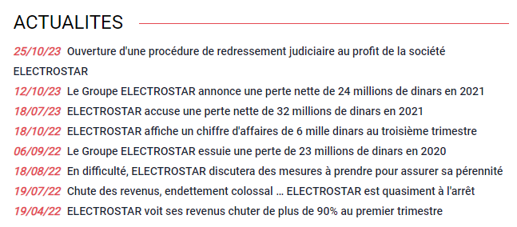

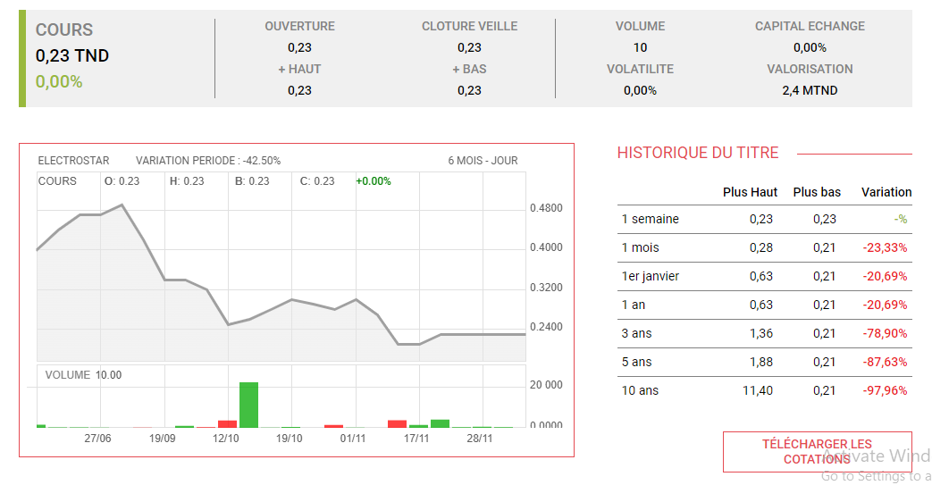

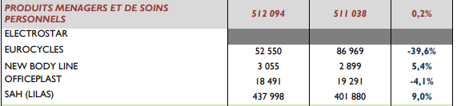

**5. Industry sector**

1. **Building and Construction Materials**

* The whole sector is carried by the progress of CARTHAGE CEMENT which increased by 23.7%. The substantial growth of this key player has acted as a mitigating factor, potentially offsetting some of the overall difficulties faced by the sector.
* The last balance sheet published by AMS, a company undermined by forgery and killed by COVID, was in 2019. It showed a deficit of 28.924 million Tunisian dinars, including 8.6 million Tunisian dinars in salary costs and 7 million Tunisian dinars in net financial costs.

The Loukil Group will have to repay its former shareholders more than TND 7 million

* [Loukil Group’s AMS to delist from the TSE](https://en.africanmanager.com/tunisair-just-as-guilty-as-loukil-and-hachicha-groups-but-still-untouchable/) (Tunis Stock Exchange).
* Potential growth of MPBS 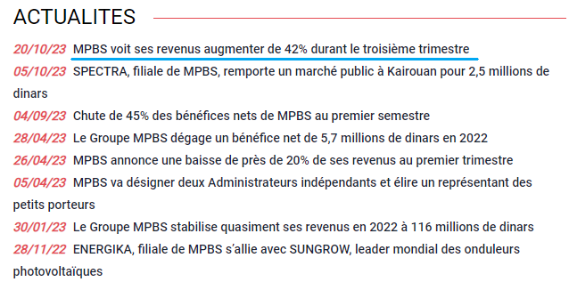

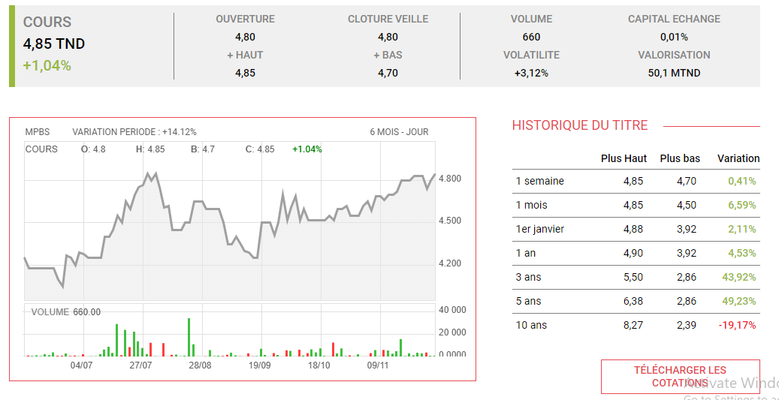

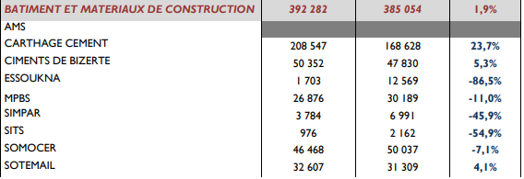

1. **Industrial Goods and Services**

* Overall , the sector is doing well thanks to its key players ONE TECH HOLDING , SIAME , SOTUVER
* One tech holding increased by 14.4% , SIAME by 24.5% and SOTUVER by 4% .

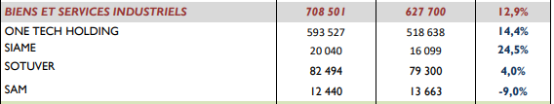



**6.The basic materials sector**

* Overall half-year earnings in the Basic Materials sector **fell sharply to 30 million versus 52 million** in the same period of 2022.

1. **Chemicals**

* This decline is attributable to the poor performance of the Chemicals sub-sector
* ICF, whose half-yearly results **fell by 56.7%** compared with the same period of 2022. This is due to the ongoing strike for more than one month 12/07/2023 , internal theft (financial / product) ,less international partners now compared to before .
* The Stock Index Committee of the Tunis Stock Exchange has announced the inclusion of TPR (Tunisie Profilés Aluminium) in the Tunindex 20 index, with effect from Monday October 2, 2023. This decision, taken at the Committee's meeting on September 26, also entailed [the removal of the ICF](https://kapitalis.com/tunisie/2023/10/02/bourse-de-tunis-tpr-integre-le-tunindex-20-icf-le-quitte/) (Industries Chimiques du Fluor) stock from the same index, which groups together the shares of the best-performing and most liquid companies, including banks, financial institutions, as well as companies operating in the raw materials, consumer, industrial and technology sectors.

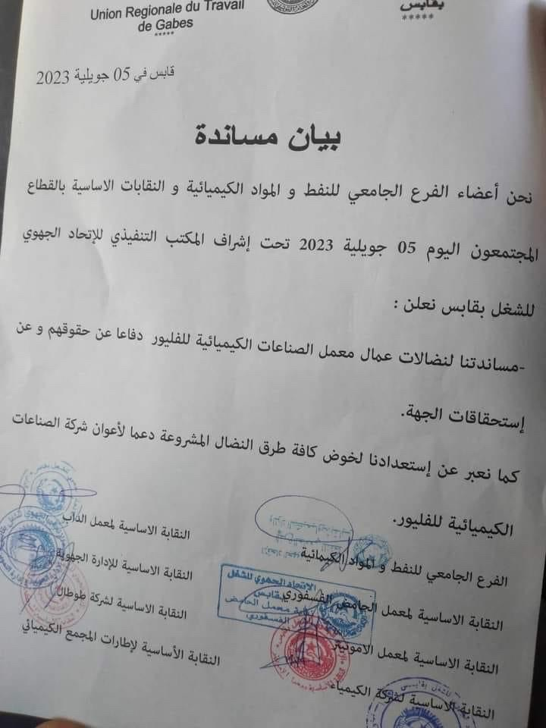

* On June 30, 2023, [**Air Liquide Tunisie recorded a 32% drop in overall sales**](http://www.maxulabourse.com.tn/actualite/air-liquide-recul-des-revenus-de-32-au-30-juin-2023) compared with the 2nd Quarter of fiscal 2022. This drop is a consequence of the cessation of local carbon dioxide supply recorded from September 2022, partially offset by imports of the same product. Export sales in Q2 2023 compared with the same period of 2022 were down 31%, and sales on the local market were down 39%.
* Production was down 17% at June 30, 2023 compared with the same period in 2022. **Medical oxygen requirements fell sharply by 19%** **in the first half of 2023** compared with the same period of 2022. **Nitrogen production also fell by 12% in the 1st half of 2023** compared with the same period in 2022.
* Chemicals company **ALKIMIA saw a 36% drop in sales to March 31, 2023**, compared with the first quarter of 2022, according to the company's quarterly activity indicators published on the Tunis Stock Exchange website. This fall is explained by the drop in sales volume of its two products (sodium tripolyphosphate and crystallized MAP), due in particular to the overpricing by Groupe Chimique Tunisien of the two main raw materials, phosphoric acid and ammonia.

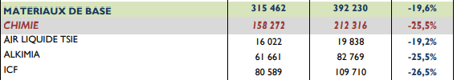

1. **Raw Material**

* The Raw Materials sub-sector, which posted a **12.6% decline**.

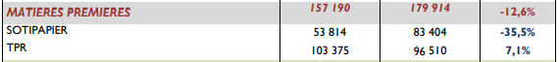

* Potential increase of SOTIPAPIER and TPR. *This trend will be further investigated in the analysis.*

**7.Oil & Gas sector**

* The only company included is SOTRAPIL
* During the first half of 2023, there was a 2.44% decrease in the quantities of goods transported, falling from 888,887 m3 to 867,159 m3 compared to the same period the previous year. **This decline can be attributed to a 2.68% reduction in quantities transported through the Bizerte-Rades pipeline**. In contrast, there was a marginal increase in activity on the Jet A1 pipeline, with quantities rising by 0.02%.



**8.Technology sector**

* Telnet, with its robust position in digital technologies, stands out as one of the few groups that have successfully weathered the impact of the Covid-19 crisis. The pandemic has accelerated a significant shift toward digital technologies, telecommuting, digital payments, and software utilization. In the upcoming years, Telnet's management team has charted a strategic roadmap that focuses on internationalization and the enhancement of technological expertise. This strategic direction aims to position Telnet in emerging fields such as satellites, drones, electric cars, and robotics. The company is proactively adapting to the evolving landscape, leveraging its strength in digital technologies for sustained growth and diversification.
* AETECH **declined by 34%**



**9.Telecommunication sector**

* The overall sector is **declining by 1.5%.**
* [SERVICOM SA](http://www.maxulabourse.com.tn/actualite/servicom-liquidation-de-la-soci%C3%A9t%C3%A9-servitra-filiale-du-groupe-servicom) announces that the Tunis Court of First Instance has handed down a ruling dated 11/01/2022 to liquidate SERVITRA. SERVITRA was a subsidiary of the SERVICOM group specializing in public works, and in 2017 accounted for almost 70% of the group's consolidated sales. Since 2017, this company has experienced financial difficulties as a result of the significant delay in payment of its invoices by the State and the significant fluctuation in its purchasing costs, combined with the absence of an effective mechanism to reflect price variations in public contracts. SERVITRA's difficulties were the main cause of the SERVICOM Group's cash flow problems.
* [Tawasol Group Holding](https://managers.tn/2023/07/31/tawasol-group-holding-une-croissance-solide-malgre-les-defis-economiques-en-tunisie/): solid growth despite Tunisia's economic challenges that are limiting its development. Despite this, TGH's subsidiaries in the Democratic Republic of Congo, Ethiopia and Morocco performed encouragingly, thanks in particular to solid contracts with partners such as ZTE and Nokia.

The management of Tawasol Group Holding is also in the process of finalizing the consolidated accounts for 2022, and plans to hold its Annual General Meeting in the near future to approve the financial statements for 2021 and 2022.

* [Servicom, Tawasol Group Holding have not yet published their financial statements for 2022](https://kapitalis.com/tunisie/2023/10/13/bourse-de-tunis-16-societes-nont-pas-publie-leurs-comptes-semestriels/) which may imply a lack of transparency.

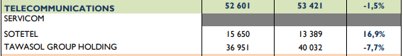

Conclusion: Through meticulous research aimed at comprehensively understanding the distinctive features of each sector - strengths, challenges, expectations, prevailing trends, etc - a conclusive analysis reveals the following conclusions :

* Focus on the financial sector with all its components (banks, leasing,insurance) . This sector showed remarkable resilience and ability to withstand challenges, minimizing losses even in adverse conditions.
* Avoid companies that lack transparency (UADH, MIP, Tunisair, Siphat, GIF filter, Electrostar, AMS, SERVICOM , TGH) , the situation of these companies represents a growing risk to the interests of shareholders due to repeated non-compliance with the obligation to publish financial information imposed by the laws and regulations in force
* Take advantage of potential growth of health care sector (UNIMED) , Raw Material (SOTIPAPIER , TPR) , Technology sector (Telnet holding)
* Exercise caution in sectors with limited prospects. This includes travel and leisure (like Tunisair), media (such as MIP), automotive and equipment (ASSAD, GIF, STIP), chemicals (ICF, ALKIMIA, Air Liquide), and oil and gas (SOTRAPIL).These sectors are grappling with challenges like raw material shortages, internal conflicts, and strikes, requiring prolonged correction periods that may not align with the timeframe of our project.

## Listed Companies Analysis

| **Financial Industry** | | | | | | | | | | | | | | |
| --- | --- | --- | --- | --- | --- | --- | --- | --- | --- | --- | --- | --- | --- | --- |
|  | | | | | | | | | | | |  |  |  |
| **N°** | **Company's Name** | | **Analysis** | | | | | | | | | | | |
|
| 1 | Attijari Bank | | -In 2023, Attijari is likely to face a gloomy environment marked by sluggish(Swiss) investment, rising non-payment risks and tight liquidity. However, Attijari should be relatively among the banks least affected by the crisis, thanks to its solid financial base, good portfolio quality and comfortable liquidity cushion. | | | | | | | | | | | |
| -The bank's high liquidity (with a low transformation ratio) and the quality of its portfolio give it considerable leeway to cope with monetary tensions, the prevailing gloom and the tightening of the regulatory framework. | | | | | | | | | | | |
| -Appreciated by foreign investors for the quality of its management, its high stock market liquidity and its commercial responsiveness, Attijari Bank is an excellent vehicle for gaining exposure to the listed banking sector  -In the coming years, Attijari will have to contend with a gloomy post-covid environment marked by sluggish investment, rising payment risks and tight liquidity. However, Attijari should be relatively among the banks least affected by the crisis, thanks to its solid capital base, good portfolio quality and comfortable liquidity cushion.  -Despite its evolution in 2022, the share is trading at a discounted valuation that underestimates Attijari Bank's fundamental qualities  and its organic growth profile, which is superior to that of its listed peers.  -The bank's high level of liquidity (with one of the lowest loan-to-deposit ratios in the listed banking sector) and the quality of its portfolio give it considerable room for maneuver to counteract any downturns.  -It is classified as the second private bank in Tunisia in terms of credits and deposits.   * *Prized by foreign investors for the quality of its management, high stock market liquidity and commercial responsiveness, Attijari Bank is an excellent vehicle for gaining exposure to the listed banking sector.* | | | | | | | | | | | |

| 2 | UIB | | -The Société Générale Group subsidiary has opted to draw on the expertise of two consulting firms to build its strategic plan and  roadmap for 2022-2025. This roadmap should focus on the following areas: customer relations, operational efficiency and the solidity  of the Group, operational efficiency and balance sheet strength. Management remains confident in the bank's ability to reach new levels of profitability and consolidate its competitive position | | | | | | | | | | | |
| --- | --- | --- | --- | --- | --- | --- | --- | --- | --- | --- | --- | --- | --- | --- |
| -Given its multiples and prospects for continued profitable growth in 2022, UIB is well-equipped to continue its stock market rebound  in the coming years. | | | | | | | | | | | |
| -Its commercial responsiveness and the quality of its portfolio, UIBs affiliation with the Société Générale Group and the progress made  in adopting international standards (IFRS and Basel solvency and liquidity standards) are guarantees that the Group will be able to overcome the current crisis. | | | | | | | | | | | |
| -UIB might be negatively affected by the increase in BCT which might limit the growth of its activities given the inflationary  environment.   * *Its commercial responsiveness and the quality of its portfolio constitute guarantees that UIB can support current environmental*   *crisis and keep a growing stock performance.* | | | | | | | | | | | |
| 3 | BH Bank | | -In the first half of 2023, BH Bank recorded net banking income (NBI) of 312,818 thousand Tunisian dinars, demonstrating significant growth compared with the same period last year, when it stood at TND 288,565. This growth was driven by several key factors. | | | | | | | | | | | |
| -BH's strategy for the coming years is essentially based on customer focus and growth accompanied by profitability and compliance.  The bank's efforts over the next few years will focus primarily on: 1) rebalancing rebalancing business between the Corporate, SME and Retail segments, 2) relaunching the housing loan business, the bank's core business and its flagship product, 3) mastering the  development 4) controlling the cost of resources and 5) optimizing processes to improve operating efficiency. | | | | | | | | | | | |
| -Income from BH Bank's investment portfolio reached 56,086 thousand dinars at June 30, 2023, compared with 52,750 thousand  dinars at June 30, 2022, indicating continued growth in its investment activities. | | | | | | | | | | | |
| -The valuation of BH is attractive for a bank that is well advanced in its restructuring process and whose fundamentals are very close to private sector standards.   * *Overall, BH Bank continues to demonstrate its robustness and steady growth, reinforcing its position as a key player in the*   *Tunisian banking sector.* | | | | | | | | | | | |
| 4    4 | BIAT | | -The share price of Tunisia's No. 1 bank continues to be on a roll, posting double-digit returns for the second year running. BIAT's landing in the first half of BIAT's landing in the first half of 2022 (net profit up 86.8% at 208.7 million tonnes) once again reassures us of the solidity of Tunisia's leading bank. Intrinsic business continues to outperform the sector, proving its resilience in the face of a challenging operating environment.  -The bank's leadership on sight deposits, its comfortable leeway on the cost of funds and on the regulatory transformation ratio are  BIAT's weapons in the face of the current crisis constraints of the current crisis that is shaking the economic and financial sphere.  -BIAT has started new innovative and profitable activities in the sector : Development of investment banking and private banking , and wealth management activities . These activities allowed it to have a bigger regional scope and to become the momentum of the banking sector.  -BIAT, the second-largest equity market capitalization after SFBT, only slightly to the BCT's new conditions for dividend distribution, imposed on banks and financial institutions for the financial year 2021 | | | | | | | | | | | |
| -Despite its track record, the sector leader tempting valuation levels that incorporate the additional costs of the crisis and  underestimate the bank's fundamental qualities in terms of business model resilience in the face of external shocks. | | | | | | | | | | | |
| * *BIAT constitues a convenient investment choice : a low-risk stock , improved liquidity , and future growth prospects in a context*   *of growing interest rates.* | | | | | | | | | | | |
| 6  6 | AMEN Bank | | -AMEN Bank’s appreciable solvency level is the bank's major asset in these difficult times. It will enable the bank to absorb the "shock"  of the crisis, and to rapidly resume its quest for growth at the first signs of economic recovery. We therefore recommend holding AMEN Bank shares with a positive outlook.  -AMEN Bank distinguished itself throughout 2022 by being awarded several prestigious distinctions, as well as the renewal of two certifications. Indeed, the Bank began 2022 with two Green distinctions, that of the first Green Bank Award and that of the Best Energy Project of the Year, both awarded by the organizing committee of the 3rd WENERCON Edition. In keeping with its global strategy of  service quality and innovation, AMEN BANK was voted "Best Bank in Tunisia 2022" for the 3rd year running by the prestigious "Global Finance" magazine. Over the years, this ranking has become a standard of excellence and confidence for the global financial community.  -AMEN BANK's 100% digital experience was also recognized by Global Banking & Finance Review, which awarded it the following three prizes: "Best Bank for Youth and Students Tunisia 2022" for the 2nd year running for AMEN First Bank, the 1st 100% online bank in Tunisia since 2015, "Best Digital Bank Tunisia 2022", in recognition of the Bank's innovation in support of its digitalization strategy, and "Excellence in Innovation Digital Banking Tunisia 2022", an award that further consolidates the Bank's position as a leader in  innovation, the digitalization of its processes and the constant focus on the customer experience.   * *AMEN banks demonstrates a solid financial structure allowing it to face the risk of its activities with a reasonable leverage ratio*   *(<16%) favored by the continuous strengthening of its funds thanks to its organic growth and a rigorous dividend distribution*  *policy.* | | | | | | | | | | | |
| 7 | Attijari Leasing | | -Key Rating Drivers Shareholder Support Drives Ratings: Attijari Leasing got a National Rating of ‘A-(tun)’ in October 2023 (1st in the sector) which reflects direct potential support from its Tunisian 65%-owner Banque Attijari de Tunisie and, in turn, indirect  extraordinary support from its Morocco-based owner, Attijariwafa Bank. The National Rating is additionally underpinned by Attijari Leasing standalone financial strength. Stable Outlook: The Stable Outlook on a company's National Long-Term Rating reflects Fitch  Ratings’ expectation that ratings pressures are equally balanced with that of peers. Good Synergies with Parent: Attijari Leasing is a well-established second-tier company in Tunisia’s leasing sector, with a 12% asset-based market share .  -Attijari Leasing has good management quality, often drawn from its direct parent with whom it has strong synergies.  -Attijari Leasing retains a market share of 12.5%.   * *Attijari Leasing represents a promising agency that is continuously demonstrating growth in different aspects of its business.* | | | | | | | | | | | |
| n 8 | BH Leasing | | -Business continues to pick up and the company's results continue to recover after accumulating deficits over the 2018-2020 period.  -The leaser benefits from significant operational synergies with its parent company. with its parent company. A tempting valuation on  the face of it, but virtually non-existent stock market liquidity (listed on the fixing).  -BH Leasing had decided to give priority to out-of-court collection, to strengthening and automating external collection, and to consolidating synergy with BH Bank in the collection of unpaid bills from joint customers.  -The downgrade of BH Leasing's (BHL) National Ratings to 'BB+(tun)’ from ‘BBB(tun)’ follows further deterioration of the operating environment for Tunisian financial institutions in 2023, and Fitch Ratings’ June downgrade of Tunisia’s Long-Term Foreign-Currency  Issuer Default Rating (IDR) to ‘CCC-’. Fitch believes that BHL’s majority shareholder BH Bank’s ability to support has deteriorated  following the recent sovereign downgrade.   * *The lack of visibility on a lasting upturn in profitability does not argue in favor of a position on the stock at present.* | | | | | | | | | | | |
| 9 | STAR | | -STAR is undeniably a quality stock. The insurer maintains its leading position in the local market, and stands out from its peers for its  solid balance sheet. balance sheet | | | | | | | | | | | |
| -Despite the continuing voluntary withdrawal of the Automotive Division, STAR has maintained its leading position in the local market.  -The insurer stands out from its peers for its solid balance sheet. This is an extremely important criterion in the context of regulatory change and the transition to IFRS standards at the beginning of 2023. In fact, the company's high level of shareholders' equity has  enabled it to post a comfortable solvency margin. solvency margin of 4.4x the required regulatory margin. The insurer also boasts the  most substantial portfolio of assets. | | | | | | | | | | | |
| -STAR trades at attractive valuation levels, underestimating the quality of the insurer's fundamentals and its technical growth potential. We recommend buying the stock.   * *In view of current attractive valuation levels, a "buy" rating is recommended for the stock, which is particularly appropriate for*   *a medium- to long-term investment horizon.* | | | | | | | | | | | |
| 10 | Maghrebia Vie | | -Assurances Maghrebia Vie, the latest addition to the Group's stock market, has floated on the main market of the Cote de la Bourse through the sale of 2,500,000 shares and the issue of 5,000,000 new shares, representing 30% of post-IPO capital.  Since then, 18,476 shares have been traded, representing a daily average of 6,158 shares. This is still below the average trading volume  for the January-June 2023 period, which was 23,147 shares per day. | | | | | | | | | | | |
| -Assurances Maghrebia Vie has established itself as a leading player in life insurance in second position in terms of written premiums, behind Attijari Assurance. | | | | | | | | | | | |
| -The Group has presented an ambitious Business Plan which combines growth and improved profitability: a challenge that  management will have to meet in a precarious economic climate.   * *A stock less liquid despite the recent introduction of Maghrebia Vie to the stock exchange which strongly pinalies the valuation*   *of the stocks compared to its competitors.* | | | | | | | | | | | |
| 11 | BH Assurance | | -BH Assurance has shown considerable resilience since the health crisis. | | | | | | | | | | | |
| -The insurer's main weakness lies in its low equity capital, which limits the growth of its business. | | | | | | | | | | | |
| -The stock is trading at a valuation level in line with that of the listed universe. Nonetheless, the stock's ungenerous distribution and  a tiny free float handicaps its stock market performance.   * *BH Assurance should be conserved as it’s suffering from high volatility in its financial position and its stock performance.* | | | | | | | | | | | |

| **Agri-Food & Beverages Industry** | | | | | | | | | | | | | | |
| --- | --- | --- | --- | --- | --- | --- | --- | --- | --- | --- | --- | --- | --- | --- |
|  | | | | | | | | | | | | | | |
| **N°** | **Company's Name** | | **Analysis** | | | | | | | | | | | |
|
| 1 | Poulina Group Holding | | -Poulina Group, a prominent Tunisian poultry and food processing company, experienced noteworthy growth in recent years, with its revenue reaching a record 3.3 billion dinars in 2021, marking an 8% increase from the previous year. This success was driven by a surge in demand for poultry and food products in Tunisia, coupled with a strategic focus on innovation and expansion into new markets, particularly in Africa.  -The positive momentum continued into the first half of 2022, with revenue reaching 3.8 billion dinars, a 15% increase from the same period in the previous year, and a net profit rise of 20% to 120 million dinars.  -However, challenges emerged in the second half of 2022, including rising inflation, supply chain disruptions from the war in Ukraine, and higher commodity prices, resulting in a slight decline in full-year 2022 revenue and a decrease in net profit.  -Despite these setbacks, Poulina Group remains resilient and well-positioned for future growth, evidenced by its diversification across various product lines and markets. Notably, the company's strategic acquisition of Carthage Ceramic, a leading Tunisian ceramics manufacturer, signals a commitment to growth and a strong presence in the expanding Tunisian construction market.  -Despite a previous downturn, the company's stock has gradually improved since October 2023, showing a 4.48% increase. However, challenges persist, as evidenced by a 29.5% decrease in net profits in 2022. The company posted a profit of 48 million dinars in the first half of 2023, indicating ongoing efforts to navigate and overcome economic headwinds.   * *In conclusion, Poulina Group's diversified portfolio and strategic moves position it to capitalize on opportunities for growth, although vigilance is required in addressing macroeconomic challenges.* | | | | | | | | | | | |
| 2 | [Délice Holding](https://www.tunisievaleurs.com/documents/Etude_D%C3%A9lice_Holding_Juin_2023.pdf) | | -[The Delice Group, a leading Tunisian player in the agri-food industry, experienced a challenging yet successful year in 2022. Despite an unfavorable economic environment marked by the war in Ukraine, rising inflation, and a decrease in purchasing power, the Group recorded an 8.8% growth in its consolidated revenues, reaching 1.3 billion dinars.](https://www.ilboursa.com/marches/news_valeur?s=DH)  -[This performance can be attributed to several factors, including:](https://www.ilboursa.com/marches/news_valeur?s=DH)   * [The resilience of demand for dairy and juice products despite the difficult economic conditions.](https://www.ilboursa.com/marches/news_valeur?s=DH) * [The Group's continuous investments in innovation and the expansion of its product range.](https://www.ilboursa.com/marches/news_valeur?s=DH) * [The Group's diversification into new markets, particularly internationally.](https://www.ilboursa.com/marches/news_valeur?s=DH) * [The Group also maintained a strong pace of investments, with over 250 million dinars invested in the last five years. These investments enabled the Group to strengthen its processing capabilities and productivity.](https://www.ilboursa.com/marches/news_valeur?s=DH)   -[In the stock market, Delice Holding's share experienced a 11.7% correction in 2022, compared to a 20.9% drop for the Agri-food and beverages index. While this performance is disappointing, it appears to reflect investors' concerns about the challenging economic conditions.](https://www.ilboursa.com/marches/news_valeur?s=DH)  -[During the first months of 2023, the Delice Group continued its growth, achieving a turnover of 702 million dinars in the first half, a 12% increase compared to the first half of 2022.](https://www.ilboursa.com/marches/news_valeur?s=DH)  -[The Delice Group is well-positioned to sustain its growth in the coming years. The company holds a leadership position in the Tunisian market for dairy and juice products, boasts a diversified product portfolio, and follows a robust investment strategy.](https://www.ilboursa.com/marches/news_valeur?s=DH)  -However, it is important to note that recent news in Gaza have led to calls for a boycott of Delice Group products due to its partnership with Danone. This could have a negative impact on the company's sales and reputation. The Delice Group will need to carefully manage this situation in order to minimize any negative impact on its business.   * *Overall, the Delice Group is a strong company with a bright future. However, the company will need to carefully manage the recent calls for a boycott in order to maintain its growth trajectory.* | | | | | | | | | | | |
| 3 | LAND'OR | | -[Land'Or has been experiencing strong growth in recent years. In 2022, the company's revenue grew by 20% to 160 million dinars. This growth continued in the first half of 2023, with revenue increasing by 14% to 80 million dinars. In the third quarter of 2023, revenue increased by 20% to 145 million dinars.](https://www.ilboursa.com/marches/news_valeur?s=LNDOR)  -[There are a number of macroeconomic factors that could be contributing to LandOr's growth. One possibility is the strong economic growth in Tunisia. The Tunisian economy grew by 3.5% in 2022, and is expected to grow by 4% in 2023. This growth is being driven by a number of factors, including increased tourism, foreign investment, and government spending.](https://www.ilboursa.com/marches/news_valeur?s=LNDOR)  -[Another possibility is the growing demand for LandOr's products. The company is a leading producer of dairy products in Tunisia, and its products are also sold in other African countries. The growing population in Africa, combined with rising incomes, is creating a growing demand for dairy products.](https://www.ilboursa.com/marches/news_valeur?s=LNDOR)  -[Land'Or is also expanding its operations. In 2022, the company opened a new factory in Morocco. This expansion is likely to help the company grow its revenue and market share.](https://www.ilboursa.com/marches/news_valeur?s=LNDOR)  -[The strong economic growth in Tunisia is likely leading to increased consumer spending, which is benefiting Land'Or's sales.](https://www.ilboursa.com/marches/news_valeur?s=LNDOR)  [The growing demand for dairy products in Africa is likely creating new opportunities for Land'Or to expand its sales.](https://www.ilboursa.com/marches/news_valeur?s=LNDOR)  -[LandOr's expansion into Morocco is likely helping the company reach new customers and markets.](https://www.ilboursa.com/marches/news_valeur?s=LNDOR)  [Of course, it is impossible to say for sure what is driving Land'Or's growth. However, the macroeconomic factors discussed above are likely playing a role.](https://www.ilboursa.com/marches/news_valeur?s=LNDOR)   * *Overall, the macroeconomic factors appear to be favorable for Land'Or. The company is well-positioned to continue growing in the coming years.* | | | | | | | | | | | |

| **Household & Personal Products Industry** | | | | | | | | | | | | | | |
| --- | --- | --- | --- | --- | --- | --- | --- | --- | --- | --- | --- | --- | --- | --- |
|  | | | | | | | | | | | | | | |
| **N°** | **Company's Name** | | **Analysis** | | | | | | | | | | | |
|
| 1 | SAH Lilas | | -At the end of 2023, the Group expects revenue growth of 12%. This forecast is certainly lower than the growth achieved at the end of  the year 2022. The reason is linked to the changes in capacities achieved during the 2022 financial year, which allowed the various  entities of the Group to reduce their production levels to almost zero levels (optimal.)  In an environment battered by the economic crisis in Tunisia and stagflation, the stock represents an attractive investment opportunity in many respects:  1) This is a defensive stock operating in a sector that is not very sensitive to downward economic cycles.  2) It is a growth value: The Group operates in booming markets. African markets are characterized by high birth rates and  economic growth and are very conducive to organic growth.  3) It has an international value: After having won the challenge of its transformation into a highly integrated national champion of  hygiene and paper products and detergents, the Group displays strong international ambitions.  4) It is a target of choice for institutional investors: Thanks to the size of its market capitalization and its free float, SAH Lilas is among  the most liquid securities on the market. In addition to its high liquidity, its institutionalized shareholder base makes the Group a  prime target for institutional investors, particularly foreign investors.  -In an environment battered by the crisis, the stock represents an interesting investment opportunity in many respects. This is a  defensive value and growth, international value and a target of choice for institutional investors looking for “Blue chips”. SAH  Lilas continues to distribute dividends, sending a strong signal to the market that the Group is ready to begin a phase of cash  flow generation and debt reduction and that it is about to reap the benefits of its investments in the coming years.   * *Overall, Lilas has a defensive positioning, its expansion strategy seems to be appropriate, particularly in the current gloomy*   *economic climate which may favor investing in the company .* | | | | | | | | | | | |
| 2 | SAM | | -The year 2021 was a good year for the office furniture specialist, posting double-digit growth in its turnover and an improvement of 74% in the level of its net profit to reach 1.8mTnd, i.e. a net margin of 7.9%. 2022 was also marked by continued double-digit growth in activity.  -During the third quarter of 2023, the company Meuble Interiors managed to recover the decline observed over the first six months of the year in terms of its turnover (-12%).Indeed, the company's revenues increased by 1% during the third quarter to reach 6 million dinars. This catch-up is the result of several commercial and marketing actions carried out.  -The confirmed order book (more than 5 million dinars), including concluded contracts, is a good support to reinforce the pace of development in the fourth quarter of 2023. Several large accounts continue to have confidence including: STAR, BIAT, LA Poste , BNA, Tunisie Telecom  -A showroom will take place in Nice for the current period (December, 2023) that is most likely to make a success.   * *Overall, SAM is a solid company with promising growth prospects.* | | | | | | | | | | | |
| 3 | [OfficePlast](https://www.ilboursa.com/marches/maxula-bourse-recommande-dacheter-le-titre-office-plast_42840) | | -Considered an essential reference in the stationery market, Office Plast has managed to maintain its place as a leader in the Tunisian market, with a market share of around 40%. The company continues to strengthen the distribution chain of its products.  Indeed, after the franchise operation of the French brand "Bureau Vallée", the company is launching its own brand "PURPLE" whose first store opened in 2023 in Charguia I.  -Since its IPO, Office Plast has managed to maintain an increasing rate of revenue with a CAGR2015-2022 of 15.15%. Regarding operational efficiency, the company managed to improve its margins, despite the increase in the price of raw materials and the increase in transport costs. The EBIT margin increased by 6 percentage points to 7% at the end of the 2022 financial year.  -Furthermore, the company's financial profitability was impacted by the increase in its financial charges. This increase is justified by the increase in short-term debt following the change in WCR for the period.  -Aware of the fragility of the economic context, Office Plast is committed to strengthening its commercial efforts and improving its  financial balance as well as its cash flow. The company continues with the plan of creating new subsidiaries in Europe in order to  optimize its commercial process. With a view to diversification, the company intends to embark on a new project, namely “A PP Film Line”.  Given the perpetual growth of its revenues on the one hand, and the company's ability to mobilize resources to transform the conditions  of its environment to its advantage and improve its efficiency on the other hand, analysts of the intermediary MAXULA Bourse indicate  that it is important to pay close attention to the future achievements of the company.   * *Overall, OfficePlast is fragile to the economic factors. Despite its efforts of stregthening and improving its outlook is uncertain.* | | | | | | | | | | | |
| 4 | Euro Cycles | | -For the current year, Mr. GHAZI announced that management plans a 38% drop in production (in volume) compared to 2022 with a view to destocking. Consequently, 2023 will be another difficult year for Euro-Cycles with a 38.5% decline in turnover to 102 million dinars,  and a 41% drop in net profits to 10 million dinars.  -The EURO-CYCLES company recorded in the 3rd quarter of 2023 a production volume of 118,284 bicycles, and a turnover of 38.4 million dinars, i.e. a drop of 11% in volume and 10% in value compared to the same period of the year 2022.  Over the first nine months of the year, the company's turnover amounted to 91 million dinars, a drop of 32% compared to the same  period of the year 2022.  Investments as of September 30, 2023 were of the order of 1.5 million dinars, and essentially consist of the finalization of construction work on a new building for a new factory, within the framework of vertical integration (bicycle valley process) and storage necessary to develop electric bicycles.   * *Overall, Euro Cycles recorded revenue and volume drops due to its new production strategy. Its working capital cost is high due to*   *new investments. Based on the current instability, we don’t favor investing.* | | | | | | | | | | | |

| **Healthcare Industry** | | | | | | | | | | | | | | |
| --- | --- | --- | --- | --- | --- | --- | --- | --- | --- | --- | --- | --- | --- | --- |
|  | | | | | | | | | | | | | | |
| **N°** | **Company's Name** | | **Analysis** | | | | | | | | | | | |
|
| 1 | UNIMED | | -During the Covid-19 , medical and pharmaceutical industries have achieved skyrocketing growth levels . However , UNIMED couldn't  profit or at least resist such a crisis as it realized a loss of 15.07% and 60.55% in revenues and net profits respectively in 2020.  This loss has resisted revenues in the next year. | | | | | | | | | | | |
| -Despite a difficult operating environment marked by the persistence of the Covid-19 pandemic and the temporary halt to sales to the Pharmacie Centrale de Tunisie (PCT) since February 2021, the sterile products specialist returned to profitable growth and  consolidated its financial equilibrium. Unimed was able to offset almost all sales to PCT over a record period with foreign sales,  generating more attractive margins | | | | | | | | | | | |
| -Thanks to its production capacity, know-how and its highly developed sales network in Tunisia and abroad, Unimed intends to  implement a strategy based on 1) consolidating the company's position on the local market, 2) increasing export sales and 3)  accelerating internationalization.  -In 2022, Unimed signed a technical partnership with Japanese industrialist GCUBE and private university ESPITA to establish a competitive and sustainable industrial system based on technology transfer and strengthening Tunisian capabilities to meet current  and future market needs. | | | | | | | | | | | |
| -Two other declarations of intent have been signed. The first was between Unimed- ESPITA and GCUBE to set up an incubator for  research and development companies, with the aim of boosting capacity in IVD (In Vitro Diagnostic) technology. The second is between Unimed and GCUBE to set up a joint venture to manufacture Rapid Diagnostic Kits for the health, environment and food sectors. | | | | | | | | | | | |
| * *The company's sector positioning (defensive sector and generic positioning on high value-added sterile products), the quality of its fundamentals and its expansion strategy seem to us to be appropriate, particularly in the current gloomy economic climate , may*   *favor investing in the company .* | | | | | | | | | | | |

| **Services To Consumers Industry** | | | | | | | | | | | | | | |
| --- | --- | --- | --- | --- | --- | --- | --- | --- | --- | --- | --- | --- | --- | --- |
|  | | | | | | | | | | | | | | |
| **N°** | **Company's Name** | | **Analysis** | | | | | | | | | | | |
|
| 1 | Ennakl Automobiles | | - [ENNAKL Automobiles, a Tunisian automotive company, serves as the exclusive distributor for major brands like Volkswagen, Audi, Porsche, and Renault. Listed on the Tunis Stock Exchange since 2006, the company has experienced positive growth in recent years. In 2022, its revenue increased by 16% to 560 million dinars, with net profit rising by 10% to 42 million dinars. Factors contributing to this success include the post-COVID-19 economic recovery, increased demand for new vehicles in Tunisia, especially luxury ones, and the expansion of its portfolio to include Renault Trucks.](https://www.ilboursa.com/marches/news_valeur?s=nakl)  [- During the first nine months of 2023, ENNAKL Automobiles sustained its growth, with revenue and net profit rising by 19% (to 440 million dinars) and 18% (to 22 million dinars), respectively. The company's positive outlook is attributed to the ongoing economic recovery and growing demand for new vehicles. Plans for continued diversification, including adding new brands, are expected to strengthen its position in the Tunisian automotive market.](https://www.ilboursa.com/marches/news_valeur?s=nakl)  [- The appointment of Anouar Ben Ammar as the new CEO in April 2023, known for his reputable track record in the automotive industry, is seen as a positive development. Additionally, the renewal of the partnership with TotalEnergies Marketing Tunisie in June 2023 underscores the strength of their relationship, benefiting customers with a broader range of products and services. Notably, the launch](https://www.ilboursa.com/marches/news_valeur?s=nakl)  [of the new Volkswagen Golf 8 in May 2022 signifies ENNAKL Automobiles' commitment to the Tunisian market.](https://www.ilboursa.com/marches/news_valeur?s=nakl)   * [*Overall, ENNAKL Automobiles appears to be a solid company with promising growth prospects, making its stock a potentially attractive investment opportunity.*](https://www.ilboursa.com/marches/news_valeur?s=nakl) | | | | | | | | | | | |
| 2 | City Cars | | - [City Cars, a Tunisian automotive company, exclusively distributes the Kia brand in Tunisia and has been listed on the Tunis Stock Exchange since 2006. Over the past two years, the company has demonstrated significant improvement in performance. In 2022, City](https://www.ilboursa.com/marches/news_valeur?s=CITY)  [Cars experienced a remarkable 45% increase in revenue, reaching 333 million dinars, while net profit surged by 58% to 33 million](https://www.ilboursa.com/marches/news_valeur?s=CITY)  [dinars. The key drivers of this success include the post-COVID-19 economic recovery, heightened demand for new vehicles in Tunisia, particularly SUVs and crossovers, and the company's emphasis on customer satisfaction and service.](https://www.ilboursa.com/marches/news_valeur?s=CITY)  - [In the first nine months of 2023, City Cars sustained its growth momentum, with revenue rising by 12% to 254 million dinars and net profit increasing by 15% to 15 million dinars. The positive outlook for City Cars in the coming years is attributed to the ongoing](https://www.ilboursa.com/marches/news_valeur?s=CITY)  [economic recovery, coupled with the sustained growth in demand for new vehicles. The company intends to maintain its competitive](https://www.ilboursa.com/marches/news_valeur?s=CITY)  [edge by continuing to focus on customer satisfaction and service.](https://www.ilboursa.com/marches/news_valeur?s=CITY)  -[Several specific observations highlight the positive trajectory of City Cars:](https://www.ilboursa.com/marches/news_valeur?s=CITY)   * [The acquisition of a 10% stake by the HORCHANI Group in August 2023 is considered a favorable development. The HORCHANI Group is a reputable Tunisian conglomerate with a strong track record in the automotive industry.](https://www.ilboursa.com/marches/news_valeur?s=CITY) * [The launch of the new KIA Niro Hybrid in May 2023 is a significant event, showcasing City Cars' commitment to offering a](https://www.ilboursa.com/marches/news_valeur?s=CITY)   [diverse range of vehicles, especially the popular hybrid SUV Niro.](https://www.ilboursa.com/marches/news_valeur?s=CITY)   * [The company's sponsorship of the Tunis Open by KIA tennis tournament in May 2022 underscores its commitment to](https://www.ilboursa.com/marches/news_valeur?s=CITY)   [promoting the Kia brand in Tunisia.](https://www.ilboursa.com/marches/news_valeur?s=CITY)   * [*Overall, City Cars emerges as a solid company with promising growth prospects, making its stock a potentially attractive investment opportunity.*](https://www.ilboursa.com/marches/news_valeur?s=CITY) | | | | | | | | | | | |
| 3 | MONOPRIX | | [Monoprix, a key player in the country's distribution sector, is facing a series of challenges that pose a threat to its stability:](https://www.businessnews.com.tn/monoprix--resister-malgre-les-caprices-de-letat,519,129757,3)   * [The primary causes of Monoprix's crisis include high taxation, with the company paying 35% in corporate taxes compared to the standard 15% for other businesses, creating an unjust disadvantage.](https://www.businessnews.com.tn/monoprix--resister-malgre-les-caprices-de-letat,519,129757,3) * [The thriving parallel economy, constituting around 40% of the GDP, fueled by smuggling and tax evasion, competes with Monoprix and erodes its market share.](https://www.businessnews.com.tn/monoprix--resister-malgre-les-caprices-de-letat,519,129757,3) * [The economic downturn has led to a decline in purchasing power among Tunisians, resulting in reduced demand for everyday consumer products sold by Monoprix.](https://www.businessnews.com.tn/monoprix--resister-malgre-les-caprices-de-letat,519,129757,3) * [Ongoing shortages of essential goods, such as rice, coffee, sugar, and semolina, attributed to supply chain issues exacerbated by economic crises and government mismanagement, further contribute to the company's challenges.](https://www.businessnews.com.tn/monoprix--resister-malgre-les-caprices-de-letat,519,129757,3)   [Monoprix's crisis is indicative of Tunisia's broader economic and political struggles, revealing the state's inability to support the country's economic fabric.](https://www.businessnews.com.tn/monoprix--resister-malgre-les-caprices-de-letat,519,129757,3)  [As for Monoprix's outlook, it remains uncertain. The company must explore solutions to navigate the challenges it faces. One potential approach is diversification, such as venturing into online commerce or the restaurant sector. Alternatively, cost reduction measures, such as closing certain stores or negotiating price reductions with suppliers, could be considered. Regardless, Monoprix will need to adapt to Tunisia's new economic reality.](https://www.businessnews.com.tn/monoprix--resister-malgre-les-caprices-de-letat,519,129757,3)   * [*Monoprix's outlook is uncertain, requiring potential diversification or cost-cutting measures. Caution is advised when considering Monoprix.*](https://www.businessnews.com.tn/monoprix--resister-malgre-les-caprices-de-letat,519,129757,3) | | | | | | | | | | | |
| 4 | SOTUMAG | | [SOTUMAG has not only demonstrated consistent growth over the past six years but has also showcased resilience and strategic adaptability in the evolving market landscape. The company's commendable financial performance is highlighted by a 10% increase in](https://www.ilboursa.com/marches/news_valeur?s=mgr)  [net profit to 6 million dinars in 2022, marking the second consecutive year of growth. This success can be attributed to SOTUMAG's proactive efforts in expanding its market share and implementing measures to enhance operational efficiency.](https://www.ilboursa.com/marches/news_valeur?s=mgr)  [The positive momentum continued into the first half of 2023, with the company's net profit registering an impressive 12% growth, reaching 3.6 million dinars. This sustained growth reinforces the company's position as a key player in the distribution sector,](https://www.ilboursa.com/marches/news_valeur?s=mgr)  [showcasing its ability to navigate challenges and capitalize on market opportunities.](https://www.ilboursa.com/marches/news_valeur?s=mgr)  [Tunisie Valeurs, has recommended a "buy" rating for SOTUMAG's stock, emphasizing the company's favorable positioning for future growth. This endorsement reflects confidence in SOTUMAG's strategic positioning and its outlook for continued expansion in the future.](https://www.ilboursa.com/marches/news_valeur?s=mgr)  [The proactive steps taken by SOTUMAG's leadership further contribute to its positive trajectory. The appointment of Yasser Ben Khlifa](https://www.ilboursa.com/marches/news_valeur?s=mgr)  [as CEO in October 2022 is a strategic move aimed at leveraging his seasoned executive experience in the food industry to further](https://www.ilboursa.com/marches/news_valeur?s=mgr)  [enhance the company's management capabilities.](https://www.ilboursa.com/marches/news_valeur?s=mgr)  [Additional specific observations underscore the depth of SOTUMAG's success story. A remarkable 40% increase in net profit over the](https://www.ilboursa.com/marches/news_valeur?s=mgr)  [past four years showcased not just growth but sustained financial improvement. Concurrently, a 10% rise in revenue during the same period indicates the company's effective market share expansion strategies.](https://www.ilboursa.com/marches/news_valeur?s=mgr)   * [*SOTUMAG emerges as a well-managed and forward-thinking company, with its robust financial performance, strategic leadership appointments, and favorable market positioning making it an attractive investment opportunity. The company's commitment to continuous improvement and its resilience in the face of economic fluctuations contribute to its positive image in the eyes of*](https://www.ilboursa.com/marches/news_valeur?s=mgr)   [*investors, particularly those seeking stable returns and attractive dividend yields.*](https://www.ilboursa.com/marches/news_valeur?s=mgr) | | | | | | | | | | | |
| 5 | STA | | - [STA, the Tunisian distributor of Chery cars, is confronting a severe crisis as evidenced by a staggering 60% drop in net profit to 1.2](https://www.ilboursa.com/marches/news_valeur?s=STA)  [million dinars in the first half of 2023.](https://www.ilboursa.com/marches/news_valeur?s=STA) [This downturn is attributed to several factors, including the suspension of the registration and commercialization of the popular QQ model, which had constituted a substantial portion of the company's sales.](https://universnews.tn/sta-suspend-la-commercialisation-de-trois-types-de-voitures/#google_vignette) The discontinuation of the Arrizo 3 and Arrizo 5 sedan models further contributed to the financial challenges. The broader decline in the Tunisian automotive  market, driven by factors such as inflation, the depreciation of the Tunisian dinar, and the ongoing economic crisis, has exacerbated  STA's difficulties. Consequently, the company's market share plummeted to 1.91%, down from 4.7% in the same period last year,  relegating STA to the 14th position in the Tunisian automotive market.  - This crisis significantly impacts Chery's brand presence in Tunisia, posing a threat to the success the Chinese automaker has been enjoying in the country. The QQ model, in particular, known for its affordability and fuel efficiency, was a key contributor to STA's sales.  The discontinuation of the higher-end Arrizo 3 and Arrizo 5 models adds to the challenges, as these vehicles offered enhanced features  and comfort.  - STA has expressed its commitment to developing a turnaround plan, but the success of this initiative remains uncertain. The  company's situation is compounded by the overarching challenges in the Tunisian automotive market, where economic hardships are hindering people's ability to afford new cars, coupled with the increased cost of imported vehicles due to the depreciation of the  Tunisian dinar.   * *In summary, news articles about the company paint a bleak outlook, signaling significant challenges that the company must*   *navigate. The suspension of key models, coupled with broader market dynamics, raises questions about STA's ability to overcome*  *these hurdles and underscores the uncertain future facing the company.* | | | | | | | | | | | |

| **Automobiles & Equipments Industry** | | | | | | | | | | | | | | |
| --- | --- | --- | --- | --- | --- | --- | --- | --- | --- | --- | --- | --- | --- | --- |
|  | | | | | | | | | | | | | | |
| **N°** | **Company's Name** | | **Analysis** | | | | | | | | | | | |
|
| 1 | Assad | | -The company l'Accumulateur Tunisien ASSAD has just published its interim financial statements as of June 30, 2023. These statements show a net loss of 7.2 million dinars, compared to a deficit of 3.7 million a year earlier.  The company saw its half-year turnover drop from 42.8 million dinars to 37 million between June 2022 and last June, a decline of 13.5%. As for operating expenses, they stood at 39.9 million dinars in the first half, compared to 43.3 million dinars a year earlier, a  decline of around 8%. Consequently, the half-year operating result was negative at 2.5 million dinars, compared to -93 thousand  dinars at the end of June last year. In addition, net financial charges increased from 3.7 million dinars to 4.6 million between the two semesters.  -The company emphasizes that although the Russo-Ukrainian conflict does not affect demand for the company's products, it does have an effect of scarcity of supply of lead on the international market since Russia and Ukraine are countries producing and exporting this mineral. This reduces the future possibilities of supplying lead on the international market and tends to increase its price.  - The slowdown in sales in the original equipment and spare parts segments only fuels doubts about an uncertain recovery of  Assad which defines for the moment a risky investment.  *⇒ ASSAD company faces many challenges explaining the slowdowns in sales and decline in revenues. With no future promissing plans*  *it is considered to be a negative risky investment.* | | | | | | | | | | | |
| 2 | STIP | | -The activity of the Tunisian Society of Pneumatic Industries (STIP) during the first quarter of 2023 was marked by the increase in total turnover of 10% compared to the same period of the 2022 financial year to rise at 33.3 million dinars.  However, the company's local turnover decreased by 9% compared to the same period of the 2022 financial year to 24.4 million dinars. This decline is explained, according to the company, by the flooding of the local market with tires from the parallel market.  -The Tunisian Society of Pneumatic Industries (STIP) issued an information note on April 20, 2023, informing all employees and workers of the M'saken and Menzel Bourguiba factories that activities will be suspended for a period of one month from May 1, 2023.  The decision is taken due to the current circumstances that the company is going through, in particular the silence of the General Directorate of Customs on the smuggling of rubber tires from the Libyan borders", according to a press release from STIP. The sole manufacturer of tires in Tunisia specifies that "smuggling has had negative repercussions on the economic situation of the company".  -the group's financial imbalances persist and the improvement in the financial base remains dependent on recurring profit capacity and the technical-commercial efforts undertaken by the group.  *⇒ STIP is facing many challenging macroeconomic factors and internal management problems making it a risky investment to avoid.* | | | | | | | | | | | |

| **Primary Materials Industry** | | | | | | | | | | | | | | |
| --- | --- | --- | --- | --- | --- | --- | --- | --- | --- | --- | --- | --- | --- | --- |
|  | | | | | | | | | | | | | | |
| **N°** | **Company's Name** | | **Analysis** | | | | | | | | | | | |
|
| 1 | TPR | | -The turnover stood at 86 million dinars as of May 30, 2023, an increase of 11% over one year. TPR has succeeded in recent years  in regaining lost market share thanks to a new aggressive strategy and strong commercial dynamics. The company still remains  the leader in the local market with a market share of 65%.  Internationally, TPR is in the process of consolidating its positioning, particularly on the European market, thanks to the quality and  strong competitiveness of the TPR product. Moreover, export revenues increased during the first five months by 18% to 35.8 million dinars.  -Taking into account the achievements of the first five months of the TPR company, the strong demand for the products of the Algerian subsidiary and the consolidation of the activity of other subsidiaries, the landing of 2023 would be better than the  previous year. As a reminder, the year 2022 ended with a group share of net income up 52% ​​to 29 million dinars.  -The Ordinary General Meeting, held on June 6, 2023, approved the distribution of a dividend of 0.350 dinars against 0.330 dinars initially planned, corresponding to a dividend yield of 7% based on the current price.  -The interim financial statements, closed on June 30, 2023, of the Tunisie Profilé Aluminum Company (TPR) show a net profit up 8% to 13.8 million dinars, compared to 12.8 million at the end of June 2022.  The company achieved a turnover of around 103.5 million dinars, compared to 96.5 million in the first half of 2022, thus recording growth of 7%. These revenues come from 59.3 million dinars from local sales (-1.2%) and 44 million dinars from export sales (+21%).  As for operating expenses, they increased from 82.1 million dinars to 86.3 million between June 2022 and last June, an increase of 5%.  Consequently, the operating profit for the period increased by 13.7% to reach 17.2 million dinars, compared to 15.1 million dinars a year earlier.   * *Positive and promissing performance in the future.* | | | | | | | | | | | |
| 2 | SOTIPAPIER | | - SOTIPAPIER is Africa's **leading manufacturer** of corrugated paper and kraft paper for bags.  - Despite recent challenges, SOTIPAPIER stock remains a sound investment opportunity. While **the global paper market**  **has experienced a decline in demand since the last quarter of 2022**, SOTIPAPIER is well-positioned to weather this storm thanks to its **strong market share in Tunisia**, its **recent decision to increase production capacity**, and its **ability to adapt to changing market conditions**.  -The company's positive track record and its strong financial position suggest that it will be able to navigate the current market  downturn and emerge as a stronger player in the long run.  -Other potential negative macroeconomic factors that could impact the company's performance, such as **inflation** and **rising**  **interest rates**. Inflation could lead to **higher costs** for the company, and rising interest rates could make it more expensive for the company to borrow money.  *⇒ Overall, the macroeconomic factors analysis suggests that SOTIPAPIER is a good investment. The company is well-positioned to*  *benefit from the current positive trends in the global paper market, and it has a strong track record of profitability.* | | | | | | | | | | | |

| **Building & Construction Industry** | | | | | | | | | | | | | | |
| --- | --- | --- | --- | --- | --- | --- | --- | --- | --- | --- | --- | --- | --- | --- |
|  | | | | | | | | | | | | | | |
| **N°** | **Company's Name** | | **Analysis** | | | | | | | | | | | |
|
| 1 | Carthage Cement | | [Carthage Cement, a leading Tunisian cement producer, has demonstrated robust growth in recent years. In 2022, the company's net profit surged by an impressive 63% to 32 million dinars, attributed to increased domestic demand, enhanced operational efficiency resulting in lower costs, and expanded exports to new African and Middle Eastern markets. The positive momentum continued in the first half of 2023, with revenues rising by 24% to 208 million dinars and net profit increasing by 57% to 24 million dinars. This outstanding performance has translated into a stock price appreciation of over 50% in the past year.](https://www.ilboursa.com/marches/news_valeur?s=CC)  [Despite the challenges posed by high inflation and political instability in the Tunisian economy, as well as heightened global competition in the cement market, Carthage Cement remains well-positioned for future growth. The company boasts a strong track record of profitability and operational efficiency, a diversified product portfolio, and a robust export market. The acquisition of a 5% stake by EL HANA, a reputable Tunisian investment company, is a noteworthy development and reflects confidence in Carthage Cement's future prospects.](https://www.ilboursa.com/marches/news_valeur?s=CC)  [Additional positive indicators include the signing of a one-million-ton export contract, a significant achievement poised to expand market reach and boost revenues. Furthermore, the company's announcement of being a beneficiary for the third consecutive year underscores its ability to generate profits and create shareholder value.](https://www.ilboursa.com/marches/news_valeur?s=CC)   * *In conclusion, Carthage Cement is currently on a strong growth trajectory, well-equipped to navigate challenges and capitalize on opportunities. The positive developments, strategic investments, and encouraging financial performance position the company as a leading player in the Tunisian cement industry, poised for continued success in the future.* | | | | | | | | | | | |
| 2 | SOTEMAIL | | - [SOTEMAIL, a Tunisian ceramic tile manufacturer, has experienced a fluctuating trajectory in recent years. In 2022, the company achieved a positive 25% increase in revenue, amounting to 65 million dinars. This growth was attributed to the recovery of the Tunisian construction sector from the COVID-19 pandemic and the company's focus on new product development and marketing. However, SOTEMAIL's net profit saw a decline of 20% to 2.3 million dinars during the same period, primarily due to heightened competition from Chinese imports and rising input costs such as energy and raw materials.](https://www.ilboursa.com/marches/news_valeur?s=SOTEM)  [- In the first half of 2023, there are signs of a potential turnaround for SOTEMAIL. The company's revenue increased by 4% to 32 million dinars, and net profit showed a notable improvement, rising by 40% to 1.2 million dinars. These positive results indicate that SOTEMAIL is actively addressing its challenges, including investments in new production capacity and expanding its export market.](https://www.ilboursa.com/marches/news_valeur?s=SOTEM)  [- However, the company still faces risks moving forward. Continued innovation and investment will be crucial for SOTEMAIL to navigate a competitive market successfully. The increase in revenue in 2022 suggests a recovery from the pandemic's impact, but the decline in net profit underscores ongoing challenges. The positive trends observed in the first half of 2023 indicate the company's efforts to address these issues, presenting a mixed but cautiously optimistic picture for SOTEMAIL's future.](https://www.ilboursa.com/marches/news_valeur?s=SOTEM)   * *SOTEMAIL presents a mixed picture. The company is showing signs of recovery, but it still faces some challenges.* | | | | | | | | | | | |
| 3 | SOMOCER | | -[SOMOCER, a Tunisian manufacturer of sanitary ware, has exhibited a mixed trajectory in recent years. In 2022, the company](https://www.ilboursa.com/marches/news_valeur?s=SOMOC)  [experienced a positive 7% increase in revenue, reaching 100 million dinars, driven by the recovery of the Tunisian construction sector](https://www.ilboursa.com/marches/news_valeur?s=SOMOC)  [and the company's emphasis on new product development and marketing. However, this growth was counteracted by a concerning 23% decline in net profit to 2 million dinars, attributed to increased competition from Chinese imports and rising input costs such as energy](https://www.ilboursa.com/marches/news_valeur?s=SOMOC)  [and raw materials.](https://www.ilboursa.com/marches/news_valeur?s=SOMOC)  -[In the first half of 2023, SOMOCER faced challenges as its revenue decreased by 7% to 50 million dinars. Nevertheless, there were](https://www.ilboursa.com/marches/news_valeur?s=SOMOC)  [positive signs with a noteworthy 100% improvement in net profit, totaling 4 million dinars. These results indicate that SOMOCER is addressing challenges and implementing strategies to enhance its financial performance. Notably, the company is investing in new production capacity and expanding its export market.](https://www.ilboursa.com/marches/news_valeur?s=SOMOC)  -[Observations about the challenges SOMOCER faces include increased competition from Chinese imports, which has impacted profit margins, and rising input costs, prompting the company to focus on productivity enhancements and negotiation with suppliers for better prices.](https://www.ilboursa.com/marches/news_valeur?s=SOMOC)  -[To counter these challenges, SOMOCER is investing in new production capacity to increase output and reduce costs. Additionally, the company is actively expanding its export market to diversify its customer base and reduce reliance on the Tunisian market.](https://www.ilboursa.com/marches/news_valeur?s=SOMOC)   * *While the company's recovery from the impact of the COVID-19 pandemic is evident in the increased revenue, the decline in net*   *profit raises concerns. However, SOMOCER's initiatives to improve financial performance in the first half of 2023 are encouraging.*  *The company is navigating challenges by proactively investing and expanding, showcasing a commitment to sustained growth. The effectiveness of these strategies in overcoming challenges will determine SOMOCER's future success.* | | | | | | | | | | | |
| 4 | MPBS | | [MPBS, a Tunisian manufacturer of wood products, has undergone a volatile trajectory in recent years. In 2022, the company recorded a positive 6% increase in revenue, reaching 116 million dinars, attributed to the recovery of the Tunisian construction sector from the COVID-19 pandemic and the company's strategic focus on new product development and marketing. Despite this growth, the company's net profit experienced a significant decline of 45% to 5.7 million dinars, influenced by increased competition from Chinese imports and rising input costs, including energy and raw materials.](https://www.ilboursa.com/marches/news_valeur?s=MPBS)  [The challenges persisted into the first half of 2023, with MPBS witnessing a 20% decrease in revenue to 65 million dinars and a corresponding 45% decline in net profit to 3 million dinars. Despite these setbacks, indications suggest that MPBS is actively addressing these challenges through strategic initiatives. The company is making investments in new production capacity and expanding its export market to mitigate risks associated with increased competition and rising input costs.](https://www.ilboursa.com/marches/news_valeur?s=MPBS)  [Observations about the challenges MPBS faces include the heightened competition from Chinese imports, impacting profit margins and overall profitability. Additionally, rising input costs, particularly in energy and raw materials, have posed challenges for the company, prompting efforts to enhance productivity and negotiate better prices with suppliers.](https://www.ilboursa.com/marches/news_valeur?s=MPBS)  [To counter these challenges, MPBS is proactively investing in new production capacity to increase output and reduce costs. Moreover,](https://www.ilboursa.com/marches/news_valeur?s=MPBS)  [the company is strategically expanding its export market to diversify its customer base and reduce reliance on the Tunisian market.](https://www.ilboursa.com/marches/news_valeur?s=MPBS)   * *While the increase in revenue in 2022 signals recovery from the pandemic's impact, the notable decline in net profit raises concerns. However, the positive trends observed in the first half of 2023 suggest that MPBS is taking decisive steps to address challenges and improve its financial performance. The company's commitment to these strategic actions will play a crucial role in determining its potential for sustained growth in the future.* | | | | | | | | | | | |
| 5 | SANIMED | | -[SANIMED, a Tunisian manufacturer of sanitary ware and furniture, has been experiencing a downward trajectory in recent years. In 2022, the company witnessed an 8% decline in revenue, amounting to 58 million dinars, attributed to multiple factors including the](https://www.ilboursa.com/marches/news_valeur?s=SMD)  [disruptions caused by the COVID-19 pandemic on supply chains and reduced demand, increased competition from Chinese imports,](https://www.ilboursa.com/marches/news_valeur?s=SMD)  [and escalating input costs such as energy and raw materials. The challenges persisted into the first half of 2023, with SANIMED facing a substantial 42% drop in revenue to 12 million dinars, leading to a widened net loss of 6 million dinars.](https://www.ilboursa.com/marches/news_valeur?s=SMD)  -[These results indicate that SANIMED is encountering significant obstacles and struggling to compete in a challenging market environment. Specific observations highlight concerns about the company's ability to maintain market share, generate sufficient revenue to cover costs, and navigate the competitive landscape.](https://www.ilboursa.com/marches/news_valeur?s=SMD)  -[However, there are some positive signs. The company's restructuring of its commercial policy suggests that SANIMED is taking active steps to address its challenges. Additionally, the acquisition of an 11% stake in the company's capital by SOTEMAIL is a noteworthy development, signaling an interest in investing in SANIMED and potentially aiding the company in turning around its fortunes.](https://www.ilboursa.com/marches/news_valeur?s=SMD)   * *Despite these positive signals, the overall portrayal from the provided news articles remains bleak. SANIMED faces significant challenges, and its future appears uncertain. The company's ability to successfully implement strategic changes and capitalize on external investments will play a crucial role in determining its prospects for recovery and sustained growth.* | | | | | | | | | | | |

| **Industrial Goods & Services Industry** | | | | | | | | | | | | | | |
| --- | --- | --- | --- | --- | --- | --- | --- | --- | --- | --- | --- | --- | --- | --- |
|  | | | | | | | | | | | | | | |
| **N°** | **Company's Name** | | **Analysis** | | | | | | | | | | | |
|
| 1 | One Tech Holding | | [OneTech, a Tunisian industrial group, has showcased a robust growth trajectory in recent years. In 2022, the company's revenue surpassed 1 billion dinars, marking a notable increase from 900 million dinars in 2021. Several factors contributed to this growth, including the recovery of the Tunisian economy from the impact of the COVID-19 pandemic and the company's strategic emphasis on new product development and innovation.](https://www.ilboursa.com/marches/news_valeur?s=OTH)  [The positive momentum continued into the first half of 2023, with OneTech's revenue reaching 520 million dinars. The company's net profit also witnessed an increase, rising to 21 million dinars. These results underscore OneTech's strong position for sustained growth in the future. The company's commitment to innovation, demonstrated by its continuous development of new products and services to meet customer needs, is identified as a key driver for its success.](https://www.ilboursa.com/marches/news_valeur?s=OTH)  [Moreover, OneTech's diversification across various industries stands out as a strength, mitigating risks by avoiding reliance on a single industry or customer.](https://www.ilboursa.com/marches/news_valeur?s=OTH)   * *The news articles provide a positive outlook for OneTech, portraying it as a well-positioned entity with a track record of generating profits, creating shareholder value, and successfully navigating economic challenges. Overall, OneTech appears poised for continued growth and success in the future.* | | | | | | | | | | | |
| 2 | SOTUVER | | -[The SOTUVER, a Tunisian manufacturer of glass packaging, has experienced exceptional growth in recent years. In 2022, the company achieved a record turnover of 120 million dinars, representing a 4% increase compared to 2021. The net profit of the company also saw a significant rise of 24%, reaching 21 million dinars.](https://www.ilboursa.com/marches/news_valeur?s=sotuv)  -[This outstanding performance can be attributed to several factors, including the recovery of the Tunisian economy following the COVID-19 pandemic, a strong demand for glass packaging, particularly in the food and beverage sectors, and the ongoing investment by SOTUVER in new technologies and production capacities.](https://www.ilboursa.com/marches/news_valeur?s=sotuv)  -[During the first half of 2023, SOTUVER sustained its growth with a turnover of 82 million dinars, marking a 4% increase compared to](https://www.ilboursa.com/marches/news_valeur?s=sotuv)  [the first half of 2022. The net profit of the company also grew by 24%, reaching 21 million dinars.](https://www.ilboursa.com/marches/news_valeur?s=sotuv)  -[The recent results of SOTUVER suggest that the company is well-positioned to continue its growth in the coming years. With a diversified product portfolio, a strong customer base, and a leading position in the Tunisian market for glass packaging, the company appears robust and poised for further expansion.](https://www.ilboursa.com/marches/news_valeur?s=sotuv)  -[Specific observations from news articles include the positive trend in SOTUVER's revenue and net profit over recent years, indicating financial health and profit generation capabilities. The continuous investment by SOTUVER in new technologies and production](https://www.ilboursa.com/marches/news_valeur?s=sotuv)  [capacities is recognized as another positive factor, positioning the company well to meet the growing demand for glass packaging. Additionally, the decision of SOTUVER to open its capital to a new investor is deemed as an interesting development, potentially](https://www.ilboursa.com/marches/news_valeur?s=sotuv)  [facilitating the financing of the company's future growth and reinforcing its market position.](https://www.ilboursa.com/marches/news_valeur?s=sotuv)   * *Overall, the press articles suggest that SOTUVER is a well-managed company, well-positioned to sustain its growth in the years*   *ahead. But, as part of our strategy , we have decided to not include SOTUVER due to ethical beliefs and considerations.* | | | | | | | | | | | |

| **Oil & Gas Industry** | | | | | | | | | | | | | | |
| --- | --- | --- | --- | --- | --- | --- | --- | --- | --- | --- | --- | --- | --- | --- |
|  | | | | | | | | | | | | | | |
| **N°** | **Company's Name** | | **Analysis** | | | | | | | | | | | |
|
| 1 | SOTRAPIL | | -The Société de Transport des Hydrocarbons par Pipelines (SOTRAPIL) achieved, at the end of last September, a total transport revenue of around 11.8 million dinars, compared to 12.3 million dinars at the end of September 2022, i.e. a drop  of 4.2%.  This decline is explained by the combined factor of the drop in revenues from the Bizerte-Radès multiproduct pipeline of 6.8% following the drop in quantities transported via this pipeline, and the increase in revenues from the Jet A1 pipeline  of 13%, explained by the increase in the quantities of Jet A1 transported accompanied by the upward revision of the transport price via this pipeline of approximately 12% from December 1, 2022.  In addition, operating expenses of around 7 million dinars, compared to 7.1 million dinars at the end of September 2022,  a slight decrease of 1%.  As for financial products, they reached 4 million dinars at the end of last September, compared to 3 million dinars a year earlier, an increase of 30%.  *⇒ Overall, from the provided news, SOTRAPIL faces significant challenges, and its future appears uncertain* | | | | | | | | | | | |

| **Technological Industry** | | | | | | | | | | | | | | |
| --- | --- | --- | --- | --- | --- | --- | --- | --- | --- | --- | --- | --- | --- | --- |
|  | | | | | | | | | | | | | | |
| **N°** | **Company's Name** | | **Analysis** | | | | | | | | | | | |
|
| 1 | Telnet Holding | | -The Covid-19 crisis will bring a quantum leap in digital technologies , digital payments and software use. All activities in which the  Telnet Group is well positioned today. | | | | | | | | | | | |
| -Telnet is one of the few groups to have withstood the repercussions of the Covid-19 crisis over the period 2020-2021. | | | | | | | | | | | |
| -Over the next few years, the roadmap was drawn up by the internationalization and the development of technological expertise to  position the company in satellites, drones, electric cars and robotics. | | | | | | | | | | | |
| -Telnet Holding Group recorded remarkable revenue growth to June 30, 2023, testifying to its leading position in the technology and innovation sector. The outstanding performance of the product engineering R&D division, accounting for 84.67% of operating revenues, demonstrates the Group's ongoing commitment to innovation and its ability to seize market opportunities.  However, despite this overall growth, Telnet Holding Group faces challenges in the telecoms and network integration division, which recorded a decline of 39.3%.  -In addition, the stability of the PLM services division is a positive sign, confirming the Group's expertise in providing high-quality  product lifecycle management services. | | | | | | | | | | | |
| * *Despite the growth registered by Telnet Holding , its risk profile is still high due to the sector characteristics within the country and*   *its nature of activities that are expected to bear its fruit in the medium and long term.* | | | | | | | | | | | |

| **Telecommunications Industry** | | | | | | | | | | | | | | |
| --- | --- | --- | --- | --- | --- | --- | --- | --- | --- | --- | --- | --- | --- | --- |
|  | | | | | | | | | | | | | | |
| **N°** | **Company's Name** | | **Analysis** | | | | | | | | | | | |
|
| 1 | SOTETEL | | -Management's roadmap for the next few years focuses on : 1) develop export business, 2) consolidate local business, 3) set up a performance evaluation system and 4) differentiate ourselves from the competition through digital transformation tools. | | | | | | | | | | | |
| -According to management, the actions undertaken over the past few years should make it possible, on the one hand, to further  reinvigorate the business, and on the other, to seize new opportunities arising in connection with digitalization and future connectivity needs. On the one hand, and to seize new opportunities arising from digitalization and future connectivity needs on the other. | | | | | | | | | | | |
| -It should be noted that while intrinsic business is beginning to recover, SOTETEL's long-term prospects remain dependent on  three main factors outlook for SOTETEL remains dependent on three main factors: i) its ability to regain market share in a competitive sector, ii) its readiness to structurally diversify its customer portfolio and reduce its dependence on Tunisie Télécom, and iii) its ability  to structurally diversify its customer portfolio and reduce its dependence on Tunisie Télécom to structurally diversify its customer  portfolio and reduce its dependence on Tunisie Télécom, and iii) its ability to clear its outstanding receivables (mainly from Tunisie Télécom) receivables (mainly from Tunisie Télécom) and to develop autonomous cash flow generation. | | | | | | | | | | | |
| -Since 2019, SOTETEL's share price has been on a long and long descent. The succession of deficits (not taking into account the  exceptional capital gain 11.7 million realized in 2020 on the disposal of the stake in the private university ESPRIT, the net income for  2020 would have been a loss of 7.8 million and the advent of the Covid-19 pandemic cast a shadow over the stock market. | | | | | | | | | | | |
| * *The company's current management team in charge since April 2018 intends to continue the restructuring project to restore*   *SOTETEL's image enabled it to regain its place in a transformed market , this is why the company should be conserved.* | | | | | | | | | | | |

**Conclusion :** After conducting an exhaustive analysis of 58 listed companies, our assessment has led us to identify 20 standout entities. These selected companies have not only showcased inherent strength in their operations but have also exhibited promising future prospects which can lead to winning investment strategies .

## 20 Stocks Analysis

## Attijari Leasing

1. ***Description***

Attijari Leasing specializes in leasing real estate and professional equipment for industrial, agricultural and service use. The Group is also developing a factoring business. Sales by activity break down as follows: leasing (96.4%) and factoring services (3.6%).

1. ***SWOT Analysis***

| **Strengths** | **Weaknesses** |
| --- | --- |
| * Staff with good front (sales/collections) and back-office experience; * A high level of management and a relatively good social climate; * Belonging to a group with an international reputation in banking and finance * Finance in general: the Moroccan Attijari wafabank group; * Development of commercial digitization and other services offered to customers to differentiate and act on deadlines. | * Several organizational projects improvements to manage; * Communication and marketing. |
| ***Opportunities*** | ***Threats*** |
| * Internal reorganization to comply with current regulations and improve portfolio quality; * Repercussion of increased costs through upward revision of leasing contract exit rates; * Implementation of rate variability to limit the effects of upstream MMR variations; * Excessive half-yearly rates in the leasing and factoring business have risen, enabling an increase in exit rates and the corresponding margin; * Search for other niches (or sectors of activity) business development by prioritizing profitability profitability rather than volume. | * Widespread increase in rolling stock prices following successive devaluations in the price of the Tunisian dinar against foreign currencies: Euro and Dollar ; * Difficulties encountered by certain traditional economic sectors that use leasing products in terms of business volume: construction and public works/transport; * Increasing exit rates for leasing contracts and a shrinking traditional leasing market; * Increasing competition from banks for the leasing product; * Increasingly stringent external regulations: KYC files and AML/CFT regulations, customer ratings, beneficial owners, etc. |

1. ***Stock Performance***

* Title : Attijari Leasing Stock Evolution 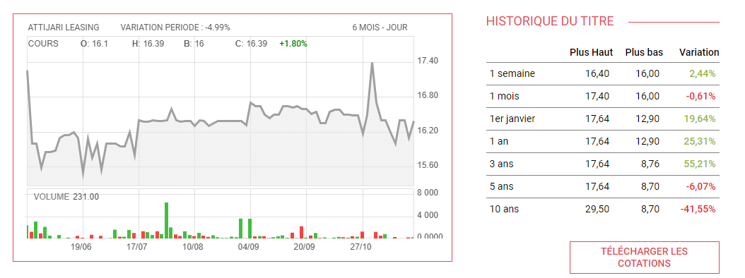
* [The stock has seen a positive evolution especially in the last 3 years and it is still in an increasing trend where it has **risen by 2.44%** this week in comparison to the last.](https://www.ilboursa.com/marches/cotation_TJL)

1. ***Financial Statements Analysis***

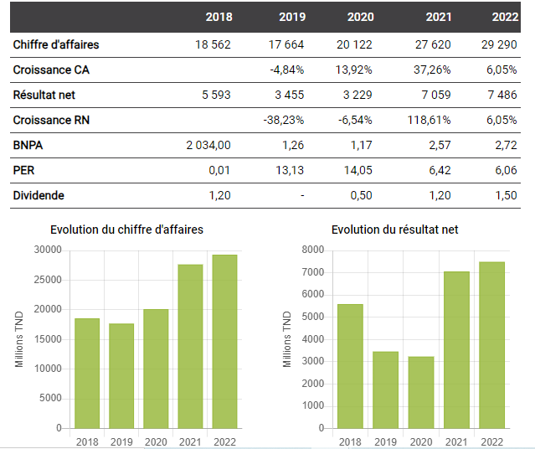

* Title : The Evolution of Attijari Leasing Revenues and Net Profits
* [Attijari Leasing reported **sales of 29.99 million TND**, compared with TND 28.53 million a year ago. **Net profit amounted to TND 4.03 million**, versus TND 3.63 million the previous year.](https://www.ilboursa.com/marches/societe/TJL)

[-At 31/03/2023, Attijari Leasing's net income fell slightly by 2.7% compared with the same period of the previous year, coming in at 7,180 mDT versus 7,376 mDT at 03/31/2022.](https://www.cmf.tn/sites/default/files/pdfs/emetteurs/informations/references/doc_reference_attijati_leasing_2023.pdf)

[-Financing approvals at 03/31/2023 amounted to 86,606 mDT versus 79,271 mDT at 03/31/2022, an increase of 9.3%.](https://www.cmf.tn/sites/default/files/pdfs/emetteurs/informations/references/doc_reference_attijati_leasing_2023.pdf)

* **Valuation ratios[1]**

| **EPS** | |  |  |  |  |  |  |
| --- | --- | --- | --- | --- | --- | --- | --- |
| **Interpretation :** Attijari Leasing has realized **an increase of 10.84%** in its shares, exceeding the average increase in the industry by 6.29 basis points. | | | | | |
| ***Company*** | ***Industry*** |
| +10.84 | +4.55 |  |  |  |  |  |  |
|  |  |  |  |  |  |  |  |
| **P/E** | | **Interpretation :** While the willingness of investors to pay for each dinar of earnings of the industry has reached 8.78 in 2022, Attijari Leasing has registered a P/E ratio of only 5.72 . This may indicate that the company’s stocks are undervalued by the investors or that its future earnings are expected to be lower than its competitors. | | | | | |
| ***Company*** | ***Industry*** |
| 5,72 | 8,78 |  |  |  |  |  |  |

* **Liquidity ratios**

| **Current Ratio** | |  |  |  |  |  |  |
| --- | --- | --- | --- | --- | --- | --- | --- |
| **Interpretation :**Attijari Leasing’s current assets cover 1.56 times its current liabilities. This ratio is relatively higher than that of the industry indicating that the company has a high liquidity compared to the competitors. | | | | | |
| ***Company*** | ***Industry*** |
| 1.56 | 0.02 |  |  |  |  |  |  |
| * **Profitability ratios** | | | |  |  |  |  |
| **Gross Margin** | |  |  |  |  |  |  |
| **Interpretation :** The profits retained after paying the cost of sales have skyrocketed in the third trimester of 2023 , **to reach an increase of 99.03% in 2022**.  On the other hand,this margin has increased on average by only 3.53% for the industry, indicating that Attijari Leasing has more effective cost management, pricing power, or a unique competitive advantage. than its competitors. | | | | | |
| ***Company*** | ***Industry*** |
| +99.03 | +3.53 |  |  |  |  |  |  |
|  |  |  |  |  |  |  |  |
| **Operating Margin** | | **Interpretation :** After paying the operating expenses , Attijari Leasing retained a profit that has registered an **increase of 73.97%** **in 2022**. This growth is approximately 1.4 times greater than the average increase in the industry, indicating that the company can generate higher profits from its core business than its rivals. | | | | | |
| ***Company*** | ***Industry*** |
| +73,97 | +48,33 |  |  |  |  |  |  |

* **Capital structure ratio**

| **Debt to Equity** | |  |  |  |  |  |  |
| --- | --- | --- | --- | --- | --- | --- | --- |
| **Interpretation :** Attijari Leasing has increased its debt to finance its assets relative to the value of shareholders' equity by **12.22%** , meanwhile the competitors have only increased it by 5.68%. This difference may raise the default risk of the company relative to the competitors. | | | | | |
| ***Company*** | ***Industry*** |
| +12,22 | +5,68 |  |  |  |  |  |  |

1. ***Conclusion***

Given the available information , Attijari Leasing represents a positive

investment prospect .

## 2. Tunisie Profilés Aluminium (TPR)

1. ***Description***

Founded in 1977, TPR is currently Tunisia's sole producer of aluminum profiles. Profiles are mainly used in the building industry (glass facades, interior fittings, sliding doors, windows, etc.).

1. ***Stock Performance***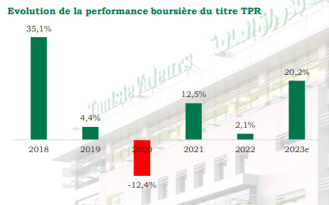

* Title: Evolution of the TPR Stock Performance
* [On the stock market, TPR shares continue to gain momentum. Hailing achievements, the extruder's share price has **risen by 20.2%** since the beginning of the year.](https://www.tunisievaleurs.com/documents/Etude_TPR_07062023.pdf)
* Title: Evolution of the TPR Stock Performance over the past 10 year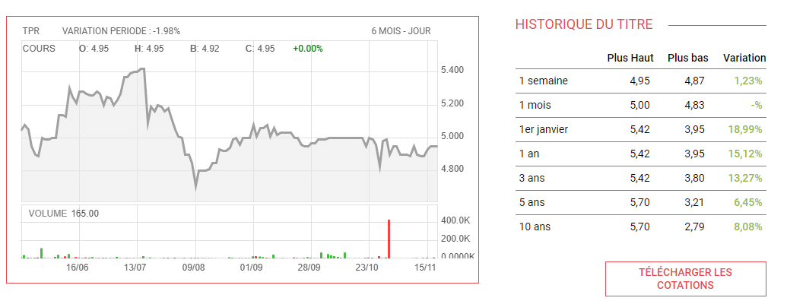
* [TPR stock have been **constantly growing** since 10 years ago](https://www.ilboursa.com/marches/cotation_TPR)

1. ***Swot Analysis***

| **Strengths** | **Weaknesses** |
| --- | --- |
| * TPR is the local market leader for aluminum profiles * with a market share of 65%. * The extruder's position as market leader means that its revenues are appreciably resilient, despite a generally unfavorable environment. High-value-added European markets protect TPR's export margins, as sales prices are indexed to the LME. * A solid balance sheet (low gearing of 7% by 2021) and steady cash flow generation | * The appreciation of the Dinar is likely to slow down the company's export sales, resulting in a less favorable currency effect. * The rise in the international price of aluminum is affecting the aluminum profiler's margins on the local market |
| ***Opportunities*** | ***Threats*** |
| * Algerian subsidiary PROFAL MAGHREB represents a growth lever for the Group * 12 million investment in surface treatment equipment will enable the aluminum profiler to reduce energy costs and serve new markets, notably the automotive sector. * The three newly-created subsidiaries (TPR Glass, TPR Color, TPR Anodal) (due to come on stream in 2022) will serve to improve the Group's vertical integration rate and cushion rising input costs. | * Unfair foreign competition, marketing a counterfeit product under the name of TPR * Tunisia's real estate crisis and budgetary difficulties weigh on the extruder's growth prospects in the local market. |

1. ***Financial Statement Analysis***

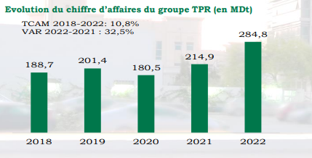

* Title : Evolution of TPR Revenues
* [Despite a difficult operating environment, the TPR Group has announced **record sales of 284.8 MDt** **for 2022, up 32.5% on 2021**, reflecting both the surge in export sales (+31% to 156.0 MDt) and the increase in sales on the local market (+34% to 128.8 MDt). In 2023, we expect more moderate **sales growth of 10% to 313.3 Mdt**.](https://www.tunisievaleurs.com/documents/Etude_TPR_07062023.pdf)

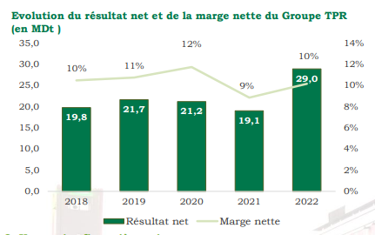

* Title: Evolution of Net Income and Net Margin from 2018 to 2022
* The net income has seen an important growth between 2021 and 2023 , where it achieved **29% annual increase**. 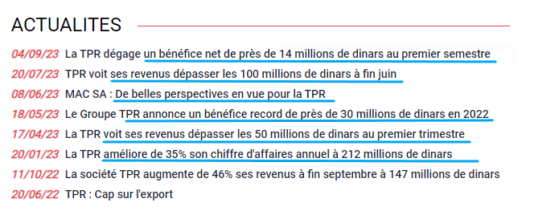
* [TPR has constantly produced high revenues and profits over the course of 2023 .](https://www.ilboursa.com/marches/cotation_TPR)
* **Valuation ratios**

| **EPS** | |  |  |  |  |  |  |
| --- | --- | --- | --- | --- | --- | --- | --- |
| **Interpretation :** TPR has registered a **stagnation in its shareholders’ profits,** meanwhile the industry has noted an increase of 3.32%. This might indicate a poor performance of TPR’s stocks in the period. | | | | | |
| ***Company*** | ***Industry*** |
| +0 | +3.32 |  |  |  |  |  |  |

| **P/E** | |  |  |  |  |  |  |
| --- | --- | --- | --- | --- | --- | --- | --- |
| **Interpretation :** Investors are willing to pay 8.58 times TPR's earnings for each share of its stock in 2022. On the other hand, the average valuation of stocks in the industry reached 3.51, implying that TPR’s stocks are trading at a premium compared to the competitors | | | | | |
| ***Company*** | ***Industry*** |
| 8.58 | 3.51 |  |  |  |  |  |  |

* **Liquidity ratio**

| **Current Ratio** | | **Interpretation :**The current liabilities of TPR are 2.06 times covered by the current assets. This level is higher than the industry indicating a higher liquidity in favor of the firm. | | | | | |
| --- | --- | --- | --- | --- | --- | --- | --- |
| ***Company*** | ***Industry*** |  | | | | | |
| 2.06 | 0.45 |  |  |  |  |  |  |

* **Profitability ratios**

| **Gross Margin** | |  |  |  |  |  |  |
| --- | --- | --- | --- | --- | --- | --- | --- |
| **Interpretation :** The portion of revenues retained after covering the cost of sales has **increased by 30.38% in 2022** which can suggest that TPR is becoming more efficient in managing its costs. However , this rate is lower by 3.51 basis points than industry implying that TPR hasn’t yet reached the level of competitors' efficiency. | | | | | |
| ***Company*** | ***Industry*** |
| +30.38 | +33.89 |  |  |  |  |  |  |
|  |  |  |  |  |  |  |  |
| **Operating Margin** | |  |  |  |  |  |  |
| **Interpretation :**TPR has increased its portion of revenues after the payment of operating costs by 14.81% in 2022 exceeding the average industry growth by 4.86 basis points which may indicate that TPR has not only enhanced its operational efficiency , but also has exceeded the average competitors efficiency . | | | | | |
| ***Company*** | ***Industry*** |
| +14.81 | +9.95 |  |  |  |  |  |  |

* **Capital structure ratio**

| **Debt to Equity** | |  |  |  |  |  |  |
| --- | --- | --- | --- | --- | --- | --- | --- |
| **Interpretation :** TPR did not change its capital structure since it has remained constant. Nevertheless , the competitors have increased their debt financing by 87.2%. This significant difference can imply that TPR has a conservative financing approach as it didn't take any additional debt and it relies more on equity financing or internally generated funds . | | | | | |
| ***Company*** | ***Industry*** |
| +0 | +87.2 |  |  |  |  |  |  |

1. ***Conclusion***

As the company has shown great strength in terms of its financial state and stock performance , we can conclude that TPR represents a profitable and non risky investment opportunity

## 3. SAH Lilas

1. ***Description***

The SAH Group plays a leading role in the Tunisian economy. Specializing in the manufacture of hygienic articles, it was founded in 1994 by Mrs Jalila MEZNI and Mr Mounir EL JAYEZ. Thanks to their expertise and astute management, they have succeeded in building an indisputable reputation and gaining the trust of their commercial and financial partners.

1. ***Macroeconomic Factors***

-SAH Lilas is characterized by **high diversification either in terms of products or geography** which allowed it to confront global circumstances , such as Covid-19 , successfully (increase by 27.2%and 11.5% in revenues in 2019 and 2020 respectively).

-SAL Lilas is investing in Africa (in more than 20 countries) which is currently identified with booming markets thanks to high economic growth.

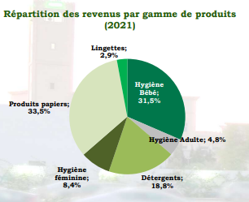

1. ***SWOT Analysis***

| **Strengths** | **Weaknesses** |
| --- | --- |
| * A brand that is well positioned in its various markets and widely recognized * A presence in some twenty African countries and confirmed leadership in Tunisia, Libya, Mauritania and Congo, giving SAH Lilas brand power * A diversified product range and complementary products to ensure a presence in consumers' baskets * Diversification of production sites: Tunisia, Algeria, Libya, Ivory Coast and Senegal * A Research & Development department to position to position itself in high value-added markets and keep abreast of technology watch * An efficient, powerful distribution network (the lifeblood of the consumer products) * Diversification, internationalization and upstream integration strategies upstream integration to create added value and achieve the critical mass critical mass, enabling the Group to compete with the African behemoths * Institutionalized shareholding, with foreign investors in the investors in the Group's shareholding and a governance structure that is modernized | * Low staff management levels * Some subsidiaries have not yet reached break-even point (SAH Côte D'ivoire, Azur Détergent, SAH Maroc, SAH Algérie). |
| ***Opportunities*** | ***Threats*** |
| * Penetration of the Sub-Saharan West and East African markets, with their estimated growth potential, thanks to the recent creation of industrial units in Côte d'Ivoire and Senegal, and the start-up of exports to Kenya and Uganda in October 2020. * Increased capacity (extension of the Ouate deCellulose and SAH Tunisia plants) and launch of the detergent business, with significant logistical and commercial synergies. * Untapped growth potential in Tunisia, the Maghreb countries and sub-Saharan Africa (highly fragmented markets with high birth rates, increasing urbanization and Westernized lifestyles). * The start of the Group's debt reduction process, thanks to the recapitalization carried out in 2019 (a raising of50MDt), to the "Detergents" business reaching its cruising speed, and to the turnaround in cash flow-flows The forthcoming penetration of the cosmetics segment, which should benefit from operational and commercial synergies with the Group's other entities. | * Higher prices for imported raw materials and significant fluctuations on the trade market. * Strong foreign competition and logistical disruptions typical of the post-covid period. |

1. ***Stock Performance***

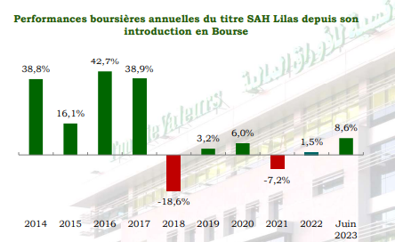

* Title: Annual stock market performance of SAH Lilas shares since IPO
* Over the 2018-2022 period, SAH Lilas shares had a difficult stock market performance due to delays in investment projects. However, the stock is now showing great signs of growth that achieved the level of 8.6% until June 2023.

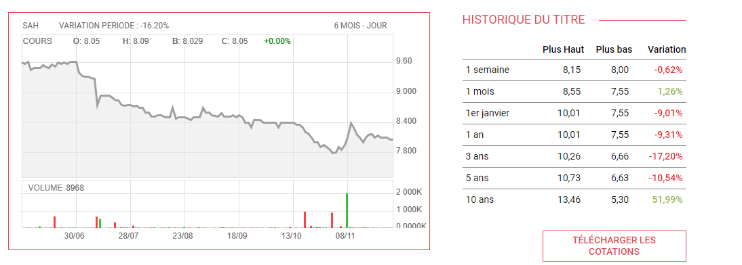

* Title: Evolution of the Lilas Stock Performance over the past 10 year
* SAH Lilas stocks have been **underperforming** in the majority of the last 10 year period, with an exception in 2014 and a month ago.
* **Further Information**

-**Launch of a new category of cosmetic products:** In terms of commercial development, the SAH Group is making great strides in the finalization of its cosmetic products project located in El Zriba. Indeed, the launch of production is planned for the last quarter of the current year with a marketing of more than 200 products on the local market.

* This news can have a positive impact on the stock’s growth

-**A target of choice for institutional investors:** Thanks to the size of its market capitalization and its free float, SAH Lilas is among the most liquid securities on the market. In addition to its high liquidity, its institutionalized shareholding makes the Group a prime target for institutional investors, particularly foreign investors.

-**A strong international value:** After winning the challenge of its transformation into a highly integrated national champion of hygiene and paper products and detergents, the Group displays strong international ambitions.

1. ***Financial Statement***

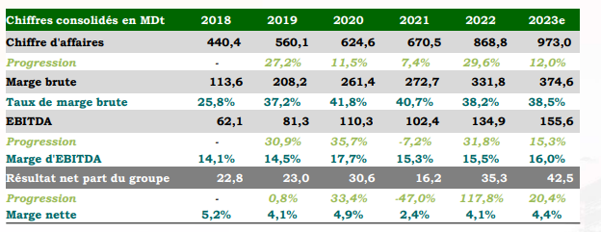

* Title : Consolidated financial statements of SAH Lilas
* SAH Lilas saw its sales soar by **29.6% to 868.8MDt**, thus outperforming the business plan unveiled in July 2022.
* In 2022, the Group reached a new level of operating profitability since the consolidated **EBITDA rose by 31.8% to 134.9MDt** (against a budgeted level of 125.2MDt), while **operating income increased by 59.9% to 81.6MDt.**
* SAH Lilas is the listed only company in the market which makes it represent the whole industry. For this reason , the analysis is made in comparison to historical data.
* **Valuation ratios**

| **EPS** | |  |  |  |  |  |  |
| --- | --- | --- | --- | --- | --- | --- | --- |
| **Interpretation :** In 2023 , Sah Lilas registered a decrease of 6.85% in its profitability on a per-share basis despite the skyrocketing increase registered in 2018. This may imply that the company may be affected by sectors or economic conditions . This decrease can raise concerns about the firm’s ability to generate consistent earnings and maintain financial stability. | | | | | |
| ***2023*** | ***2018*** |
| -6.85 | +111.33 |  |  |  |  |  |  |

| **P/E** | |  |  |  |  |  |  |
| --- | --- | --- | --- | --- | --- | --- | --- |
| **Interpretation :** The price per earning ratio has slightly decreased by 0.42% between 2023 and 2022 which indicates that Investors may be adjusting their expectations or perceptions about the company, potentially due to changes in economic conditions, industry dynamics, or company-specific factors. | | | | | |
| ***2023*** | ***2022*** |
| 19.23 | 19.65 |  |  |  |  |  |  |

* **Liquidity ratio**

| **Current ratio** | |  |  |  |  |  |  |
| --- | --- | --- | --- | --- | --- | --- | --- |
| **Interpretation :** In the second semester of 2023, the company’s current assets cover 1.09 times of its current liabilities. This ratio has increased in comparison to 2022 which implies that the liquidity position of Lilas improved during this period. | | | | | |
| ***2023*** | ***2022*** |
| 1.09 | 0.95 |  |  |  |  |  |  |

* **Profitability ratios**

| **Gross Margin** | |  |  |  |  |  |  |
| --- | --- | --- | --- | --- | --- | --- | --- |
| **Interpretation :**  The revenues retained after paying COGS has increased at a lower speed in 2023 compared to 2018 implying that the company has maintained its cost efficiency level during the 5 year period. | | | | | |
| ***2023*** | ***2018*** |
| +35.31 | +37.42 |  |  |  |  |  |  |
|  |  |  |  |  |  |  |  |
|  |  |  |  |  |  |  |  |
| **Operating Margin** | |  |  |  |  |  |  |
| **Interpretation :** Sah Lilas has maintained its operating profitability as its operating margin has increased at approximately the same rate between 2023 and 2018. | | | | | |
| ***2023*** | ***2018*** |
| +9.31 | +9.67 |  |  |  |  |  |  |

* **Capital structure ratios**

| **Debt to Equity** | |  |  |  |  |  |  |
| --- | --- | --- | --- | --- | --- | --- | --- |
| **Interpretation :** SAH Lilas has registered a high level of increases consecutively in 2023 and 2022. This may indicate that the company is increasing its reliability of debt financing, which may either raise concerns about the firm’s ability to generate funds that enables it to finance operations, investments, or expansion plans, or imply that this decision is driven by strategic implications. | | | | | |
| ***2023*** | ***2022*** |
| +184.51 | +229.07 |  |  |  |  |  |  |

1. ***Conclusion***

Through a deep investigation , we realized that SAH Lilas is preparing for a new project (introduction of new product lines) that requires a lot of funds and investment which explains the negative financial indicators for the company.

In addition , the postponement of this introduction, which will not be achieved until 2024, has decreased its stocks’ performance as it didn’t align with investors expectations.

Given all this information , we can conclude that SAH Lilas does not represent a profitable investing opportunity in the long term.

## 4. BH Bank

1. ***Description***

BH Bank is a state-controlled bank in Tunisia that has more than 20000 collaborators. Today, the BH Bank Group is an integrated group comprising the bank and specialized subsidiaries

1. ***Stock Performance***

* Title: Stock Performance of BH Bank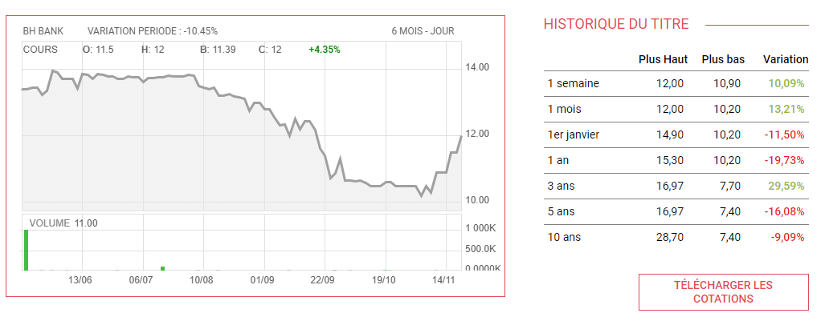
* [Despite the bad performance of the stock at the beginning of 2023 , it is now recovering to reach an **increase of 10.09%** during last week.](https://www.ilboursa.com/marches/cotation_BH)

1. ***SWOT Analysis***

| **Strengths** | **Weaknesses** |
| --- | --- |
| * Support from the Tunisian government. * A good governance structure with a well-matched board of directors. * Universal bank within the framework of an integrated group operating mainly in the following sectors: banking, insurance, leasing, venture capital, financial intermediation and real estate development. * Maintain public shareholding through proactive management similar to private banking. * Diversification of loan portfolio by business sector. * An adapted, varied and innovative range of products and services. * Strong capacity to mobilize savings. * Ongoing overhaul of the company's information system, including the implementation of an ERP banking system. * Expertise in real estate processing. * The digitalization of services and processes and its impact on the customer experience, the diversification of products/services, and the expansion of the customer portfolio. * Targeted recruitment of new profiles and skills to meet the needs of the bank's transformation, and the upgrading of HR skills. * **The bank's Corporate Social Responsibility (CSR) strategy as a socially responsible bank that creates economic, social and environmental value.** | * The country's economic and political situation; * Scarcity of resources and rising costs; * High cost of risk, exacerbated by the COVID 19 health crisis; * Information system currently being overhauled; * Liquidity ratio and loan/deposit ratio not in line with regulatory thresholds. |
| ***Opportunities*** | ***Threats*** |
| * Ability to grow in the retail and SME markets. * Growing demand for banking services * Unmet financing needs of SMEs * Synergy between the various companies making up the BH Bank Group, particularly in terms of complementarity by business line and line of business. * Sector reform | * Difficult economic, health and political climate not conducive to investment by individuals and businesses; * Fierce competition between banks, eroding margins; * Reinforcement of the regulatory arsenal by the BCT and implementation of new regulatory requirements (operational risk, market risk, deposit guarantee fund, IFRS, etc.); * Difficulties in marketing the real estate sector; * Fiscal pressure on banks in relation to the economic situation. |

1. ***Financial Statements Analysis***

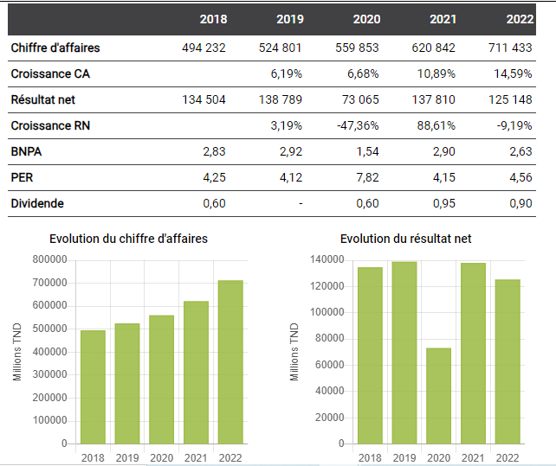

* Title : The Evolution of BH Bank Revenues and Net Profits
* [Despite an **increase of 14.59% in revenues in 2022** , BH Bank has encountered a **decrease in net profits by 9.19%** .](https://www.ilboursa.com/marches/societe/BH)

[-During the first half of 2023, BH Bank recorded a **net banking income (NBI) of 312,818 thousand Tunisian dinars,** demonstrating significant growth compared to the same period of the previous year, where it was 288,565 TND.](https://www.ilboursa.com/marches/la-bh-bank-renforce-son-pnb-de-8-sur-le-premier-semestre_42371?fbclid=IwAR2lNMHvcMU4y43IxBPWDgftOkRudIg7M9UWj6hqK5Us8uikf_MUPtyprGg)

[-**The bank's interest and similar income in the first half of 2023 amounted to 509,527 TND, up compared to 409,268 TND for the same period of the previous year.** This increase demonstrates BH Bank’s ability to generate consistent income from its credit and investment activities.](https://www.ilboursa.com/marches/la-bh-bank-renforce-son-pnb-de-8-sur-le-premier-semestre_42371?fbclid=IwAR2lNMHvcMU4y43IxBPWDgftOkRudIg7M9UWj6hqK5Us8uikf_MUPtyprGg)

[-**The bank's commissions also experienced a notable increase, going from 62,029 thousand dinars as of June 30, 2022, to 70,314 thousand dinars as of June 30, 2023.** This figure reflects the diversification of the bank's sources of income and its ability to offer value-added services to its customers.](https://www.ilboursa.com/marches/la-bh-bank-renforce-son-pnb-de-8-sur-le-premier-semestre_42371?fbclid=IwAR2lNMHvcMU4y43IxBPWDgftOkRudIg7M9UWj6hqK5Us8uikf_MUPtyprGg)

[-**BH Bank's investment portfolio income reached 56,086 thousand dinars as of June 30, 2023, compared to 52,750 thousand dinars as of June 30, 2022**, indicating continued growth in its investment activities.](https://www.ilboursa.com/marches/la-bh-bank-renforce-son-pnb-de-8-sur-le-premier-semestre_42371?fbclid=IwAR2lNMHvcMU4y43IxBPWDgftOkRudIg7M9UWj6hqK5Us8uikf_MUPtyprGg)

[-Combining these elements, **the total banking income for the first half of 2023 amounts to TND 679,512, a clear increase compared to TND 552,485 for the same period of the previous year**.](https://www.ilboursa.com/marches/la-bh-bank-renforce-son-pnb-de-8-sur-le-premier-semestre_42371?fbclid=IwAR2lNMHvcMU4y43IxBPWDgftOkRudIg7M9UWj6hqK5Us8uikf_MUPtyprGg)

-The net banking income of BH BANK during the first half of 2023 is up sharply, to 312,818 TND, which testifies to the solidity of its financial activities compared to the 288,565 TND for the same period in 2022.

* **Valuation ratios**

| **EPS** | |  |  |  |  |  |  |
| --- | --- | --- | --- | --- | --- | --- | --- |
| **Interpretation :**BH Bank has registered a **stagnation in its shareholders’ profits,** meanwhile the industry has noted an increase of 4.45%. This might indicate a poor performance of BH Bank’s stocks in the period. | | | | | |
| ***Company*** | ***Industry*** |
| +0 | +4.45 |  |  |  |  |  |  |

| **P/E** | |  |  |  |  |  |  |
| --- | --- | --- | --- | --- | --- | --- | --- |
| **Interpretation:** The bank’s price per earnings is approximately half of the industry in 2022 , indicating that This may indicate that the company’s stocks are undervalued by the investors or that its future earnings are expected to be lower than its competitors. | | | | | |
| ***Company*** | ***Industry*** |
| 4.53 | 8.78 |  |  |  |  |  |  |

* **Liquidity ratio**

| **Current Ratio** | |  |  |  |  |  |  |
| --- | --- | --- | --- | --- | --- | --- | --- |
| **Interpretation :** The current liabilities of BH Bank are 0.13 times covered by the current assets. This level is higher than the industry indicating a higher liquidity in favor of the bank. | | | | | |
| ***Company*** | ***Industry*** |
| 0.13 | 0.02 |  |  |  |  |  |  |

* **Profitability ratios**

|  | |  |  |  |  |  |  |
| --- | --- | --- | --- | --- | --- | --- | --- |
| **Operating Margin** | |  |  |  |  |  |  |
| **Interpretation :**The portion of revenues retained after covering the operating costs has **increased by 45.75% in 2022** which can suggest that BH Bank is becoming more efficient in managing its costs. However , this rate is lower by 2.58 basis points than industry, implying that BH Bank hasn’t yet reached the level of competitors' efficiency. | | | | | |
| ***Company*** | ***Industry*** |
| +45.75 | +48.33 |  |  |  |  |  |  |

* **Capital structure ratios**

| **Debt to Equity** | |  |  |  |  |  |  |
| --- | --- | --- | --- | --- | --- | --- | --- |
| **Interpretation :**BH Bank did not change its capital structure since it has remained constant. Nevertheless , the competitors have increased their debt financing by 20.73%. This significant difference can imply that BH Bank has a conservative financing approach as it didn't take any additional debt and it relies more on equity financing or internally generated funds . | | | | | |
| ***Company*** | ***Industry*** |
| +0 | 20.73 |  |  |  |  |  |  |

1. ***Conclusion***

BH Bank represents a favorable company to invest in .

## 

**5. Poulina Group Holding**

1. ***Description***

Poulina Group Holding is a Tunisian group created in 1967. Originally specialized in poultry farming, the group gradually diversified to become the first private capital group in Tunisia. The group operates 8 distinct businesses: poultry integration, consumer products, steel processing, packaging, real estate, wood and capital goods, construction materials and trade and Services.

1. ***Stock Performance***

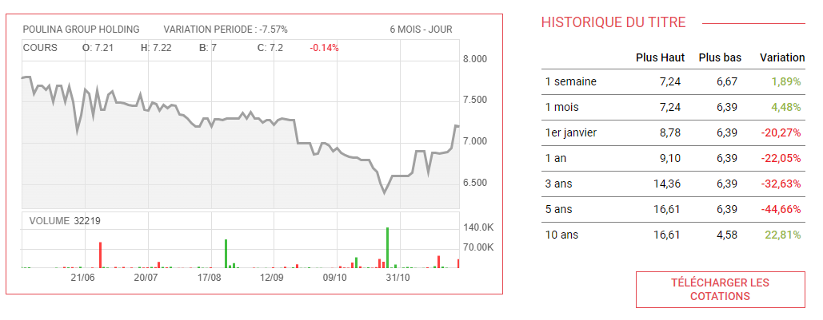

* Title: Stock Performance of Poulina Holding
* [Despite the bad performance of the company’s stock , it has gradually seen an enhancement starting from October 2023 where **it increased by 4.48%.**](https://www.ilboursa.com/marches/cotation_PGH)

1. ***SWOT Analysis***

| **Strengths** | **Weaknesses** |
| --- | --- |
| * Pioneer in the poultry market with 40 years of experience in the field. * Market leader with a share of 50%. * Belonging to a solid financial group in Tunisia and North Africa. * Existence of a production infrastructure. * Significant economies of scale. * Brand awareness. * Product quality. * Large distribution network. | * A restricted commercial margin. * No regular new products and innovations in product ranges. * Minimal control of deductibles. * Uncontrolled and uncontrolled digital marketing. |
| ***Opportunities*** | ***Threats*** |
| * Growing demand for poultry products. * Poultry products represent a less expensive alternative. * High barriers to entry. | * Increasingly demanding hygiene norms and standards. * New entrants to the market. * customers consider Salami as waste. |

1. ***Financial Statement***

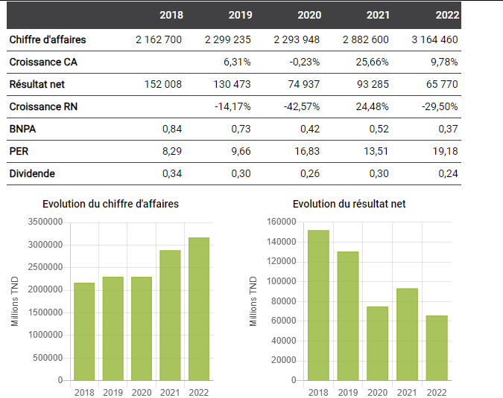

* Title : The Evolution of Poulina Holding Revenues and Net Profits
* [Despite the **9.78% increase in the revenues** , Poulina Holding couldn’t keep that trend for the **net profits as they decreased by 29.5% in** 2022.](https://www.ilboursa.com/marches/societe/PGH)

- Poulina Group has posted **a profit of 48 million dinars** in the first half of 2023.

* **Valuation ratios**

| **EPS** | |  |  |  |  |  |  |
| --- | --- | --- | --- | --- | --- | --- | --- |
| **Interpretation :** Poulina has registered a **stagnation in its shareholders’ profits,** meanwhile the industry has noted an increase of 11.82%. This might indicate a poor performance of Poulina’s stocks in the period. | | | | | |
| ***Company*** | ***Industry*** |
| +0 | 11.82 |  |  |  |  |  |  |

| **P/E** | |  |  |  |  |  |  |
| --- | --- | --- | --- | --- | --- | --- | --- |
| **Interpretation :** Investors are willing to pay 18.22 times Poulina's earnings for each share of its stock. On the other hand, the average valuation of stocks in the industry reached 13.63, implying that Poulina’s stocks are trading at a premium compared to the competitors.  The stock is overvalued by investors. | | | | | |
| ***Company*** | ***Industry*** |
| 18.22 | 13.63 |  |  |  |  |  |  |

* **Liquidity ratio**

| **Current Ratio** | |  |  |  |  |  |  |
| --- | --- | --- | --- | --- | --- | --- | --- |
| **Interpretation :**The current ratio of Poulina is approximately similar to the industry, which suggests that the firm’s short-term liquidity position is in line with the average for its competitors. | | | | | |
| ***Company*** | ***Industry*** |
| 1.45 | 1.55 |  |  |  |  |  |  |

* **Profitability ratios**

| **Gross Margin** | |  |  |  |  |  |  |
| --- | --- | --- | --- | --- | --- | --- | --- |
| **Interpretation :** The portion of revenues retained after covering the cost of sales has **increased by 32.4%** which can suggest that Poulina is becoming more efficient in managing its costs. This rate is higher by 2.78 basis points than industry implying that Poulina has reached the level of competitors' efficiency. | | | | | |
| ***Company*** | ***Industry*** |
| +32.4 | 29.62 |  |  |  |  |  |  |
|  |  |  |  |  |  |  |  |
|  |  |  |  |  |  |  |  |
| **Operating Margin** | |  |  |  |  |  |  |
| **Interpretation :** Poulina has increased its portion of revenues after the payment of operating costs by 9.44% in 2023 exceeding the average industry growth by 0.8 basis points which may indicate that Poulina has not only enhanced its operational efficiency , but also has exceeded the average competitors efficiency . | | | | | |
| ***Company*** | ***Industry*** |
| +9.44 | 8.65 |  |  |  |  |  |  |

**Capital structure ratio**

| **Debt to Equity** | |  |  |  |  |  |  |
| --- | --- | --- | --- | --- | --- | --- | --- |
| **Interpretation :**  Poulina has increased its debt to finance its assets relative to the value of shareholders' equity by **248.71%** , meanwhile the competitors have only increased it by 164.63%. This difference may raise the default risk of the company relative to the competitors. | | | | | |
| ***Company*** | ***Industry*** |
| +248.71 | 164.63 |  |  |  |  |  |  |

1. ***Conclusion***

Given the available financial information , as well as the recent recovery of the Poulina Holding stock , we can conclude that we have to be reserved toward this company and keep an eye on the future changes .

## 6. UNIMED

1. ***Description***

Unimed is a pharmaceutical company created in the 90s. Unimed is mainly positioned on generic products (70% of its turnover)

1. ***Macroeconomic***

During the Covid-19 , medical and pharmaceutical industries have achieved skyrocketing growth levels . However , UNIMED couldn't profit or at least resist such a crisis as it realized **a loss of 15.07% and 60.55% in revenues and net profits respectively in 2020. This loss has resisted revenues in the next year.**

1. ***SWOT Analysis***

| **Strengths** | **Weaknesses** |
| --- | --- |
| * A benchmark player in the 'injectables and eye drops' segment, with a market share approaching 30%. * A "generic" business model (70% of products manufactured) reducing dependence on foreign partners * High barriers to entry: highly regulated sector, sensitive health environment and capital-intensive industry * A laboratory with a number of international certifications and approvals, applying technologies that comply with European standards: an undeniable asset for conquering export markets. * export markets * A dynamic R&D activity, enabling the development of new products and the ongoing expansion of our portfolio of marketing authorizations. * Modern equipment, mastery of the production process and a strong reputation on local and international markets * High-value-added products with profitability levels that compare favorably with industry standards at both national and international level: an EBITDA margin in excess of 30%, on average over the last four years, among the highest on the market. * A sound financial structure (gearing of 22.4% in 2021) with a comfortable cash cushion, enabling the company to self-finance a large proportion of capital expenditure | * Administered prices on the local market, leaving little room for maneuver in terms of price evolution, and a lengthy registration process in foreign countries. |
| ***Opportunities*** | ***Threats*** |
| * This is a major growth potential for the pharmaceuticals sector, particularly in export markets, which the company is preparing to support through investments in capacity and automation. This 60 million-tonne investment project, which was completed in 2022, should enable Unimed to expand its production range and increase its capacity for high value-added products. * The company has opted for an internationalization strategy, and preliminary steps have been taken with investment funds, including EastLane Partners, to set up an international platform to generate synergies and strengthen Unimed's exports through a distribution network or industrial presence. * Diversification of export markets: contracts have been signed with new customers and in new markets in the MENA region (Iraq, Sudan, Jordan, the United Arab Emirates and Qatar) and in Africa (Mali). * With the withdrawal of the company's current Managing Director and reference shareholder, Mr. Ridha CHARFEDDINE, from political and associative life, and the removal of any potential conflict of interest, sales with PCT should resume from 2022, according to the management. | * Exposure to foreign exchange risk penalizes the company's procurement costs. However, this situation remains generally under control, thanks to the maintenance of export sales prices in foreign currencies. * A competitive business, particularly on the export market |

1. ***Stock Performance***

* Title : Stock Performance of UNIMED since 5 years ago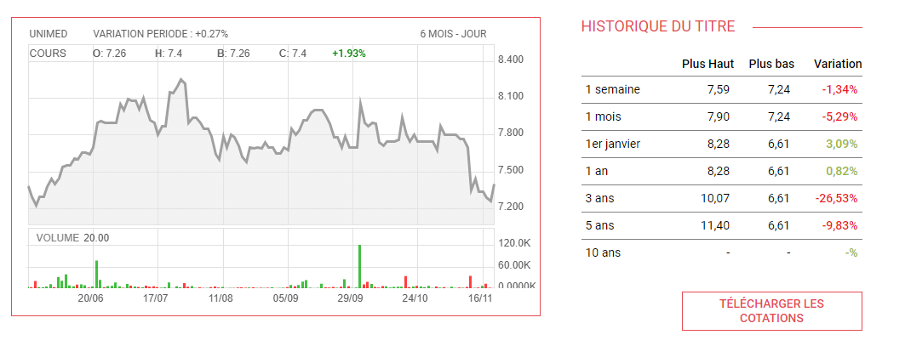
* [Even though UNIMED stocks have strongly started the year of 2023 with an increase of 3.09% , this trend did not continue where **it has decreased by 5.29% and 1.34% in October and a week ago respectively.**](https://www.ilboursa.com/marches/cotation_UMED)

1. ***Financial Statements Analysis***

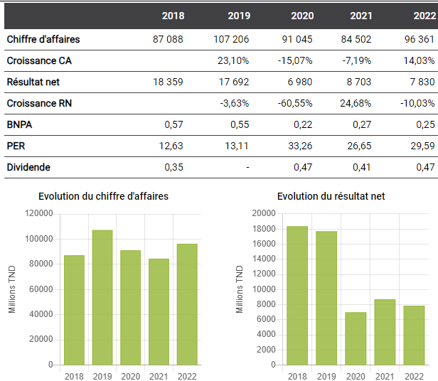

* Title : The Evolution of UNIMED Revenues and Net Profits
* [During 2022, UNIMED has seen a great **growth of 14.03% in revenues**. However , the **net profits decreased by 10.03%** in the same year.](https://www.ilboursa.com/marches/societe/UMED)

[Since the first semester of 2023 , the revenues of UNIMED **have increased by 37%**. This rise is the result of the growth in their pharmacy turnover(18%) and of the exportation(4%). The level of **investments has also increased to achieve 4.9MDT.** The long-term has followed the same trend where it **increased from 25.3MDT to 29.3MDT.**](https://www.ilboursa.com/marches/unimed-ameliore-de-37-ses-revenus-trimestriels-a-pres-de-30-millions-de-dinars_40321)

* **Valuation ratios**

| **EPS** | |  |  |  |  |  |  |
| --- | --- | --- | --- | --- | --- | --- | --- |
| **Interpretation :** UNIMED has registered a skyrocketing increase in shareholders’ earnings that achieved 380.86%. Despite this important increase , the industry has realized a higher growth rate of 392.94% . This difference may suggest that the company has a lower positioning in the market compared to its rivals. | | | | | |
| ***Company*** | ***Industry*** |
| +380.86 | +392.94 |  |  |  |  |  |  |

| **P/E** | |  |  |  |  |  |  |
| --- | --- | --- | --- | --- | --- | --- | --- |
| **Interpretation :** Investors are willing to pay 18.03 times UNIMED's earnings for each share of its stock in 2022. On the other hand, the average valuation of stocks in the industry reached 17.3, implying that UNIMED’s stocks are trading at a premium compared to the competitors | | | | | |
| ***Company*** | ***Industry*** |
| 18.03 | 17.3 |  |  |  |  |  |  |

* **Liquidity ratios**

| **Current Ratio** | |  |  |  |  |  |  |
| --- | --- | --- | --- | --- | --- | --- | --- |
| **Interpretation :**The current liabilities of UNIMED are 1.81 times covered by the current assets. This level is higher than the industry indicating a higher liquidity in favor of the firm. | | | | | |
| ***Company*** | ***Industry*** |
| 1.17 | 1.11 |  |  |  |  |  |  |

* **Profitability ratios**

| **Gross Margin** | |  |  |  |  |  |  |
| --- | --- | --- | --- | --- | --- | --- | --- |
| **Interpretation :** UNIMED has doubled its earnings that remain after paying the COGS , a rate which is higher by 2.46 basis points than the rate achieved by the average industry . This enhancement can imply that UNIMED is managing its production costs more effectively than its competitors. | | | | | |
| ***Company*** | ***Industry*** |
| +52.22 | +49.76 |  |  |  |  |  |  |

| **Operating Margin** | |  |  |  |  |  |  |
| --- | --- | --- | --- | --- | --- | --- | --- |
| **Interpretation :**UNIMED has increased its portion of revenues after the payment of operating costs by 19.21% in 2022 exceeding the average industry growth by 0.9 basis points which may indicate that UNIMED has approximately the same operational efficiency as its rivals. | | | | | |
| ***Company*** | ***Industry*** |
| +19.21 | +18.31 |  |  |  |  |  |  |

* **Capital structure ratio**

| **Debt to Equity** | |  |  |  |  |  |  |
| --- | --- | --- | --- | --- | --- | --- | --- |
| **Interpretation :** UNIMED has more than doubled its debt to finance its assets relative to the value of . This rate is slightly more than industry which may suggest that the pharmaceutical industry is inclined to using more leverage to finance their activities | | | | | |
| ***Company*** | ***Industry*** |
| +53.15 | 50.65 |  |  |  |  |  |  |

1. ***Conclusion***

Given the available information , UNIMED does not represent a sure investment but it deserves a further investigation

## 7. SOTETEL

1. ***Description***

Société Tunisienne d'Entreprises de Télécommunications engages in the construction, manufacture, and installation of telecommunications equipment. It operates in the following activities: backbone and core network; network access; and wireless network. It provides data center, unified communications, and security solutions. The company was founded in 1981 and is headquartered in Tunis, Tunisia.

Actionnariat: Tunisie Télécom : 35% Autres actionnaires: 65%

1. ***Latest news***

**15/11/23** La SOTETEL concludes a partnership with the Libyan company AWSS Technology & Security

**27/10/23** SOTETEL increases its revenues by 17% to 40 million dinars at the end of September

**18/09/23** SOTETEL launches a recruitment campaign to support its development

**05/09/23** SOTETEL continues its growth momentum in the first semester

**01/08/23** SOTETEL increases its half-yearly revenues by 18% to 27 million dinars

**20/06/23** La SOTETEL renoue avec les bénéfices en 2022

**27/04/23** SOTETEL increases its EBITDA by more than 50% in the first quarter

**02/02/23** SOTETEL increases its revenues by 25% to 50 million dinars in 2022

1. ***Swot Analysis***

| **Strengths** | **Weaknesses** |
| --- | --- |
| * Leader in technological know-how and telecom infrastructures. * Major project references * Flexibility to meet customers * National coverage | * Treasury * Social climate * High cost structure - impact on profitability and competitiveness * Information system |
| ***Opportunities*** | ***Threats*** |
| * International development * IoT & Smartcities projects * Diversification of SC solutions * IT projects and systems integration * Targeting other customers & sectors | * Competition from new entrants * Budget restrictions * Slower growth domestic market growth * Worldwide fiber shortage. * Decline in wireless activity |

1. ***Stock Performance***

Business indicators for Société Tunisienne d'Entreprises de Télécommunications (Sotetel) show sales of 12.8 million dinars in the 3rd quarter of 2023, up 13.8% on the same period in 2022, when sales stood at 11.2 million dinars.

Consequently, cumulative revenues for the first 9 months of the current year stood at 39.6 million dinars versus 33.9 million recorded a year earlier, marking a 16.9% improvement.

Sotetel's performance was particularly evident in its export business, which grew by 144%. Export sales rose from 635 thousand dinars in 2022 to 1.5 million dinars this year.

On a more moderate scale, local sales also increased by 14%.

However, revenue growth was accompanied by a rise in operating expenses, which reached 36.5 million dinars by September 30, 2023, compared with 30.5 million dinars for the same period in 2022.

This increase is due in part to purchases consumed, including subcontracting, amounting to 21.3 million dinars, as well as personnel expenses of 12 million dinars.

At the end of the first nine months, the company generated EBITDA of over 3 million, compared with 3.3 million a year earlier.

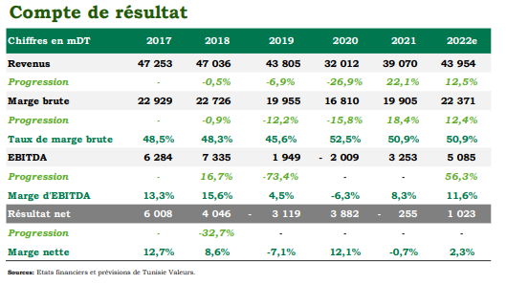

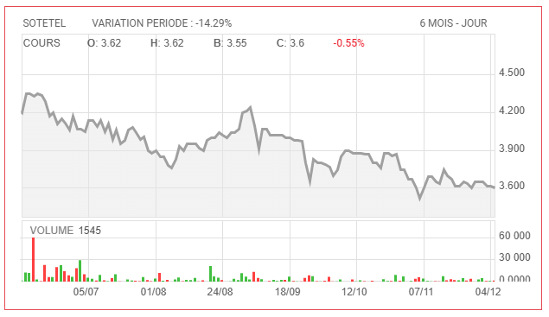

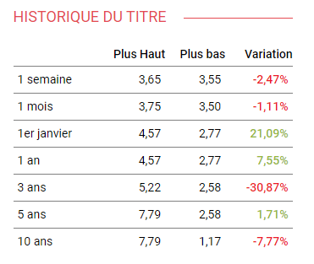

1. ***Financial Statements Analysis***

**Valuation ratios**

| **EPS (ANN)** | |  |  |  |  |  |  |
| --- | --- | --- | --- | --- | --- | --- | --- |
| **Interpretation :** SOTETEL has the same EPS as industry . | | | | | |
| ***Company*** | ***Industry*** |
| 0.26 | 0.26 |  |  |  |  |  |  |

| **P/E (TTM)** | |  |  |  |  |  |  |
| --- | --- | --- | --- | --- | --- | --- | --- |
| **Interpretation :** Investors are willing to pay 15.59 times UNIMED's earnings for each share of its stock in 2022. On the other hand, the average valuation of stocks in the industry reached 15.68, implying that UNIMED’s stocks are trading at a deficit compared to the competitors | | | | | |
| ***Company*** | ***Industry*** |
| 15.59 | 15.68 |  |  |  |  |  |  |

**Liquidity ratios**

| **Current Ratio (MRQ)** | |  |  |  |  |  |  |
| --- | --- | --- | --- | --- | --- | --- | --- |
| **Interpretation :**current assets of SOTETEL are in proportion to its current liabilities in a manner similar to the average ratio observed in the industry. | | | | | |
| ***Company*** | ***Industry*** |
| 1.41 | 1.41 |  |  |  |  |  |  |

**Profitability ratios**

| **Gross Margin (TTM)** | |  |  |  |  |  |  |
| --- | --- | --- | --- | --- | --- | --- | --- |
| **Interpretation :** company's gross profit is equivalent to the industry average when expressed as a percentage of revenue. | | | | | |
| ***Company*** | ***Industry*** |
| 17.4% | 17.4% |  |  |  |  |  |  |

**Capital structure ratio**

| **Debt to Equity** | |  |  |  |  |  |  |
| --- | --- | --- | --- | --- | --- | --- | --- |
| **Interpretation :** SOTETEL's proportion of debt in relation to equity is similar to the average ratio observed in the industry | | | | | |
| ***Company*** | ***Industry*** |
| 23.26% | 23.26% |  |  |  |  |  |  |

1. ***Conclusion***

SOTETEL has similar values to the industry across various financial ratios, it suggests that the company's financial performance is in line with the average performance of companies in the same sector. This indicates that SOTETEL's operational and financial management practices are comparable to those of its peers.

## 8. One Tech Holding

1. ***description***

One Tech Holding SA engages in the manufacture, development and sales of communication and electronic equipment. It operates through the following business areas: Cable, Mecatronic and Telecom. The Cable business area includes the manufacture of cables for the energy, telecommunication and automobile industry. The Mecatronic business area focuses on the manufacture and assembly of circuits. The Telecom business area covers the provision of telecommunication products and solutions. The company was founded by Moncef Sellami in 1978 and is headquartered in Tunis, Tunisia.

1. ***Latest news***

**20/10/23** OneTech Group revenues to end September approach 850 million dinars

**06/10/23** OneTech Group sells subsidiary Helioflex to European packaging manufacturer Aluflexpack AG

**06/09/23** OneTech Group quadruples half-year profits to 21 million dinars

**05/29/23** MAC SA: OneTech Group confirms return to normal operations

**05/24/23** OneTech Annual General Meeting: Strong earnings growth forecast for 2023

**05/11/23** OneTech proposes a dividend of 0.160 dinar per share

**04/19/23** One Tech Group announces first-quarter revenues of 300 million dinars

**01/19/23** One Tech Group revenues exceed one billion dinars by 2022

1. ***SWOT Analysis***

| **Strengths** | **Weaknesses** |
| --- | --- |
| * A diversified, high-quality customer portfolio: * leading multinationals and distributors * Mastery of industrial and technological processes * A large number of certifications and certifications and approvals * Strong strategic partners, ensuring technology transfer * Geographical proximity to customers * Young, competent and dynamic management and a sustained HR training policy * Solid financial position: strong capitalization and high leverage * Clear strategic vision | * Volatility of certain raw materials such as copper, aluminum... * Insufficient regional diversification * Greater or lesser sensitivity to the automotive sector |
| ***Opportunities*** | ***Threats*** |
| * A buoyant growth rate, particularly for the mechatronics and telecoms sectors * Existence of new markets in which the presence in these markets * Moving up the value-added chain through through external growth | * International competition, particularly from Asia * Business sectors undergoing continuous change requiring a high level of responsiveness |

1. ***Stock Performance***

The One Tech Group achieved strong growth in the first half of 2023 in all its business segments, with consolidated revenues reaching TND 593.526 million. This represents a substantial increase of 14.4% compared to the same period in 2022.

The growth in absolute terms is primarily driven by exports, which increased by 11.6% during the first half of the year. Exports accounted for a significant portion of total revenues, representing 85.8%.

As of June 30, 2023, the One Tech Group demonstrated a noteworthy decrease in total indebtedness, amounting to 159.6 million dinars, representing a 6.7% reduction in both short-term and long-term components compared to the levels recorded on June 30, 2022.

After facing challenges in 2022, including the semiconductor shortage and logistical difficulties, the situation in the Mechatronics Division has returned to normal in the first half of 2023. Margin levels have also normalized, attributed to the stabilization of volatile raw material prices and raw material cost increases aligning with sales prices.

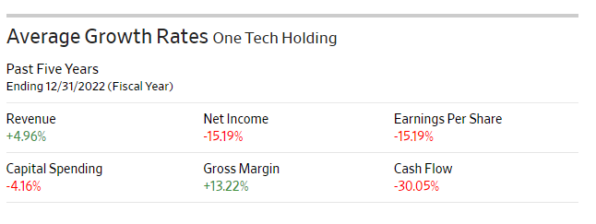

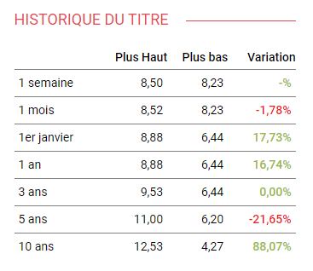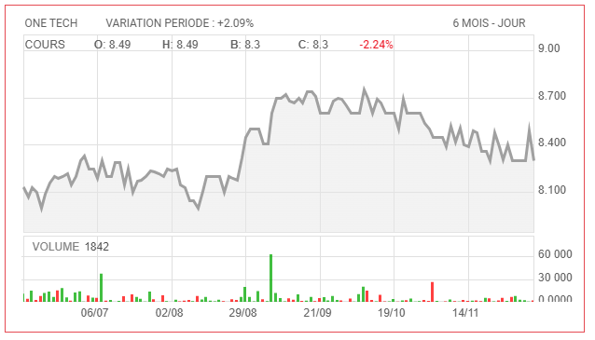

1. ***Financial Statements Analysis***

* **Valuation ratios**

| **EPS (ANN)** | |  |  |  |  |  |  |
| --- | --- | --- | --- | --- | --- | --- | --- |
| **Interpretation :** the company's EPS of 0.17 is higher than the industry average EPS of 0.14. A higher EPS indicates that the company is generating more earnings per share, which can be seen as a positive sign of profitability. | | | | | |
| ***Company*** | ***Industry*** |
| 0.17 | 0.14 |  |  |  |  |  |  |

| **P/E (TTM)** | |  |  |  |  |  |  |
| --- | --- | --- | --- | --- | --- | --- | --- |
| **Interpretation :** the OTH's P/E of 22.84 is higher than the industry average P/E of 15.59. a higher P/E ratio may suggest that investors have higher expectations for future earnings growth for the company compared to the industry average. | | | | | |
| ***Company*** | ***Industry*** |
| 22.84 | 15.59 |  |  |  |  |  |  |

* **Liquidity ratios**

| **Current Ratio (MRQ)** | |  |  |  |  |  |  |
| --- | --- | --- | --- | --- | --- | --- | --- |
| **Interpretation :**company is able to cover its short-term liabilities with its short-term assets higher than industry.  a healthier liquidity position | | | | | |
| ***Company*** | ***Industry*** |
| 1.89 | 1.84 |  |  |  |  |  |  |

* **Profitability ratios**

| **Gross Margin (TTM)** | |  |  |  |  |  |  |
| --- | --- | --- | --- | --- | --- | --- | --- |
| **Interpretation :** lower gross margin than the industry average typically suggests that OTH is retaining a smaller proportion of its revenue after accounting for the cost of goods sold. This could be due to factors such as higher production costs, competitive pricing strategies, or operational inefficiencies | | | | | |
| ***Company*** | ***Industry*** |
| 21.32 | 22.47% |  |  |  |  |  |  |

| **Return On Equity (TTM)** | |  |  |  |  |  |  |
| --- | --- | --- | --- | --- | --- | --- | --- |
| **Interpretation :** OTH's ROE is exceeding the industry ratio with 2.45% A higher ROE generally indicates that a company is generating more profit from each dollar of equity, suggesting effective use of shareholder investments. | | | | | |
| ***Company*** | ***Industry*** |
| 8.43% | 5.98% |  |  |  |  |  |  |

* **Capital structure ratio**

| **Debt to Equity (MRQ)** | |  |  |  |  |  |  |
| --- | --- | --- | --- | --- | --- | --- | --- |
| **Interpretation :** the company's Debt to Equity ratio of 44.96% is lower than the industry average Debt to Equity ratio of 54.3%. A lower Debt to Equity ratio generally indicates a lower reliance on debt for financing and suggests a relatively lower financial risk.often considered favorable as it implies less financial leverage. | | | | | |
| ***Company*** | ***Industry*** |
| 44.96% | 54.3% |  |  |  |  |  |  |

1. ***Conclusion***

OTH consistently outperforms industry averages across various key metrics, this is considered an indication of strong financial health and management effective

**9. Land Or**

1. ***Description***

Created in 1994, Land’Or is an agri-food group which is among the leaders in the cheese industry in Tunisia. The Group designs, produces and distributes a wide range of products intended for mass consumption and catering, in markets covering the Maghreb and the Middle East, with an export presence already established in Morocco, Libya and in Algeria.

1. ***Latest news***

10/17/23 Land'Or improves its revenues by more than 20% at the end of September to 145 million dinars

07/21/23 Land'Or closes the first half of the year with a turnover up 14%

04/19/23 Land'Or increases its quarterly turnover by 17% to more than 50 million dinars

01/23/23 Land'Or announces a turnover of more than 160 million dinars in 2022

22/10/22 Land'Or announces a turnover of nearly 120 million dinars at the end of September

08/09/22 Land'Or increases its capital by 2.5 million dinars

07/22/22 Land'Or improves its half-year revenue by 7% to more than 80 million dinars

06/09/22 Land'Or will hold an Elective General Meeting on June 28, 2022

1. ***SWOT Analysis***

| **Strengths** | **Weaknesses** |
| --- | --- |
| * Know-how recognised in the local market for twenty years. * A brand well positioned on the market and a wide awareness on a national and regional scale. * With a strong culture of innovation, the company is a pioneer in almost the majority of categories. * High-performance production tool, strategically well-located * A well-segmented product offering and an asset commercial constitute a real advantage in the competition. * An efficient SAP information system. * ISO 9001, FSCC 22000 and HACCP* certifications. | * Dependence on certain suppliers. * Limited market share for the GMS category due to the non-marketing of products in Monoprix and Géant chains. |
| ***Opportunities*** | ***Threats*** |
| * A thriving cheese market with relatively low per capita consumption compared to other developed countries. * Development of fast food on the walk. * A change in the habits of consumption of Tunisians. * Interesting development prospects export markets, particularly in Africa, the West and the Middle East. * The opening of the Morocco Factory and the marketing of higher-value products | * A very competitive market * Persistent inflation, a slowdown economy and decline in the purchasing power of consumers * Exposure to currency risk and volatility price of imported raw materials |

1. ***Stock Performance***

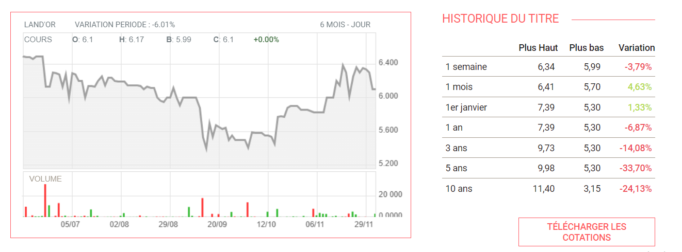

* Land Or has fluctuating variations with 2 positive ones during the begenning of the period and the last month.
* At the end of the first quarter of 2023, Land'Or achieved growth in its turnover of 17% compared to the same period of 2022, thanks to good achievements on the local market (+26%).
* Export turnover recorded a drop of 7% during the first quarter of 2023 compared to the same period of 2022. Note that the Moroccan market is now supplied by the new Moroccan factory.

***Financial Statements***

* **Valuation ratios**

| **EPS** | |  |  |  |  |  |  |
| --- | --- | --- | --- | --- | --- | --- | --- |
| **Interpretation :** In 2023 , LandOr registered a decrease of 0.72% in its profitability on a per-share basis compared with a percentage of 0.41% in the Industry. This may imply that the company may be affected by sectors or economic conditions . | | | | | |
| ***Company*** | ***Industry*** |
| -0.72 | 0.41 |  |  |  |  |  |  |
|  |  |  |  |  |  |  |  |
|  |  |  |  |  |  |  |  |
| **P/E** | |  |  |  |  |  |  |
| **Interpretation :**  While the willingness of investors to pay for each dinar of earnings of the industry has reached 13.63 in 2023, Land Or has registered a negative P/E ratio of -6.29. This indicates that the company’s stocks are undervalued by the investors and the company is losing money. | | | | | |
| ***Company*** | ***Industry*** |
| -6.29 | 13.63 |  |  |  |  |  |  |

**Liquidity ratio**

| **Current Ratio** | |  |  |  |  |  |  |
| --- | --- | --- | --- | --- | --- | --- | --- |
| **Interpretation :**The ability of LandOr to cover its short-term liabilities with its short-term assets is close to the industry. | | | | | |
| ***Company*** | ***Industry*** |
| 1.22 | 1.55 |  |  |  |  |  |  |

**Profitability ratios**

| **Gross Margin** | |  |  |  |  |  |  |
| --- | --- | --- | --- | --- | --- | --- | --- |
| **Interpretation :** The portion of revenues retained after covering the cost of sales has **increased by 20.58% in 2023** which can suggest that LandOr is becoming more efficient in managing its costs. However , this rate is lower by 9.02 basis points than industry, implying that LandOr hasn’t yet reached the level of competitors' efficiency. | | | | | |
| ***Company*** | ***Industry*** |
| 20.58 | 29.62 |  |  |  |  |  |  |
|  |  |  |  |  |  |  |  |
|  |  |  |  |  |  |  |  |
| **Operating Margin** | |  |  |  |  |  |  |
| **Interpretation :** LandOr has decreased its portion of revenues after the payment of operating costs by -2.54% in 2023 compared to an average industry growth of 8.65% which may indicate that LandOr has a very low operational efficiency compared to its rivals. | | | | | |
| ***Company*** | ***Industry*** |
| -2.54 | 8.65 |  |  |  |  |  |  |

**Capital structure ratio**

| **Debt to Equity** | |  |  |  |  |  |  |
| --- | --- | --- | --- | --- | --- | --- | --- |
| **Interpretation :** The company's Debt to Equity ratio of 63.91% is lower than the industry average Debt to Equity ratio of 164.63%. A lower Debt to Equity ratio generally indicates a lower reliance on debt for financing and suggests a relatively lower financial risk often considered favorable as it implies less financial leverage | | | | | |
| ***Company*** | ***Industry*** |
| 63.91 | 164.63 |  |  |  |  |  |  |

1. ***Conclusion***

Given the available information, we can conclude that LandOr is considered a risky investment.

## 

**10. Meuble Intérieurs SAM:**

1. ***Description***

Created in 1988, on the initiative of Mr. Hatem BEN SLIMANE, the Société Atelier du Meuble Intégrés -SAM- has since specialized in the design, manufacturing and marketing of furniture medium and high-end offices, as well as the layout of work spaces. Offering a wide choice of products at competitive prices. “Interiors” Group enjoys a strong reputation and

of great expertise in the profession.

1. ***Latest news***

**23/10/23** The Furniture Interiors group announces revenues of 20 million dinars at the end of September

**09/10/23** A notable participation of Meuble Intégrés at the MEDIBAT 2023 exhibition

**09/25/23** Meuble Interiors improves its net profit by 52% in the first half

**09/12/23** Committed to Education, Meuble “Interiors” is responsible for the fitting out of two rooms at IHEC

**07/24/23** The Furniture Interiors group achieves half-yearly revenues of more than 12 million dinars

**06/26/23** Minority Shareholders renew their confidence in Meuble Interiors

**12/06/23** Representative of minority shareholders: Meuble Interiors will hold an elective meeting on June 22

**05/30/23** Meuble Interiors, sponsor of the Afro-Mediterranean Architectural Meetings.

1. ***SWOT Analysis***

| **Strengths** | **Weaknesses** |
| --- | --- |
| * Strong reputation and know-how ; * Distribution network throughout * Tunisian territory; * Excellent purchasing logistics with both * and international suppliers; * Competitive prices on the Tunisian market; * Strong financial position. | * Sensitivity of purchasing costs to fluctuations in the * fluctuation of the dinar against the foreign currency. * Limited information system. |
| ***Opportunities*** | ***Threats*** |
| * A high-potential market, given * demographic and economic trends * Tunisia. * A market still protected by customs duties * on imports of finished products. * International development. * Development of custom-made furniture * and assembly kits. | * Strong local craft market. * Low barriers to entry in this sector. * Intensified competition following the arrival * international chains. * Rising euro exchange rate. |

​

1. ***Stock Performance***

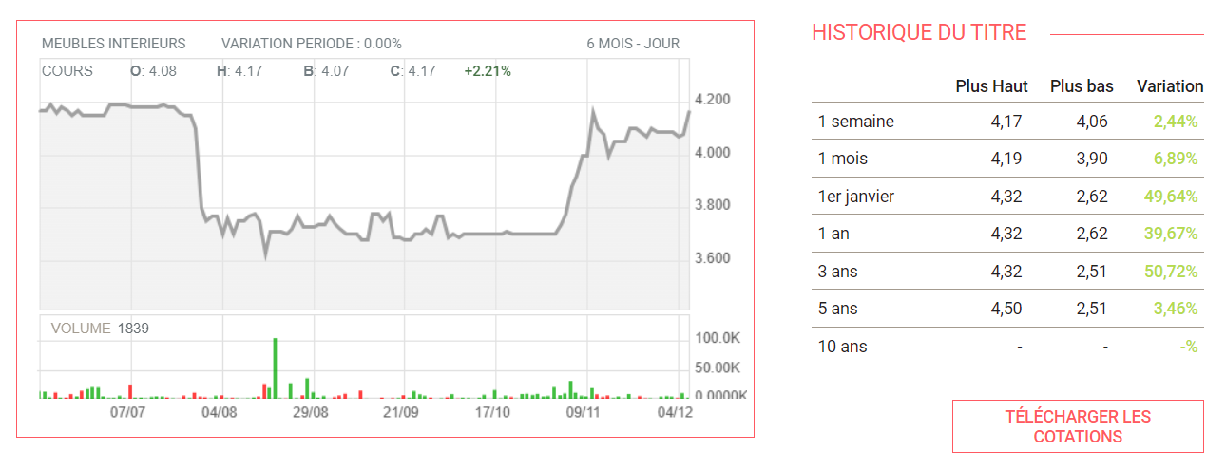

-> During the third quarter of the current year, the company Meuble Interiors managed to recover the decline observed over the first six months of the year in terms of its turnover (-12%).

-> Indeed, the company's revenues increased by 1% during the third quarter to reach 6 million dinars. This catch-up is the result of several commercial and marketing actions carried out.

1. ***Financial Statement***

* **Valuation ratio**

| **EPS** | |  |  |  |  |  |  |
| --- | --- | --- | --- | --- | --- | --- | --- |
| **Interpretation :** SAM's EPS of 0.6 is the double of the industry average EPS of 0.32. A higher EPS indicates that the company is generating more earnings per share, which can be seen as a positive sign of profitability. | | | | | |
| ***Company*** | ***Industry*** |
| 0.6 | 0.32 |  |  |  |  |  |  |

* **Liquidity ratio**

| **Current Ratio** | |  |  |  |  |  |  |
| --- | --- | --- | --- | --- | --- | --- | --- |
| **Interpretation :** No info available for SAM’s current Ratio. | | | | | |
| ***Company*** | ***Industry*** |
| - | 1.9 |  |  |  |  |  |  |

* **Profitability ratios**

| **Gross Margin** | |  |  |  |  |  |  |
| --- | --- | --- | --- | --- | --- | --- | --- |
| **Interpretation :** The portion of revenues retained after covering the cost of sales has **increased by 40.51% in 2023** which can suggest that SAM is becoming more efficient in managing its costs. However , this rate is lower by 22.46 basis points than industry, implying that SAM hasn’t yet reached the level of competitors' efficiency. | | | | | |
| ***Company*** | ***Industry*** |
| 40.51 | 62.97 |  |  |  |  |  |  |
|  |  |  |  |  |  |  |  |
|  |  |  |  |  |  |  |  |
| **Operating Margin** | |  |  |  |  |  |  |
| **Interpretation :** SAM has increased its portion of revenues after the payment of operating costs by 14.98% in 2023. Thus, it is lower than the average industry growth by 1.34 basis points which may indicate that SAM should higher it’s operational efficiency. | | | | | |
| ***Company*** | ***Industry*** |
| 14.98 | 16.32 |  |  |  |  |  |  |

* **Capital structure ratio**

| **Debt to Equity** | |  |  |  |  |  |  |
| --- | --- | --- | --- | --- | --- | --- | --- |
| **Interpretation :** A zero Debt to Equity ratio indicates a non reliance on debt for financing and suggests a relatively lower financial risk often considered favorable as it implies less financial leverage.  => SAM has a 0 leverage | | | | | |
| ***Company*** | ***Industry*** |
| 0 | 257.13 |  |  |  |  |  |  |

**11. Office plast:**

1. ***Description***

Founded in 2006, the Tunisian company specializes in the production of school and office supplies made from plastic and cardboard. It has an area of ​​10,000 m2 encompassing multiple production lines, storage depots for finished products with a capacity of more than 3,000 pallets, as well as the head office.

1. ***Macroeconomic***

Considered an essential reference in the stationery market, Office Plast has managed to maintain its place as a leader in the Tunisian market, with a market share of around 40%. The company continues to strengthen the distribution chain of its products.

Indeed, after the franchise operation of the French brand "Bureau Vallée", the company is launching its own brand "PURPLE" whose first store opened in 2023 in Charguia I.

Since its IPO, Office Plast has managed to maintain an increasing rate of revenue with a CAGR2015-2022 of 15.15%. Regarding operational efficiency, the company managed to improve its margins, despite the increase in the price of raw materials and the increase in transport costs. The EBIT margin increased by 6 percentage points to 7% at the end of the 2022 financial year.

1. ***SWOT Analysis***

| **Strengths** | **Weaknesses** |
| --- | --- |
| * A leading position in the local market; * A wide range of quality products and a diversity of * choice * A competitive product portfolio customized * requirements of each customer; * Mastery of the production process and acquired * know-how; * A well-developed distribution network, both locally and * export markets; * Qualified and competent human resources; * Strong partnerships with renowned foreign * companies that will play a very important role in the future of * development and innovation; * Tax, financial and social benefits for regional * regional development. | * Uncontrolled stock management and out-of-stocks * for raw materials and finished * and finished products; * Insufficient storage space; * Insufficient handling equipment; * Lack of quality certification; * Lack of marketing initiatives. |
| ***Opportunities*** | ***Threats*** |
| * Interesting development prospects in export * export markets, particularly in Africa; * Consolidation of its position in the local market * through the opening of its own sales outlets; * Modernization of industrial equipment with a view to * improve production processes and product quality * quality; * Differentiation opportunities through licensing * licenses; * Development and integration of new products * (school leather goods, etc.) * Cost reduction through vertical integration of certain raw * of certain raw materials. | * Tough foreign competition; * Changing consumer habits and * emergence of substitute products ; * High exposure to currency risk; * Current difficult economic climate, which * may boost the disappearance of certain customers. |

1. ***Financial Statement:***

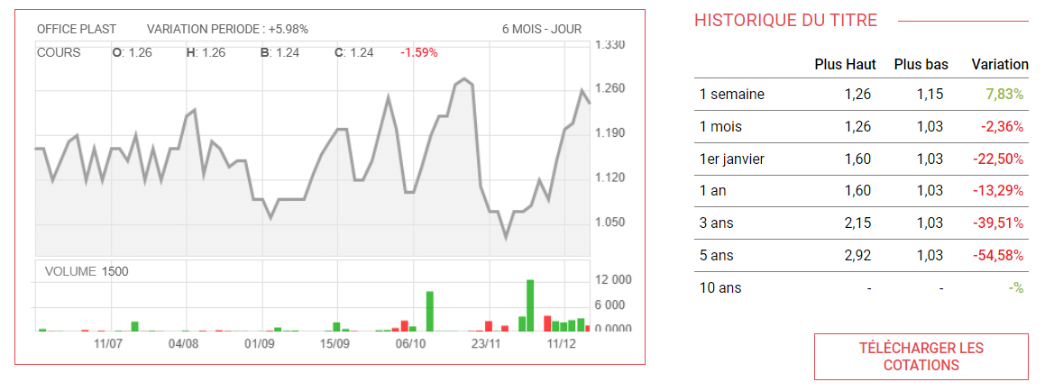

* **Valuation ratios**

| **EPS** | |  |  |  |  |  |  |
| --- | --- | --- | --- | --- | --- | --- | --- |
| **Interpretation :** In 2023 , Office Plast registered no increases in its profitability on a per-share basis compared with a percentage of 0.32% in the Industry. This may imply that the company may be affected by sectors or economic conditions . | | | | | |
| ***Company*** | ***Industry*** |
| - | 0.32 |  |  |  |  |  |  |
|  |  |  |  |  |  |  |  |
|  |  |  |  |  |  |  |  |
| **P/E** | |  |  |  |  |  |  |
| **Interpretation :** in 2023, Office Plast registered a negative P/E ratio of -953.04. This indicates that the company’s stocks are undervalued by the investors and the company is losing money. The P/E in the industry is negative too indicating that generally investors are not willing to pay for each dinar of earnings. | | | | | |
| ***Company*** | ***Industry*** |
| -953.04 | -244.23 |  |  |  |  |  |  |

* **Liquidity ratio**

| **Current Ratio** | |  |  |  |  |  |  |
| --- | --- | --- | --- | --- | --- | --- | --- |
| **Interpretation :** No info available on Office Plast current ratio. | | | | | |
| ***Company*** | ***Industry*** |
| - | 1.77 |  |  |  |  |  |  |

* **Profitability ratios**

| **Gross Margin** | |  |  |  |  |  |  |
| --- | --- | --- | --- | --- | --- | --- | --- |
| **Interpretation :** The portion of revenues retained after covering the cost of sales has **increased by 39.93% in 2023** which can suggest that Office Plast is becoming more efficient in managing its costs. However , this rate is lower by 18.46 basis points than industry, implying that Office Plast hasn’t yet reached the level of competitors' efficiency. | | | | | |
| ***Company*** | ***Industry*** |
| 39.93 | 61.4 |  |  |  |  |  |  |
|  |  |  |  |  |  |  |  |
|  |  |  |  |  |  |  |  |
| **Operating Margin** | |  |  |  |  |  |  |
| **Interpretation :** Office Plast has increased its portion of revenues after the payment of operating costs by 5.6% in 2023. Thus, it is lower than the average industry growth by 10.34 basis points which may indicate that Office Plast should higher it’s operational efficiency. | | | | | |
| ***Company*** | ***Industry*** |
| +5.6 | 15.94 |  |  |  |  |  |  |

* **Capital structure ratio**

| **Debt to Equity** | |  |  |  |  |  |  |
| --- | --- | --- | --- | --- | --- | --- | --- |
| **Interpretation :** A zero Debt to Equity ratio indicates a non reliance on debt for financing and suggests a relatively lower financial risk often considered favorable as it implies less financial leverage.  => Office Plast has a 0 leverage in 2023 | | | | | |
| ***Company*** | ***Industry*** |
| 0 | 239.34 |  |  |  |  |  |  |

1. ***.Conclusion***

We conclude that Office Plast is a fluctuating investment.

**12. Amen Bank**

1. ***Description***

Amen Bank is a Tunisian bank established in 1967. It is the country's Given the given information, and the improvements in the financial state of the

second-largest private bank, behind BIAT, in terms of balance sheet. bank, we can conclude that it will be profitable to invest in Amen Bank.

These two banks rank behind the state-owned BNA.

1. ***Macroeconomic***

Amen Bank’s appreciable solvency level is the bank's major asset in

these difficult times. It will enable the bank to absorb the "shock" of

the crisis, and to rapidly resume its quest for growth at the first signs

of economic recovery. We therefore recommend holding AmenBank

shares with a positive outlook.

1. ***SWOT Analysis***

| **Strengths** | **Weaknesses** |
| --- | --- |
| * AMEN PAY (1st Mobile banking payment application). * AMEN MOBILE. * AMEN bot (the first smart banking chatbot in Tunisia). * Management software is 100% Tunisian. * 165 branches in Tunisia. * Strong online presence. * Clear chain of command. * Low employee turnover (3.25%). * Partnerships. | * Slow decision-making. * Slow flow of information. * Most branches are situated in urban areas. * There are too many cards available (conflicting choices). * Mixed quality of staff. * Limited global presence. * High level of arrears. |
| ***Opportunities*** | ***Threats*** |
| * Availability of partnerships. * Expanding overseas. * Expanding in rural areas (Tunisia). * Financing emerging startups/projects. * Recruiting experts. * More reliance on IT and software. | * Lack of liquidity. * Increase in taxes. * Islamic banks. * Leasing industry. * The emergence of cryptocurrency. * Tunisian value compared to other currencies. |

1. ***Stock Performance***

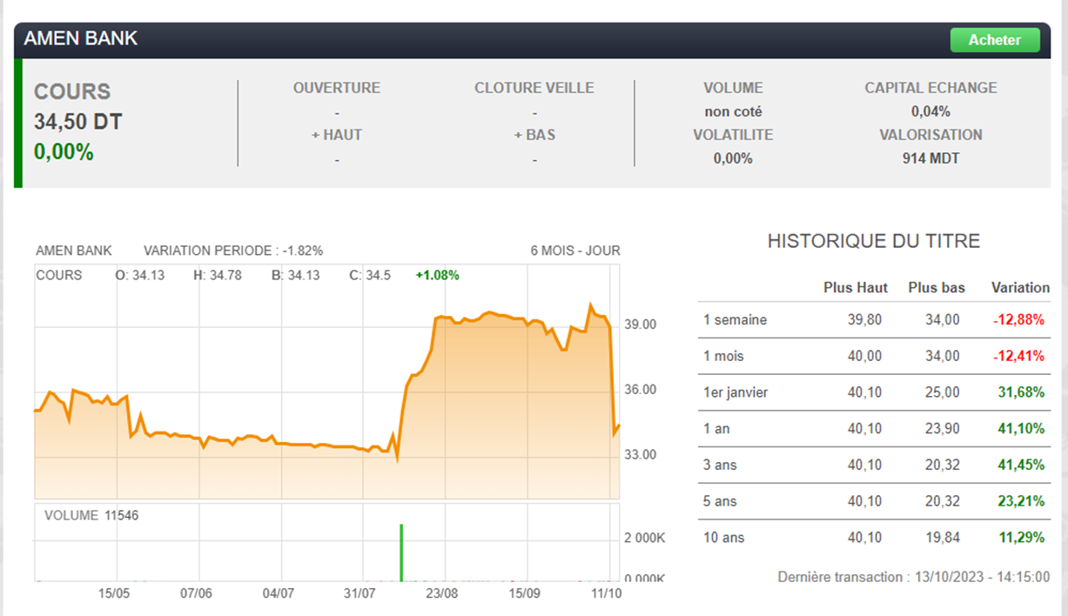

1. ***Financial Statements Analysis***

The balance sheet for the 2022 financial year confirms the bank's ability

to withstand the current crisis. Reaping the rewards of its strategy of

rebalancing the balance sheet and its NEXT transformation program,

the bank has posted a **good trend in operating activity**, a substantial

**improvement in profitability**, **better control of costs and risks**, and a

downward trend in exposure to the tourism and real estate sectors.

* **Valuation ratios**

| **EPS** | |  |  |  |  |  |  |
| --- | --- | --- | --- | --- | --- | --- | --- |
| **Interpretation :** AMEN's EPS of 5.04 is higher than the industry average EPS of 0.64. A higher EPS indicates that the company is generating more earnings per share, which can be seen as a positive sign of profitability. | | | | | |
| ***Company*** | ***Industry*** |
| 5.04 | 4.4 |  |  |  |  |  |  |
|  |  |  |  |  |  |  |  |
|  |  |  |  |  |  |  |  |
| **P/E** | |  |  |  |  |  |  |
| **Interpretation :** Investors are willing to pay 6.91 times AMEN's earnings for each share of its stock in 2023. On the other hand, the average valuation of stocks in the industry reached 9.07, implying that AMEN’s stocks are trading at a deficit compared to the competitors | | | | | |
| ***Company*** | ***Industry*** |
| 6.91 | 9.07 |  |  |  |  |  |  |

* **Liquidity ratio**

| **Current Ratio** | |  |  |  |  |  |  |
| --- | --- | --- | --- | --- | --- | --- | --- |
| **Interpretation :** No info available for AMEN’s current ratio | | | | | |
| ***Company*** | ***Industry*** |
| - | 0.02 |  |  |  |  |  |  |

* **Profitability ratios**

| **Gross Margin** | |  |  |  |  |  |  |
| --- | --- | --- | --- | --- | --- | --- | --- |
| **Interpretation :**  No info available for AMEN’s gross margin | | | | | |
| ***Company*** | ***Industry*** |
| - | 3.57 |  |  |  |  |  |  |
|  |  |  |  |  |  |  |  |
|  |  |  |  |  |  |  |  |
| **Operating Margin** | |  |  |  |  |  |  |
| **Interpretation :** AMEN has increased its portion of revenues after the payment of operating costs by 46.54% in 2023. Thus, it is lower than the average industry growth by 1.61 basis points which may indicate that AMEN should higher it’s operational efficiency. | | | | | |
| ***Company*** | ***Industry*** |
| +46.54 | +48.15 |  |  |  |  |  |  |

* **Capital structure ratio**

| **Debt to Equity** | |  |  |  |  |  |  |
| --- | --- | --- | --- | --- | --- | --- | --- |
| **Interpretation :** A zero Debt to Equity ratio indicates a non reliance on debt for financing and suggests a relatively lower financial risk often considered favorable as it implies less financial leverage.  => AMEN Bank has a 0 leverage in 2023 | | | | | |
| ***Company*** | ***Industry*** |
| 0 | 20.99 |  |  |  |  |  |  |

1. ***Conclusion***

Amen Bank is a positive promising investment

**13. Attijari Bank**

1. ***Description***

Attijari Bank is a Tunisian bank founded in 1968. It is a subsidiary of the Moroccan financial group Attijariwafa Bank. At the end of 2016, Attijari Bank had a network of 203 branches, owning what the bank describes as Tunisia's leading banking network.

1. ***Macroeconomic***

* In 2023, Attijari is likely to face a gloomy environment marked by sluggish(Swiss) investment, rising non-payment risks and tight liquidity. However, Attijari should be relatively among the banks least affected by the crisis, thanks to its solid financial base, good portfolio quality and comfortable liquidity cushion.
* The bank's high liquidity (with a low transformation ratio) and the quality of its portfolio give it considerable leeway to cope with monetary tensions, the prevailing gloom and the tightening of the regulatory framework.
* Appreciated by foreign investors for the quality of its management, its high stock market liquidity and its commercial responsiveness, Attijari Bank is an excellent vehicle for gaining exposure to the listed banking sector
* ***Swot Analysis***

| **Strengths** | **Weaknesses** |
| --- | --- |
| * Backing of an international banking group and a potential for synergies partially exploited with Attijariwafa Bank. * A benchmark in terms of commercial responsiveness: a developed agency network (200 agencies in 2021), a well-segmented product offering, a diversified customer base, a vigorous credit policy and collection among the least expensive in the market * A presence in all financial sectors thanks to specialized subsidiaries * Proven resilience and commercial dynamics: the most profitable bank in the listed banking sector in terms of financial profitability (an ROE of 22.1%, in 2021, compared to a sector average of 14.4% for the listed sector) with liquidity that compares favorably to the competition (an overall transformation ratio of 73.5%, at the end of 2021, compared to a sector average of 91.6% for the listed sector) * Portfolio quality of the highest standards in the sector: a classified debt rate of 6% covered to the extent of 72.3% by provisions * A historically attractive dividend policy, which meets the wishes of its reference shareholder, the Attijariwafa Bank Group | * Importance of the head office workforce in relation to the sales network: * The overall transformation ratio serves as a benchmark for monitoring the evolution of the regulatory transformation ratio. Due to lack of sufficient information on the composition of deposits and special resources as of December 31, 2021, our overall transformation ratio includes foreign currency deposits, bond borrowings and money market borrowings. |
| ***Opportunities*** | ***Threats*** |
| * Significant potential for businesses and institutions in Tunisia. * Significant potential for the segment of Tunisians residing abroad. * Productivity gains to be made with the development of digitalization | * Increasingly restrictive prudential regulations * The lack of political visibility * The tense social context * The deterioration of the economic situation |

***d. Stock Performance***

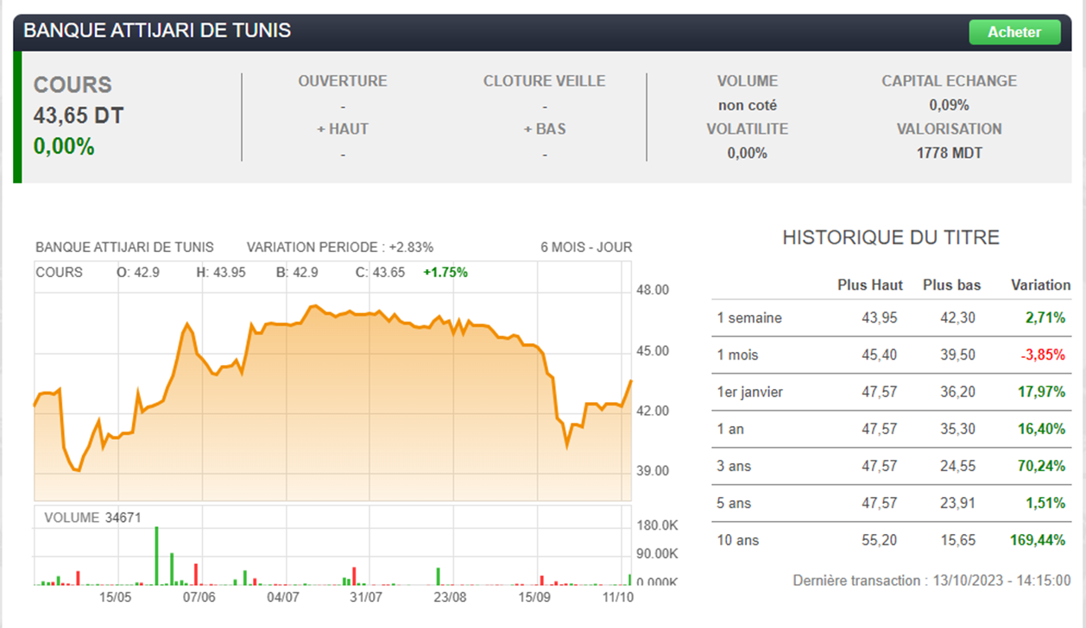

1. ***Financial State***

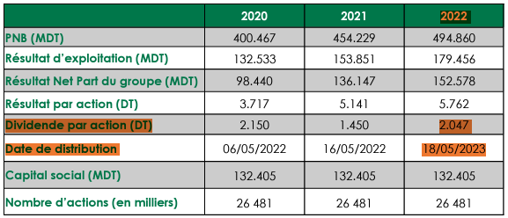

* **Valuation ratios**

| **EPS (ANN)** | |  |  |  |  |  |  |
| --- | --- | --- | --- | --- | --- | --- | --- |
| **Interpretation :** Attijari bank has higher EPS than the industry , this means that it is more profitable than other competitors which is good sign | | | | | |
| ***Company*** | ***Industry*** |
| **4.82** | **4.43** |  |  |  |  |  |  |
|  |  |  |  |  |  |  |  |
|  |  |  |  |  |  |  |  |
| **P/E (TTM)** | |  |  |  |  |  |  |
| **Interpretation :** It indicates how much people are paying for the stock in comparison to its earnings per share. P/E ratio of attijari bank is higher than the industry standards, it means the market price of the share is comparatively expensive in comparison to its earnings. | | | | | |
| ***Company*** | ***Industry*** |
| 8.91 | 8.78 |  |  |  |  |  |  |

* **Dividend ratio**

| **Payout Ratio(TTM)** | |  |  |  |  |  |  |
| --- | --- | --- | --- | --- | --- | --- | --- |
| **Interpretation :**the company ratio is too high because the company is expected to distribute more than half of its earnings as dividends, which implies less retained earnings to reinvest | | | | | |
| ***Company*** | ***Industry*** |
| 65.27% | 46.8% |  |  |  |  |  |  |

* **CF ratios**

| **Cash flow/ share(TTM)** | |  |  |  |  |  |  |
| --- | --- | --- | --- | --- | --- | --- | --- |
| **Interpretation :** indicates that a company has generated more cash in a period than what is needed to pay off its current liabilities. which is a good sign since EPS is higher than industry | | | | | |
| ***Company*** | ***Industry*** |
| 13.3 | 6.72 |  |  |  |  |  |  |
|  |  |  |  |  |  |  |  |
| * **Profitability ratio** | | | |  |  |  |  |
| **Operating Margin(TTM)** | |  |  |  |  |  |  |
| **Interpretation :** above the industry average or the overall market indicate financial efficiency and stability | | | | | |
| ***Company*** | ***Industry*** |
| +53.07 | 48.33 |  |  |  |  |  |  |

* **Sales ratio**

| **Sales Growth (5Y)** | |  |  |  |  |  |  |
| --- | --- | --- | --- | --- | --- | --- | --- |
| **Interpretation :** higher sales growth than whole industry , Attijari bank has sold more than its competitors during past 5 years | | | | | |
| ***Company*** | ***Industry*** |
| 10.23% | 10.17% |  |  |  |  |  |  |

***e.Conclusion*** Given the available information and the stock performance, we can conclude that Attijari bank is worth investing in

**14. SOTUMAG**

1. ***Description***

“Société Tunisienne des Marchés de Gros”, "SO.TU.MA.G", was created on December 4, 1980. The Bir Kassaâ market is the country's most important commercial platform. Covering an area of 50 hectares, it welcomes 30,000 visitors daily, 10,000 vehicles, 1,100 tonnes of fruit and vegetables and 50 tonnes of seafood.

1. ***Macroeconomic***

As part of the company's development strategy for the coming years, SOTUMAG has launched a study into the **rehabilitation and modernization of the Bir El Kassâa wholesale market.** In addition, specifications have been drawn up with the participation of all stakeholders and in collaboration with the supervisory authority and the Ministries of Agriculture and Industry.

1. ***SWOT Analysis***

| **Strengths** | **Weaknesses** |
| --- | --- |
| * Support from the Tunisian State * A good governance structure and * composition of the Board of Directors (presence * of independent directors, competent directors * and varied profiles...) * A rich and diversified customer base * Diversification of credit portfolio by business sector * sector * Good credit risk management * An adapted, varied and innovative range of products and services * innovative * A relatively extensive network * A strong capacity to mobilize savings * A targeted recruitment plan which has gone hand in hand with a voluntary voluntary departures | * High exposure to disaster-stricken * (tourism) and risky sectors (industry) * High level of risk, exacerbated by the health * Crisis. * High cost/income ratio * Underestimation of required provisions * Lack of multi-currency accounting * Information system failure * impact on the justification and reconciliation * reconciliation of flows and transactions and * commitments. * Statement of off-balance sheet commitments * off-balance sheet commitments. |
| ***Opportunities*** | ***Threats*** |
| * Market with strong growth potential (low level of banking) * still low) * Growing demand for banking services * Unmet financing needs of SMEs * Synergy between the various companies making up the * STB BANK group, particularly in terms of complementarity by * and business lines. | * The country's economic situation. * Development of a network of major * preempting the bank's future * future development of the bank * Reinforcement of the regulatory arsenal by the * BCT and implementation of new regulatory * regulatory requirements (operational risk, * market risk, IFRS...) * Increased competition in STB's * STB's preferred market segment * Liquidity problems on the Tunisian market * Sensitive economic situation * and internal shocks. |

1. ***Stock Performance***

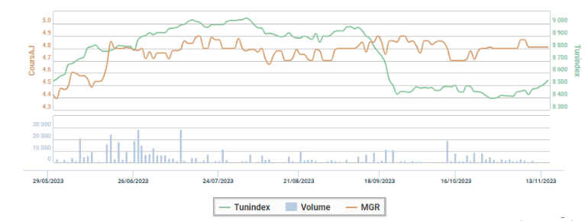

On the stock market, the company continues to benefit from the general craze for **defensive** stocks. SOTUMAG's satisfactory achievements and the **upward curve** of its results have been rewarded by investors. Pending more factual communication on the integrated market megaproject, SOTUMAG's main niche for improving profitability lies in **optimizing its expenses**. Despite its track record, **the stock is attractively valued**. A position in SOTUMAG is recommended, particularly for a CEA profile, given the company's annuity profile and the good dividend yield it offers.

1. ***Financial Statement***

The Tunisie Valeurs stock market intermediary devotes a note to SOTUMAG, which despite the prevailing gloom confirms the resilience of its business model, posting **encouraging achievements for the year 2022**. The company remained on course for growth. It has **achieved new levels of profitability and improved its financial equilibrium**. In 2022, the wholesale market operator achieved a **net profit of 6.2 million tonnes**, the highest level ever achieved since the company was founded.

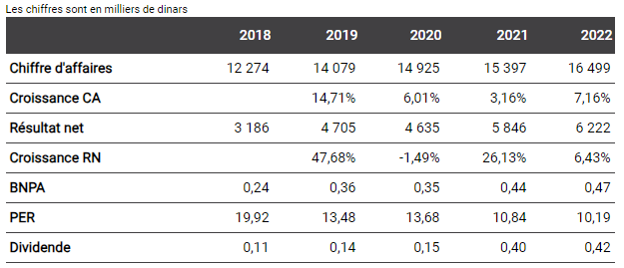

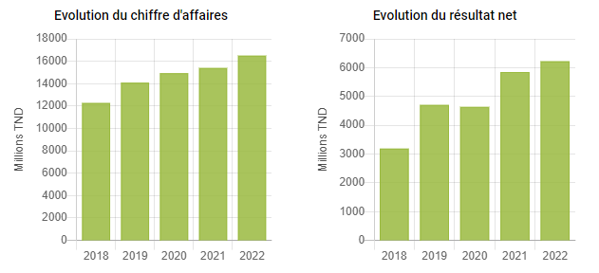

* **Valuation ratios**

| **EPS (ANN)** | |  |  |  |  |  |  |
| --- | --- | --- | --- | --- | --- | --- | --- |
| **Interpretation :** SOTUMAG’s EPS has increased by 0.47 compared to last year, this means that the company is increasing its profitability. | | | | | |
| ***Company*** | |
| **+0.47** | |  |  |  |  |  |  |
|  |  |  |  |  |  |  |  |
|  |  |  |  |  |  |  |  |
| **P/E (TTM)** | |  |  |  |  |  |  |
| **Interpretation :** It indicates how much people are paying for the stock in comparison to its earnings per share. P/E ratio of SOTUMAG is relatively high. | | | | | |
| ***Company*** | |
| 9.75 | |  |  |  |  |  |  |

* **Profitability ratios**

| **GROSS MARGIN** | |  |  |  |  |  |  |
| --- | --- | --- | --- | --- | --- | --- | --- |
| **Interpretation :** Gross Margin has grown by 42.34 compared to last year. | | | | | |
| ***Company*** | |
| +42.34 | |  |  |  |  |  |  |

* **Earnings ratio**

| **EBITDA Growth (5Y)** | |  |  |  |  |  |  |
| --- | --- | --- | --- | --- | --- | --- | --- |
| **Interpretation :** EBITDA has grown by 3.69M compared to last year. | | | | | |
| ***Company*** | |
| +3.69M | |  |  |  |  |  |  |

* **Liquidity ratio**

| **Quick Ratio** | |  |  |  |  |  |  |
| --- | --- | --- | --- | --- | --- | --- | --- |
| **Interpretation :** The company could pay off current liabilities 4.92 times over. | | | | | |
| ***Company*** | |
| 4.92 | |  |  |  |  |  |  |

1. ***Conclusion***

Given the stock's defensive nature and its negative correlation with the

market, it could serve as a valuable addition to our portfolio, enhancing its overall diversification.

**15. SOTIPAPIER**

1. ***Description***

SOTIPAPIER "Société Industrielle du Papier et du Carton" was founded in 1981 and specializes in the production of Kraft paper, Testliner and Fluting paper in Tunisia. SOTIPAPIER is a key player in the Tunisian paper market. The company was floated on the stock exchange on March 28, 2013.

1. ***Macroeconomic***

- The company's corporate ***social responsibility*** program has a long history of protecting and preserving the environment. In 2020, it created the "Sotipapier s'engage" platform to bring together all the associative projects it supports.

- SOTIPAPIER is Africa's **leading manufacturer** of corrugated paper and kraft paper for bags.

- Despite recent challenges, SOTIPAPIER stock remains a sound investment opportunity. While **the global paper market has experienced a decline in demand since the last quarter of 2022**, SOTIPAPIER is well-positioned to weather this storm thanks to its **strong market share in Tunisia**, its **recent decision to increase production capacity**, and its **ability to adapt to changing market conditions**.

The company's positive track record and its strong financial position suggest that it will be able to navigate the current market downturn and emerge as a stronger player in the long run.

Other potential negative macroeconomic factors that could impact the company's performance, such as **inflation** and **rising interest rates**. Inflation could lead to **higher costs** for the company, and rising interest rates could make it more expensive for the company to borrow money.

Overall, the macroeconomic factors analysis suggests that SOTIPAPIER is a good investment. The company is **well-positioned** to benefit from the current positive trends in the global paper market, and it has a strong track record of profitability.

- Tunisie Valeurs recommends a **buy** position on SOTIPAPIER stock.

1. ***SWOT Analysis***

| **Strengths** | **Weaknesses** |
| --- | --- |
| * Quasi-monopolistic position on the Kraft paper market (70% market share) * Comfortable position on the Testliner market * A solid balance sheet structure and a structurally cash-generating activity. * The successful completion of a vast development plan which made it possible to upgrade the production tool, improve the quality of finished products and double the capacity and increase the value of the Testliner line. * From 2022 and until 2026, the paper maker will begin a new phase of increasing its production capacity to 80,000 tonnes/year compared to a current cruising capacity of 60,000 tonnes/year | * The exacerbation of the energy bill. * The cyclicality of the activity, highly exposed to fluctuations in raw materials, particularly paper pulp, and its dependence on the local market remain the two main shortcomings of SOTIPAPIER |
| ***Opportunities*** | ***Threats*** |
| * The surge in paper prices which continued in 2023, is likely to improve the revenues and margins of the paper manufacturer, able to revise upwards its prices on the local market * The packaging paper sector is facing an exceptional decade benefiting from new levers favoring its growth, namely e-commerce and the substitution of plastic * The signing of an agreement with the pan-African investment firm "Sango Capital" for a majority stake (52%) in the capital of SOTIPAPIER and the gradual exit of Swicorp from the capital should constitute a strong catalyst for the stock. | * The Testliner market is more competitive with a strong foreign presence (more than half of the market is served by imports) and local competition (the Poulina Group, since 2011) * Correlation with the real estate sector in difficulty and in particular with the cement sector, the main outlet for Kraft paper |

***d. Stock Performance***

**Stock Performance compared to Tunindex in the last 6 months**

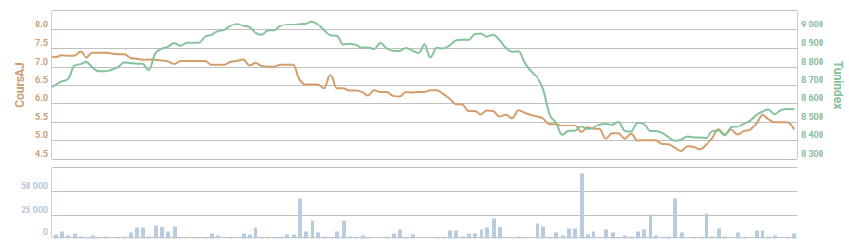



The **lowest price** for the stock was **3.1DT** on **December 15, 2017**, with **5,701 shares traded**.

The **highest price** for the stock was **7.9DT** on **April 10, 2023**, with **1,785,938 shares traded**. This was the **highest trading volume** for the stock.

***e. Financial State***

**Shareholder base: (June 2018)**

- RECALL HOLDING 34.40%

-Value Consulting 28.80%

- Public: 36.80%

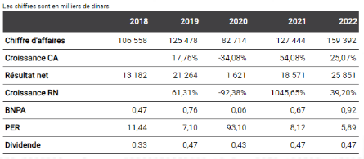

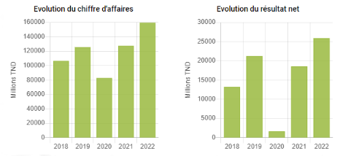

On September 7, 2023, the Board of Directors of SOTIPAPIER decided to propose a **postponement of the payment of dividends for the 2022** fiscal year. The dividends, amounting to 470 millimes per share, for a **total of 13,246,522,770** Tunisian dinars, **will now be paid on January 2, 2024.**

***f. Financial Statements Analysis***

* **Valuation ratio**

| **EPS** (ANN) | |  |  |  |  |  |  |
| --- | --- | --- | --- | --- | --- | --- | --- |
| **Interpretation :** SOTIPAPIER has realized **an 0.92** in its earnings per share, exceeding the average in the industry . | | | | | |
| ***Company*** | ***Industry*** |
| 0.92 | 0.7 |  |  |  |  |  |  |

* **Dividend ratio**

| **Payout Ratio**(TTM) | |  |  |  |  |  |  |
| --- | --- | --- | --- | --- | --- | --- | --- |
| **Interpretation :**the company ratio is too high because the company is expected to distribute more than half of its earnings as dividends, which implies less retained earnings to reinvest | | | | | |
| ***Company*** | ***Industry*** |
| 51.24% | 47.59% |  |  |  |  |  |  |

* **Profitability ratios**

| **Gross Margin**(TTM) | |  |  |  |  |  |  |
| --- | --- | --- | --- | --- | --- | --- | --- |
| **Interpretation :** The profits retained after paying the cost of sales  **reach an increase of 37.54% in 2022**.  On the other hand,this margin has increased on average by only 2.73% for the industry, indicating that SOTIPAPIER has more effective cost management, pricing power, or a unique competitive advantage. than its competitors. | | | | | |
| ***Company*** | ***Industry*** |
| 37.54% | 34.81% |  |  |  |  |  |  |
|  |  |  |  |  |  |  |  |
| **Operating Margin**(TTM) | |  |  |  |  |  |  |
| **Interpretation :** After paying the operating expenses , SOTIPAPIER retained a profit that has registered an **increase of 21.32%** **in 2022**. This growth is approximately 1.17 times greater than the average increase in the industry, indicating that the company can generate higher profits from its core business than its rivals. | | | | | |
| ***Company*** | ***Industry*** |
| 21.32% | 18.17 |  |  |  |  |  |  |

* **Capital structure ratio**

| **Asset Turnover** (TTM) | |  |  |  |  |  |  |
| --- | --- | --- | --- | --- | --- | --- | --- |
| **Interpretation :** high asset turnover ratio of 1.31 indicates a SOTIPAPIER that is exceptionally effective at extracting a high level of revenue(high level of sales increase 25.07% more than its competitors 19.19%) from a relatively low number of assets. | | | | | |
| ***Company*** | ***Industry*** |
| 1.31 | 1.26 |  |  |  |  |  |  |

***g. Conclusion***

The company's valuation is attractive, and the macroeconomic factors are generally positive. Sotipapier is a good addition to our portfolio.

## 

**16. Carthage Cement**

1. ***Description***

Carthage Cement specializes in the production and marketing of building materials, quarrying of building stone and by-products, manufacture and sale of all cement-based products (parapets, agglomerates, concrete, etc.).

1. ***Macroeconomic***

- The **positive performance** of Carthage Cement is being driven by a combination of favorable macroeconomic factors, including the **recovery of the Tunisian economy**, the **rise in global construction activity**, and the **increase in prices for cement**. These factors have led to **increased demand for cement**, which has in turn driven up sales and profits for Carthage Cement.

- The **recent investment by** El Hana in Carthage Cement is a further **sign of confidence in the company's future prospects**. This investment, coupled with the company's **recent contract wins** and its **consistent profitability**, suggests that Carthage Cement is **well-positioned for continued growth in the years to come.**

- ***However***, The stagnant Tunisian economy and the projected global construction **slowdown** are likely to impede the company's growth.

1. ***SWOT Analysis:***

| **Strengths** | **Weaknesses** |
| --- | --- |
| * A portfolio of high-value activities added (gross margin and margin   comfortable operating conditions)   * A cement plant with production capacity important and new technology   allowing less energy consumption   * Vertical integration of the activity is well studied. | * Marketing dependence on aggregates towards the company GCN Trade. |
| ***Opportunities*** | ***Threats*** |
| * A market with strong growth potential both on a local scale and on a global scale. * An upward trend in the prices of sales supported by strong demand. * The proliferation of mega projects real estate and infrastructure planned in Tunisia in the coming years. | * Installation of new cement plants in Tunisia and neighboring countries, in addition to increases in capacity of existing units. * Possible delays and difficulties relating to the construction of the new factory cement * The obligation to satisfy the local market as a priority, according to regulations. |

**Stock Performance compared to Tunindex in the last 6 months**

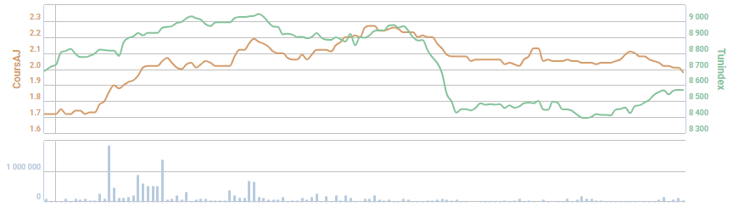



The **lowest price** for the stock was **1.68DT** on **April 17, 2023**, with **20,408 shares traded**.

The **highest price** for the stock was **2.27DT** on **August 8, 2023**, with **120,100 shares traded**.

The **highest trading volume** for the stock was **1,891,601** on **June 15, 2023**.

- Whatever the time horizon, the stock remains in a **bearish trend**. In fact, it is **moving below all its moving averages**.

The share's **negative trend** could continue, as **negative technical indicators continue to dominate**, notably: the downward exit from the Bollinger Bands, the MACD, which remains stuck below its signal, and the sharp drop in volumes over the past week.

1. ***Financial Statement***

**Shareholding (August 2020) :**

- BINA CORPORATE: 40.20% Al Karama Holding: 14.85

- Al Karama Holding: 14.85

- Banque de Tunisie: 5.24

- Other shareholders: 39.71

At the end of the **third quarter of 2023**, Carthage Cement achieved **total sales of 322.866 MTND**, **up 23% on the same period of 2022**.

At **September 30**, cement sales showed a **positive trend**, mainly due to :

- A **26% rise in local sales** (cement and clinker), from 198.432 MTND at the end of the third quarter of 2022 to 249.508 MTND on September 30, 2023.

- A **14% rise in export sales**, from 41.187 MTND at the end of the third quarter 2022 to 46.806 MTND on September 30, 2023.

*Carthage Cement thus maintains its* ***leading position*** *in the Tunisian cement sector.*

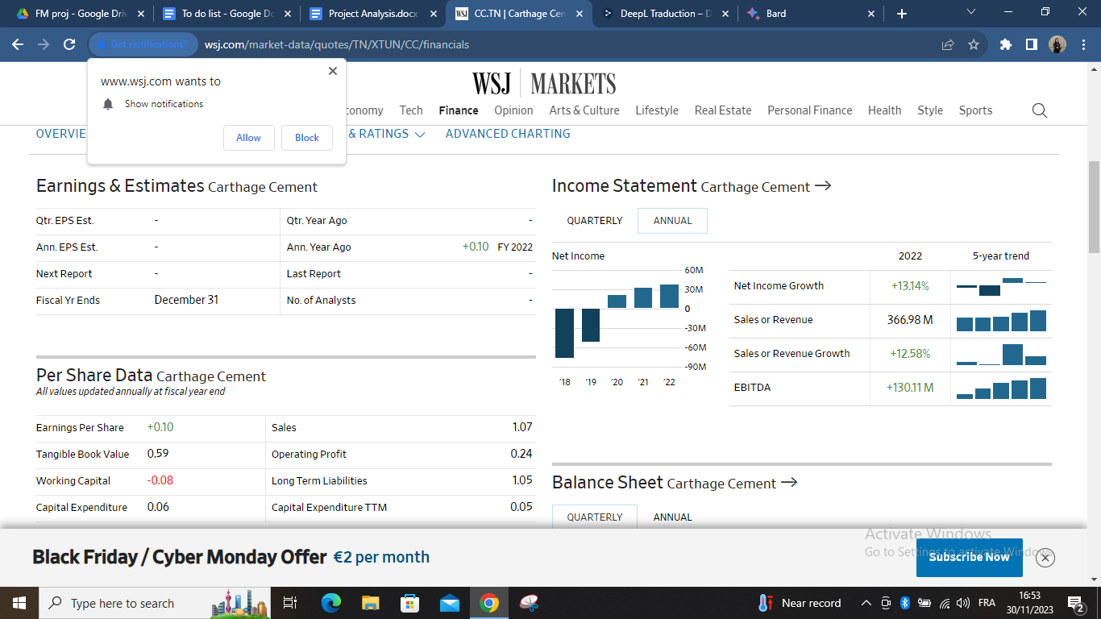

* **Valuation ratio**

| **EPS** (ANN) | |  |  |  |  |  |  |
| --- | --- | --- | --- | --- | --- | --- | --- |
| **Interpretation :** Carthage Cement has realized **an 0.1** in its earnings per share, same as the average in the industry . | | | | | |
| ***Company*** | ***Industry*** |
| 0.1 | 0.1 |  |  |  |  |  |  |

* **Dividend ratio**

**Carthage Cement does not pay dividends to its shareholders.**

* **Profitability ratios**

| **Gross Margin**(TTM) | |  |  |  |  |  |  |
| --- | --- | --- | --- | --- | --- | --- | --- |
| **Interpretation :** The company retains 47.9% of its revenues as gross profit, higher than the industry, indicating that Carthage Cement has more effective cost management, pricing power, or a unique competitive advantage. than its competitors. | | | | | |
| ***Company*** | ***Industry*** |
| 47.9% | 45.3% |  |  |  |  |  |  |
|  |  |  |  |  |  |  |  |
|  |  |  |  |  |  |  |  |
| **Operating Margin**(TTM) | |  |  |  |  |  |  |
| **Interpretation :** After paying the operating expenses, Carthage Cement retained a profit that has registered an **increase of 22.24%** **in 2022**. This growth is approximately 1.11 times greater than the average increase in the industry, indicating that the company can generate higher profits from its core business than its rivals. | | | | | |
| ***Company*** | ***Industry*** |
| 22.24% | 20.12% |  |  |  |  |  |  |

* **Capital structure ratio**

| **Asset Turnover** (TTM) | |  |  |  |  |  |  |
| --- | --- | --- | --- | --- | --- | --- | --- |
| **Interpretation :** Both the company's asset turnover and the industry's asset turnover are 0.49. This means that, on average, the company and the industry are generating $0.49 in net sales for every dollar of average total assets. The company's performance in this aspect is in line with the industry average. | | | | | |
| ***Company*** | ***Industry*** |
| 0.49 | 0.49 |  |  |  |  |  |  |

1. ***Conclusion***

Due to the current economic uncertainties and Carthage Cement's stock’s suboptimal performance, investing in the company poses significant risks. Hence, it is prudent to postpone investment decisions until Carthage Cement exhibits improved financials and a more favorable macroeconomic climate prevails.

**17. Telnet Holding**

1. ***Description***

Telnet Holding SA engages in the provision of technology consulting and engineering services. It operates through the following business divisions: Research and Development and Product Engineering; Telecom and Network Integration; and Product Lifecycle Management Services and Mechanical Studies. The firm carries out activities in the sectors of telecommunication and multimedia; industry and energy; automotive; avionics; security and system; and electronic payment. The company was founded by Mohamed Frikha on November 25, 1994 and is headquartered in Tunis, Tunisia.

1. ***Latest news***

**23/10/23** TELNET Group improves revenues by 9% to end September at 45 million dinars

**09/28/23** TELNET Group improves first-half profits by 6% to over 30 million dinars

**07/27/23** TELNET Group improves half-year revenues by 9% to over 30 million dinars

**02/05/23** TELNET Group achieves first quarter revenues of over 15 million dinars

**04/17/23** TELNET Group achieves net profit of 8.3 million dinars in 2022

**27/01/23** TELNET Group increases revenues by 16% in 2022 to 57 million dinars

**26/10/22** TELNET Group increases revenues by 17% to end September at over 40 million dinars

**05/10/22** Signature of a series of cooperation agreements between TELNET and the CS-Sopra Steria group

1. [***S***](https://managers.tn/2023/08/01/le-groupe-telnet-holding-enregistre-une-croissance-exceptionnelle-de-ses-produits-dexploitation-au-1er-semestre-2023/)***WOT Analysis :***

| **Strengths** | **Weaknesses** |
| --- | --- |
| * A fully exporting group which generates the majority of its revenues in hard currencies * A strong added value positioning and recognized know-how in cutting-edge technologies * Highly qualified and cost-competitive human capital * A stable and internationally renowned customer base (Worldline, Softathome, CETIM and DASSAULT) * Partnerships and privileged relationships with research laboratories in Tunisia and abroad * Robust fundamentals, good profitability and a healthy financial structure * In teleworking mode since the application of general confinement in Tunisia, the Group's activity has been slightly impacted by the Covid-19 health crisis | * A relative concentration of customers (high exposure to the SAFRAN Group) and a weak presence in markets other than the French market |
| ***Opportunities*** | ***Threats*** |
| * A sector of activity (NICT) in full swing and arousing keen interest from the Tunisian authorities * The consolidation of the core business and current projects with historic partners in France such as INGENICO, CAPGEMINI, and CETIM France * A strategy focused on continued internationalization and increasing technological skills to position itself on electric cars, robotics, satellites and drones: the start of the “Satellites activity” and the realization of the drone project with the Japanese partner FUJI IMVAC * Launch of artificial intelligence and cloud computing which will be managed by the American subsidiary “Telnet Corporation INC” established in Silicon Valley since 2019 * The Covid-19 crisis will bring a big leap forward for digital technologies, teleworking, digital payments, use of software. So many activities in which the Group is well positioned today. | * Strong competition from India, Egypt, Morocco and Eastern European countries in new technologies. Strong competition from IT services companies in the sector which benefit from a lighter cost structure * Exposure to exchange rate risk (appreciation of the dinar) |

1. [***Stock Performance***](https://managers.tn/2023/08/01/le-groupe-telnet-holding-enregistre-une-croissance-exceptionnelle-de-ses-produits-dexploitation-au-1er-semestre-2023/)

The Telnet Holding Group recorded remarkable growth in revenues to June 30, 2023, testifying to its leading position in the technology and innovation sector. The outstanding performance of the product engineering R&D division, accounting for 84.67% of operating revenues, demonstrates the Group's ongoing commitment to innovation and its ability to seize market opportunities.

Telnet holding's high Ebitda is an indicator of its solid financial performance, underlining its ability to generate substantial profits after covering operating costs. However, Telnet holding's Ebitda margin of 18.68% highlights the need to improve operating efficiency and seek solutions to increase overall profitability.

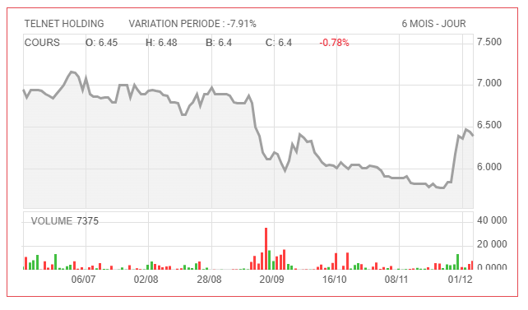

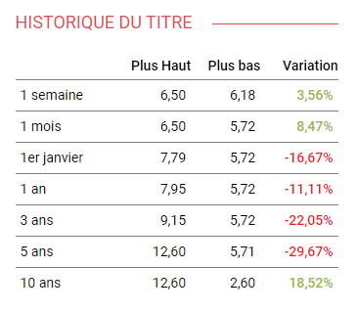

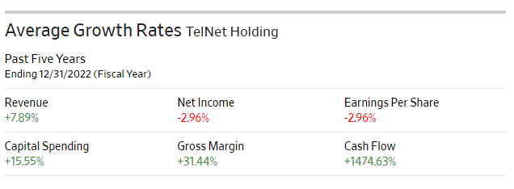

***d. Financial Statements Analysis***

* **Valuation ratios**

| **EPS** (ANN) | |  |  |  |  |  |  |
| --- | --- | --- | --- | --- | --- | --- | --- |
| **Interpretation :** the company's individual share profitability falls just beneath the prevailing industry standard. While the discrepancy is subtle, it indicates that, on average, other companies in the industry are realizing slightly higher earnings per share than Telnet holding . | | | | | |
| ***Company*** | ***Industry*** |
| 0.66 | 0.67 |  |  |  |  |  |  |
|  |  |  |  |  |  |  |  |
|  |  |  |  |  |  |  |  |
| **P/E** (TTM) | |  |  |  |  |  |  |
| **Interpretation :** The Price-to-Earnings (P/E) ratio on a trailing twelve months (TTM) basis for the company is 9.42, while the industry average is 9.21. This means that Telnet Holding’s stock is trading at a slightly higher valuation than the industry average based on its earnings over the past twelve months.  a higher P/E ratio may indicate higher market expectations for the company's future earnings growth compared to the industry average. | | | | | |
| ***Company*** | ***Industry*** |
| 9.42 | 9.21 |  |  |  |  |  |  |

* **Liquidity ratio**

| **Quick Ratio**(MRQ) | |  |  |  |  |  |  |
| --- | --- | --- | --- | --- | --- | --- | --- |
| **Interpretation :**  The Quick Ratio for TH is 1.3, slightly exceeding the industry average of 1.29. This indicates that the company has a slightly stronger ability to meet its short-term obligations using its most liquid assets compared to the industry average. | | | | | |
| ***Company*** | ***Industry*** |
| 1.3 | 1.29 |  |  |  |  |  |  |

* **Profitability ratios**

| **Gross Margin** (TTM) | |  |  |  |  |  |  |
| --- | --- | --- | --- | --- | --- | --- | --- |
| **Interpretation :** The Gross Margin on a trailing twelve months (TTM) basis for TH is -287.35%, while the industry average is -283.98%. both the company and the industry appear to have negative gross margins, indicating that the cost of goods sold exceeds the revenue generated. However, the company's gross margin is slightly lower than the industry average, signifying potentially higher costs relative to revenue compared to industry peers. Negative gross margins could raise concerns about the profitability of operations | | | | | |
| ***Company*** | ***Industry*** |
| -287.35% | -283.98 |  |  |  |  |  |  |
|  |  |  |  |  |  |  |  |
|  |  |  |  |  |  |  |  |
| **Operating Margin** | |  |  |  |  |  |  |
| **Interpretation :**A higher operating margin suggests that the company is effectively managing its operational expenses and generating a relatively higher profit per dollar of revenue when compared to industry peers. | | | | | |
| ***Company*** | ***Industry*** |
| 15.57% | 15.37 |  |  |  |  |  |  |

* **Capital structure ratio**

| **Debt to Equity** (MRQ) | |  |  |  |  |  |  |
| --- | --- | --- | --- | --- | --- | --- | --- |
| **Interpretation :**The Debt to Equity ratio on a most recent quarter (MRQ) basis for the company is 2.99%, while the industry average is 0.86%. In a straightforward interpretation,TH has a higher level of debt relative to its equity compared to the industry average. | | | | | |
| ***Company*** | ***Industry*** |
| 2.99% | 0.86 |  |  |  |  |  |  |

1. ***Conclusion***

Telnet Holding seems like a risky choice since it is highly leveraged.

**18. CITY CARS**

1. ***Description***

City Cars began operations on December 7, 2009. It is the official importer and distributor of the KIA brand on the Tunisian market, a brand whose reputation continues to grow.

1. ***Latest News***

- Contributing factors to City Cars' success include the recovery of the Tunisian economy post-COVID-19, **increased demand for cars**, substantial investments from parent company Kia Corporation, and the company's proactive expansion efforts, such as opening a new dealership and introducing a new model.

- Specific indicators, such as Kia Corporation's promotion for Tunisia, City Cars' 12% revenue growth in Q3 2023, and an investment from HORCHANI Group, underscore the company's positive outlook and ability to navigate potential risks, positioning City Cars for continued growth in the coming years.

- **City Cars is also expanding its operations.** In 2023, the company opened a new dealership in Gafsa and launched the new Kia Niro Hybride on the Tunisian market. These moves are helping City Cars to reach new customers and grow its market share.

- In December 2012, the Bouchamaoui-Chabchoub consortium bought 66.6% of the company's capital for 114 million dinars.

1. [***S***](https://managers.tn/2023/08/01/le-groupe-telnet-holding-enregistre-une-croissance-exceptionnelle-de-ses-produits-dexploitation-au-1er-semestre-2023/)***WOT Analysis :***

| **Strengths** | **Weaknesses** |
| --- | --- |
| * Backed by an internationally renowned brand. * competitive price-quality positioning in the city car segment. * A diverse range of vehicles. * 5-year warranty period. * Expertise and experience of the management team. * Solid financial foundation. | * It has a fairly long lead time. * Absence in the utility vehicle segment. * Construction of a new site is planned for 2013. * Absence in the Utility vehicle segment. * A long lead time. |
| ***Opportunities*** | ***Threats*** |
| * A Requesting market. * Expansion of the range of products marketed. * Development of its distribution network through the opening of two new agencies in 2013. | * A highly competitive market. * Exposure to currency risk. * No dealership exclusivity is given to CITY CARS. * Dependence on an import quota set by the State. * Opening of the Tunisian market to Chinese and Indian manufacturers. * Strong depreciation of the Tunisian dinar. |

1. ***Stock Performance***

Number of shares: 18,000,000

Free float: 30.00

Company valuation: 217 MTND

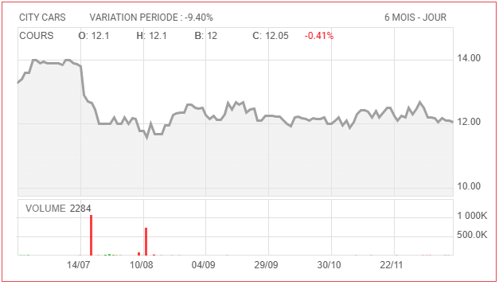

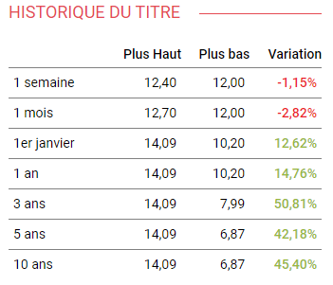

**Overall upward trend:** The stock price has generally increased over the past year, five years, and ten years.

**Recent fluctuations:** Despite the upward trend, there have been some recent fluctuations in the stock price. In the past week, it has decreased by 1.15%, and in the past month, it has decreased by 2.82%.

**High volatility:** The stock price has experienced significant highs and lows over the past ten years. For example, the highest recorded price in the past ten years was 14.09 dinars, while the lowest was 6.87 dinars. This suggests that the stock is relatively volatile.

1. ***Financial Statements***

City Cars demonstrates strong financial performance, with consistent revenue and profit growth over the past two years, including a 45% increase in 2022 and additional growth in 2023.

City Cars' revenue growth of 12% in the third quarter of 2023 is a strong sign of continued demand for cars in Tunisia.

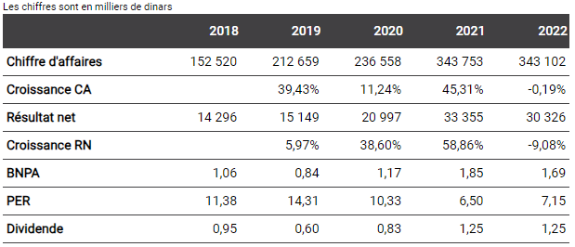

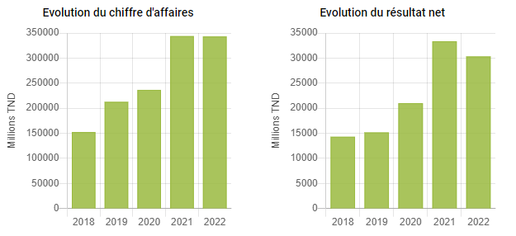

**Revenue:** City Cars' revenue has grown steadily over the past five years, from 152,520 thousand dinars in 2018 to 343,102 thousand dinars in 2022. This represents a growth of more than 120%.

**Profit:** City Cars' net profit has also grown steadily over the past five years, from 14,290 thousand dinars in 2018 to 30,320 thousand dinars in 2022. This represents a growth of more than 110%.

**Profitability:** City Cars' profitability has also improved over the past five years. The company's net profit margin (net profit as a percentage of revenue) has increased from 9.38% in 2018 to 8.84% in 2022.

**Growth:** City Cars' revenue and profit growth have been driven by a number of factors, including the growing Tunisian economy, increasing demand for cars, and the company's expansion into new markets.

1. ***Financial Statements Analysis***

**Valuation ratios**

| **EPS** (ANN) | |  |  |  |  |  |  |
| --- | --- | --- | --- | --- | --- | --- | --- |
| **Interpretation :** City Cars' EPS of 1.69 suggests stronger profitability compared to the industry average of 0.65. This implies that City Cars generates more earnings per share invested, hinting at higher shareholder returns. | | | | | |
| ***Company*** | ***Industry*** |
| 1.69 | 0.65 |  |  |  |  |  |  |
|  |  |  |  |  |  |  |  |
|  |  |  |  |  |  |  |  |
| **P/E** (TTM) | |  |  |  |  |  |  |
| **Interpretation :** City Cars has a higher P/E ratio (7.08) compared to the industry average (4.42). This means that investors are willing to pay a higher price for each dinar of earnings generated by City Cars compared to the average company in its industry. | | | | | |
| ***Company*** | ***Industry*** |
| 7.08 | 4.42 |  |  |  |  |  |  |

**Profitability ratios**

| **Gross Margin** (TTM) | |  |  |  |  |  |  |
| --- | --- | --- | --- | --- | --- | --- | --- |
| **Interpretation :** The gross margin ratio for City Cars (16.6%) is significantly higher compared to the industry average (11.9%). This indicates that City Cars retains a larger portion of its revenue as profit before accounting for operating expenses compared to its competitors.  City Cars might be more efficient at managing its production costs compared to the industry average. This could be due to better supplier negotiations, optimized production processes, or a focus on higher-margin products. | | | | | |
| ***Company*** | ***Industry*** |
| 16.6% | 11.9 |  |  |  |  |  |  |
|  |  |  |  |  |  |  |  |
|  |  |  |  |  |  |  |  |
| **Operating Margin** (TTM) | |  |  |  |  |  |  |
| **Interpretation :** The Operating Margin (TTM) of 12.89% for City Cars compared to the industry average of 8.71% indicates that City Cars is more efficient at converting its revenue into operating profit compared to its competitors. City Cars seems to manage its operating expenses better than the industry average, resulting in a higher percentage of revenue remaining as operating profit. | | | | | |
| ***Company*** | ***Industry*** |
| 12.89% | 8.71 |  |  |  |  |  |  |

**Capital structure ratio**

| **Debt to Equity** (MRQ) | |  |  |  |  |  |  |
| --- | --- | --- | --- | --- | --- | --- | --- |
| **Interpretation :** City Cars having a 0% debt-to-equity ratio indicates that the company has no long-term debt. This is an exceptionally rare scenario in any industry, including automotive.  The industry average of 0.01% is also remarkably low. It suggests that companies within the Tunisian automotive industry have minimal reliance on debt compared to other sectors. | | | | | |
| ***Company*** | ***Industry*** |
| 0% | 0.01 |  |  |  |  |  |  |

1. ***Conclusion***

In summary, City Cars shows financial strength with high profitability, no debt, and growth potential, buoyed by positive news from Kia. Yet, the high valuation could be risky. Prioritize thorough research before considering any investment.

**19. Ennakl Automobiles**

1. ***Description***

ENNAKL Automobiles, a Tunisian automotive company, serves as the exclusive distributor for major brands like Volkswagen, Audi, Porsche, and Renault. Listed on the Tunis Stock Exchange since 2006.

1. ***Latest News***

- The company has experienced positive growth in recent years. In 2022, its revenue increased by 16% to 560 million dinars, with net profit rising by 10% to 42 million dinars. Factors contributing to this success include the **post-COVID-19 economic recovery**, **increased demand for new vehicles** in Tunisia, especially luxury ones, and the expansion of its portfolio to include Renault Trucks.

- During the first nine months of 2023, ENNAKL Automobiles sustained its growth, with revenue and net profit rising by 19% (to 440 million dinars) and 18% (to 22 million dinars), respectively. The company's positive outlook is attributed to the ongoing economic recovery and growing demand for new vehicles. Plans for continued diversification, including adding new brands, are expected to strengthen its position in the Tunisian automotive market.

- The appointment of Anouar Ben Ammar as the new CEO in April 2023, known for his reputable track record in the automotive industry, is seen as a positive development. Additionally, the renewal of the partnership with TotalEnergies Marketing Tunisia in June 2023 underscores the strength of their relationship, benefiting customers with a broader range of products and services. Notably, the launch of the new Volkswagen Golf 8 in May 2022 signifies ENNAKL Automobiles' commitment to the Tunisian market.

1. [***S***](https://managers.tn/2023/08/01/le-groupe-telnet-holding-enregistre-une-croissance-exceptionnelle-de-ses-produits-dexploitation-au-1er-semestre-2023/)***WOT Analysis :***

| **Strengths** | **Weaknesses** |
| --- | --- |
| * Leader of the automobile distribution market in Tunisia with 12.6% market share. * Exclusive dealer of the VOLKSWAGEN, VOLKSWAGEN Utility, AUDI and PORSCHE brands in Tunisia. * Continuous expansion of its territorial coverage. * Diversification of its brand network through the distribution of SEAT in 2010 and SKODA in 2011. * Qualified staff. | * Network exclusively made up of independent dealerships. * Turnover is mainly generated by sales of low-margin city cars. |
| ***Opportunities*** | ***Threats*** |
| * Better competitiveness of vehicles of European origin by 2012 because of the customs dismantling included in the Free Trade Agreement between Tunisia and the European Union. * Constant innovation from the manufacturer Volkswagen AG. | * Recovery in oil prices. * The risk is linked to possible restrictive measures regarding import quotas for light vehicles. |

1. ***Stock Performance***

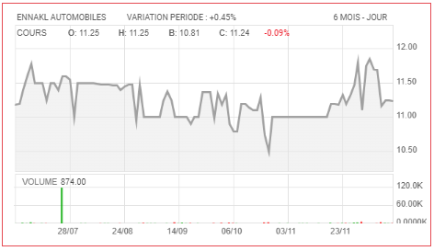

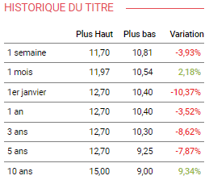

**Mixed trend:** While Ennakl Automobiles' stock price has witnessed long-term growth (10 years), the shorter timeframes show a mixed picture.

**Recent downturn:** Over the past week and month, the stock has experienced a decline, suggesting potential investor concerns or market corrections.

**Yearly and longer-term decline:** Compared to 1st January, 1 year, 3 years, and 5 years ago, the stock price is currently lower, indicating a downward trend in these timeframes.

**Key Takeaways:**

* While the long-term trend remains positive (10 years), the recent and shorter-term performance paints a more cautious picture.
* The reasons for the recent decline could be diverse, ranging from market volatility to company-specific factors.
* Further analysis of the company's performance and the reasons behind the recent dip would be necessary for a more conclusive understanding.

1. ***Financial Statement***

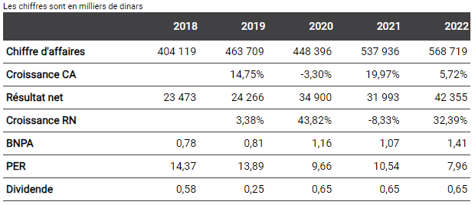

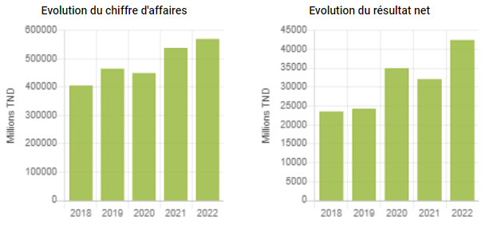

Ennakl Automobiles' finances are healthy and show growth potential:

**Revenue:** Up and down across the years, but overall increasing (5.72% in 2022).

**Profit:** Strong growth in 2020 and 2022, fueled by economic recovery and increased demand for vans and trucks.

**Earnings per share:** Similar to profit, showing strong growth and potential for future gains.

**Stock valuation:** Became more attractive (lower PER) due to slower stock price growth compared to profit.

**Dividends:** Stable at 0.65 dinars per share since 2021.

Overall, Ennakl Automobiles is well-positioned to benefit from future economic growth.

1. ***Financial Statement Analysis***

**Profitability ratios**

| **Gross Margin** (5YA) | |  |  |  |  |  |  |
| --- | --- | --- | --- | --- | --- | --- | --- |
| **Interpretation :** Ennakl Automobiles (23.72%) edges out the industry (20.51%) in efficiency at converting sales to gross profit. | | | | | |
| ***Company*** | ***Industry*** |
| 23.72% | 20.51 |  |  |  |  |  |  |
|  |  |  |  |  |  |  |  |
|  |  |  |  |  |  |  |  |
| **Operating Margin** (5YA) | |  |  |  |  |  |  |
| **Interpretation :** Ennakl Automobiles (8%) lags behind the industry (11.34%) in converting gross profit to operating profit, suggesting higher operating expenses. | | | | | |
| ***Company*** | ***Industry*** |
| 8% | 11.34 |  |  |  |  |  |  |

|  |  |  |  |  |  |  |  |
| --- | --- | --- | --- | --- | --- | --- | --- |
| **ROE** (5YA) | |  |  |  |  |  |  |
| **Interpretation :** Despite the lower operating margin, Ennakl Automobiles (11.66%) delivers a slightly higher ROE than the industry (9.18%) due to efficient use of equity. | | | | | |
| ***Company*** | ***Industry*** |
| 11.66% | 9.18 |  |  |  |  |  |  |

**Capital structure ratio**

| **Debt to Equity** (MRQ) | |  |  |  |  |  |  |
| --- | --- | --- | --- | --- | --- | --- | --- |
| **Interpretation :** Debt-free: Both Ennakl Automobiles and the industry have virtually no debt (DE < 0.01%), providing financial stability. | | | | | |
| ***Company*** | ***Industry*** |
| 0% | 0.01 |  |  |  |  |  |  |

**Payout ratio**

| **Dividend Yield** (TTM) | |  |  |  |  |  |  |
| --- | --- | --- | --- | --- | --- | --- | --- |
| **Interpretation :** Ennakl Automobiles (5.49%) offers a lower dividend yield compared to the industry (11.17%), indicating it retains more profits for reinvestment. | | | | | |
| ***Company*** | ***Industry*** |
| 5.49% | 11.17 |  |  |  |  |  |  |

Ennakl Automobiles shows strong profitability with higher gross margin and ROE, but lower operating margin and dividend yield compared to the industry. Debt-free structure provides financial stability. Overall, Ennakl Automobiles appears healthy but may focus on growth over immediate shareholder returns.

1. ***Conclusion***

Ennakl Automobiles demonstrates robust financial health, revenue growth, and no debt. However, caution is advised due to a lower operating margin, recent stock price dip, and a comparatively lower dividend yield than the industry average. This makes it a potentially promising investment if we are seeking long-term growth.

**20. MPBS**

1. ***Description***

A major player in the wood processing industry, MPBS specializes in the manufacturing and finishing of a wide range of wood panels. The company went public in December 2013 at a price of 6 Tunisian dinars per share.

**Leadership:** Chief Executive Officer: Mr. Sofiane Sellami

**Number of shares:** 10,334,430

**Float:** 40.00%

**Company valuation:** 51 million Tunisian dinars (MTND)

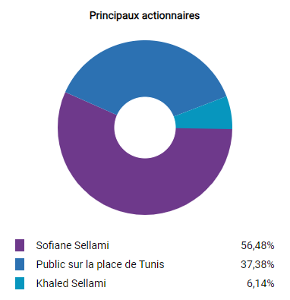

1. ***Latest News***

- [MPBS has undergone a volatile trajectory in recent years. In 2022, the company recorded a positive 6% increase in revenue, reaching 116 million dinars, attributed to the recovery of the Tunisian construction sector from the COVID-19 pandemic and the company's strategic focus on new product development and marketing. Despite this growth, the company's net profit experienced a significant decline of 45% to 5.7 million dinars, influenced by increased competition from Chinese imports and rising input costs, including energy and raw materials.](https://www.ilboursa.com/marches/news_valeur?s=MPBS)

- [The challenges persisted into the first half of 2023, with MPBS witnessing a 20% decrease in revenue to 65 million dinars and a corresponding 45% decline in net profit to 3 million dinars. Despite these setbacks, indications suggest that MPBS is actively addressing these challenges through strategic initiatives. The company is making investments in new production capacity and expanding its export market to mitigate risks associated with increased competition and rising input costs.](https://www.ilboursa.com/marches/news_valeur?s=MPBS)

[Observations about the challenges MPBS faces include the heightened competition from Chinese imports, impacting profit margins and overall profitability. Additionally, rising input costs, particularly in energy and raw materials, have posed challenges for the company, prompting efforts to enhance productivity and negotiate better prices with suppliers.](https://www.ilboursa.com/marches/news_valeur?s=MPBS)

- [To counter these challenges, MPBS is proactively investing in new production capacity to increase output and reduce costs. Moreover, the company is strategically expanding its export market to diversify its customer base and reduce reliance on the Tunisian market.](https://www.ilboursa.com/marches/news_valeur?s=MPBS)

1. [***S***](https://managers.tn/2023/08/01/le-groupe-telnet-holding-enregistre-une-croissance-exceptionnelle-de-ses-produits-dexploitation-au-1er-semestre-2023/)***WOT Analysis :***

| **Strengths** | **Weaknesses** |
| --- | --- |
| * A key player in the wood panel production sector with a market share of 30% * Investment efforts favoring advanced technologies and affecting new product categories * The refocusing on activities with higher added value such as veneered panels, acrylic panels and synchronized panels has been fruitful * MPBS reduces its exposure to the wood industry through majority stakes in two subsidiaries: HABITAT (specialized in the trade of parquet floors and security doors) and SPECTRA (installation of photovoltaic panels). These two subsidiaries contribute significantly to the Group's results (from 25% to 30%). * A solid financial structure and a controlled WCR | * An export activity that is still struggling to take off * Lack of certification according to an international standard |
| ***Opportunities*** | ***Threats*** |
| * Growing demand on the market, with wood panels increasingly appreciated for their value for money, compared to wood * Significant growth potential in the veneered panel segment, in which MPBS is the leader * MPBS acquired majority stakes in three companies operating in the timber sector, namely: “CBM: “Comptoir des bois et Matériaux”, “MBS: Maison du Bois du Sud” and “SCIAF: Scierie Africaine”, which created a size effect and positive synergies * Export potential on neighboring markets (Algeria and Libya) | * Slowdown in the construction sector and erosion of household purchasing power * Restrictions on consumer credit * Increase in the cost of raw materials following the depreciation of the dinar |

1. ***Stock Performance***

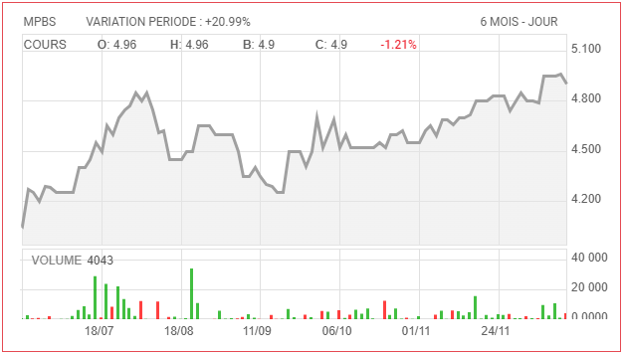

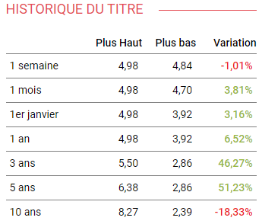

**Long-term growth:** Over the past 3, 5, and 10 years, MPBS's stock price has experienced significant growth, with the highest increase seen in the 5-year timeframe (51.23%).

**Short-term fluctuations:** Despite the upward trend, there have been recent fluctuations. Over the past week and month, the stock price has seen modest declines and gains, respectively.

1. ***Financial Statement***

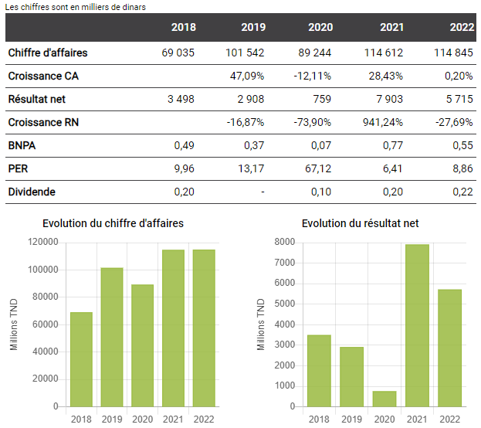



MPBS shows positive revenue growth but with volatile net income and dividend payouts.

The low PER suggests potential value, but high volatility requires caution and further analysis.

1. ***Financial Statements Analysis***

**Valuation ratios**

| **Revenues per Share** (TTM) | |  |  |  |  |  |  |
| --- | --- | --- | --- | --- | --- | --- | --- |
| **Interpretation :** MPBS (11.19) generates more revenue per share than the industry average (7.03), indicating stronger earnings per share potential. | | | | | |
| ***Company*** | ***Industry*** |
| 11.19 | 7.03 |  |  |  |  |  |  |

| **P/E** (TTM) | |  |  |  |  |  |  |
| --- | --- | --- | --- | --- | --- | --- | --- |
| **Interpretation :** MPBS (8.86) is considered slightly more **expensive** compared to the industry (6.68), reflecting higher investor expectations for its future growth. | | | | | |
| ***Company*** | ***Industry*** |
| 8.86 | 6.68 |  |  |  |  |  |  |

**Dividend ratio**

| **Payout Ratio**(TTM) | |  |  |  |  |  |  |
| --- | --- | --- | --- | --- | --- | --- | --- |
| **Interpretation :** MPBS (36.16%) retains a larger portion of its profits for reinvestment compared to the industry average (47.49%), suggesting potential for future growth but lower current dividends. | | | | | |
| ***Company*** | ***Industry*** |
| 36.16% | 47.49% |  |  |  |  |  |  |

**Profitability ratios**

| **Gross Margin**(TTM) | |  |  |  |  |  |  |
| --- | --- | --- | --- | --- | --- | --- | --- |
| **Interpretation :** Stronger Gross Margin: MPBS (26.29%) converts sales to gross profit more efficiently than the industry average (34.74%), indicating **good cost control**. | | | | | |
| ***Company*** | ***Industry*** |
| 26.29% | 34.74% |  |  |  |  |  |  |
|  |  |  |  |  |  |  |  |
|  |  |  |  |  |  |  |  |
| **Operating Margin**(TTM) | |  |  |  |  |  |  |
| **Interpretation :** However, MPBS (8.31%) struggles to convert gross profit to operating profit compared to the industry (18.09%), suggesting higher operating expenses. | | | | | |
| ***Company*** | ***Industry*** |
| 8.31% | 18.09 |  |  |  |  |  |  |

**Capital structure ratio**

| **Asset Turnover** (TTM) | |  |  |  |  |  |  |
| --- | --- | --- | --- | --- | --- | --- | --- |
| **Interpretation :** MPBS (1.11) **utilizes its assets less efficiently than the industry** average (1.26), indicating potential room for improvement in asset management. | | | | | |
| ***Company*** | ***Industry*** |
| 1.11 | 1.26 |  |  |  |  |  |  |

MPBS shows strong revenue generation, efficient cost control, and higher growth potential compared to the industry average. However, lower operating margins and asset utilization raise concerns about operational efficiency. Investors seeking immediate income may prefer the higher industry dividend payout. Ultimately, MPBS presents a potentially good investment.

1. ***Conclusion***

MPBS has promising aspects like revenue growth and strategic initiatives, but challenges like volatile profits and operational inefficiencies require careful consideration.

If we are seeking long-term growth and we are willing to tolerate risk, MPBS could be a potential buy, especially considering its historical performance and low PER.

## Behavioral Analysis:

**Overconfidence :**

Behavioral analysis of overconfidence involves examining how individuals exhibit exaggerated confidence in their abilities, judgments, or beliefs, often to a degree that exceeds their actual skills or the accuracy of their information. Overconfidence can manifest in various domains, including decision-making.

**1/ SAH LILAS :**

The Group is beginning a new page in its history, planning to launch into the manufacturing of cosmetic products. The new factory dedicated to this business line has already been built and will come into operation at the end of 2023, according to management. It will initially specialize in the production of liquid soap, shampoo, conditioner, shower gel, deodorant and toothpaste.

-> The following fact, enhanced us at the beginning to buy the stock with a certainty that the stock price will increase at the end of the period. However, the company has not launched its new product yet.

**2/ One Tech Holding:**

The One Tech Group signed a sale contract on October 4, 2023. actions under which the Group sells its entire stake in its primary pharmaceutical packaging subsidiary Helioflex, which represents 65.39%, to the benefit of the company Aluflexpack AG.

-> The following statement indicates that the company has signed a contract which can increase its profitability.

-> Based on the following belief, we encouraged the investment in one tech holding’s stocks.

## Risk profile

Given that the project is short-term in nature, the primary focus will be on stocks. This decision is influenced by the characteristics of the Tunisian market, where debt (“obligation”) is less frequent, less liquid, and involves higher costs and risks. The debt market is comparatively less dynamic and active than the stock market.

Therefore, the strategy for this short-term project revolves around purchasing stocks from diversified sectors. This approach aims to capitalize on the liquidity and activity of the stock market, aligning with the project's timeframe and the market dynamics in Tunisia.

=> By opting for a portfolio composed entirely of equities, we acknowledge and embrace the inherent volatility and fluctuation associated with the stock market. This high-risk orientation is a reflection of our confidence in navigating through market uncertainties and our belief in the potential for commensurate returns. The chosen strategy is indicative of an assertive risk tolerance, underlining our willingness to weather market fluctuations in pursuit of capitalizing on opportunities that align with the project's short-term objectives.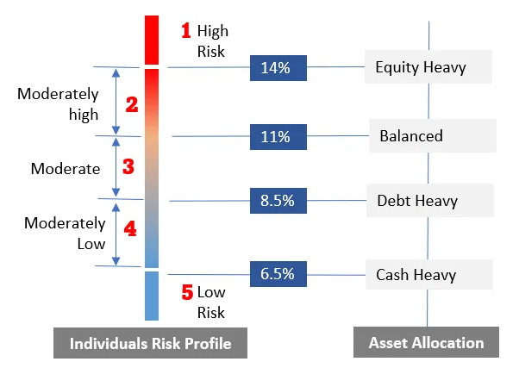

## Markowitz strategy explanation

1. **Determining the 6 companies to invest in**

Since Sam started trading on the Tunisian stock market in 2017, we will initiate the **Markowitz model using data starting from June 5, 2017**. This timeframe will allow us to have the same size of data for each company involved in the analysis.

In the **iterative application of the Markowitz portfolio optimization model** encompassing a diverse set of 12 companies, the initial optimization unveiled a strategic allocation of 85% to Carthage Cement and 15% to Sotumag. By systematically eliminating Carthage Cement and Sotumag from the equation, the subsequent optimization, focused on the remaining 10 companies, exhibited a pronounced shift. SAM emerged as the frontrunner, commanding an 88% portfolio weight, while MPBS secured a 12% allocation. The pursuit of optimal portfolio construction continued, resulting in a final iteration with a selection of 8 companies. In this latest configuration, City Cars took center stage with a commanding 90% portfolio weight, accentuating its robust position in the portfolio, while TPR assumed a measured 10% allocation.

1. **determining weight of each company**

Once the definitive list of companies for investment has been established, the next step involves assigning weights to each company based on their chronological appearance in the Markowitz optimization process and the weight provided by Markowitz. In this assignment, a scale of 1 to 6 will be employed, with 6 denoting the highest weight and 1 representing the lowest . (further calculation is presented in Markowitz excel sheet).

| **Companies** | **Sector** | **Weight assigned**  **by markowitz** |  | **Weight in the**  **portfolio** |
| --- | --- | --- | --- | --- |
| tpr | Primary Materials Industry | 10% | 1 | 4.8% |
| CITY CARS | Services To Consumers Industry | 90% | 2 | 9.5% |
| MPBS | Building & Construction Industry | 12% | 3 | 14.3% |
| sam | Household & Personal Products Industry | 88% | 4 | 19.0% |
| SOTUMAG | Services To Consumers Industry | 15% | 5 | 23.8% |
| Carthage cement | Building & Construction Industry | 85% | 6 | 28.6% |

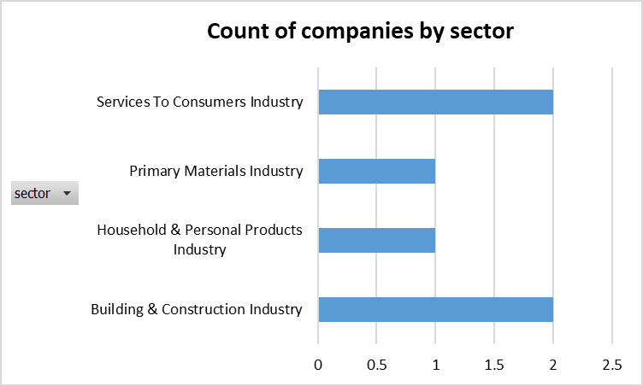

* The portfolio is composed of six companies spanning four distinct sectors: service to consumer industry, primary materials, household & personal products, and building & construction. Carthage Cement and Sotumag hold substantial weights at 28.6% and 23.8%, respectively. Following closely are SAM at 19%, MPBS at 14.3%, City Cars at 9.5%, and TPR at 4.8%.

**3. Buying time**

On 10/12/2023, following the closing of the stock exchange market and a thorough analysis through various technical indicators and additional information from [Investing.com](https://www.investing.com/portfolio/?portfolioID=ZGUyaDFkMWVmMzw3YDpjYQ%3D%3D), a decision was made to acquire stocks with a strong buy indication. We purchased 10 stocks of Sotumag, 9 stocks of SAM, and 6 stocks of MPBS on 11/12/2023.

The choice to focus on these particular stocks with a strong buy signal reflects a commitment to seizing investment opportunities based on the available market insights and signals.

| **Company** | **Price** | **15min analysis** | **Number of stocks** |
| --- | --- | --- | --- |
| Carthage cement | 1.970 | Neutral | 29 |
| Sotumag | 4.890 | Strong buy | 10 |
| SAM | 4.190 | Strong buy | 9 |
| MPBS | 4.950 | Strong buy | 6 |
| City cars | 12.190 | Neutral | 1 |
| TPR | 4.990 | Buy | 2 |

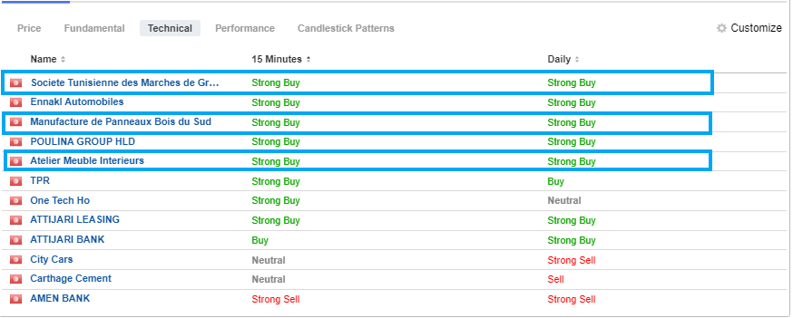(investing.com) (10/12/2023) (2:00 PM)

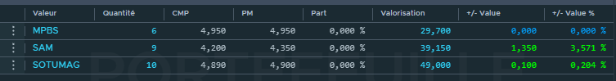 (Mac Sa) (11/12/2023) (9:00 AM)

On 12/12/2023 at 9AM, an additional strategic move was made in the investment portfolio, further expanding the holdings. 2 stocks of TPR were acquired (5000 each stock), guided by a strong buy indication. The inclusion of TPR in the portfolio aligns with the ongoing strategy to capitalize on stocks displaying favorable indicators, thereby contributing to the overall diversification and potential growth of the investment portfolio.

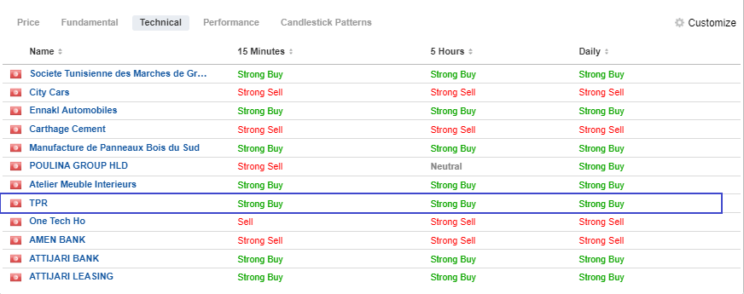(11/12/2023)(2:00 PM)

On 12/12/2023, just before the closing of the stock market at 1:30 PM, a strategic decision was made to make an additional acquisition. In this instance, 20 stocks of Carthage Cement were purchased, slightly reducing the original holding of 29 due to the observed increase in stock volatility. The stock price, initially at 1970, decreased to 1960. This move was motivated by the perception of Carthage Cement being undervalued, with the anticipation that it will rebound in the coming days. This assessment is based on positive indications from Fundamental Stock Analysis (FSA) and a retrospective evaluation of its performance over the past decade. The decision reflects a forward-looking strategy, capitalizing on potential market fluctuations and aiming to benefit from the expected resurgence in the value of Carthage Cement in the near future.

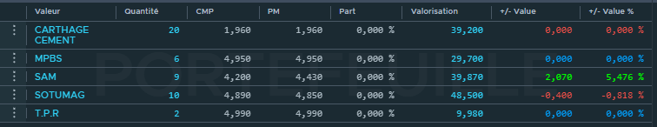(12/12/2023) (2:00 PM)

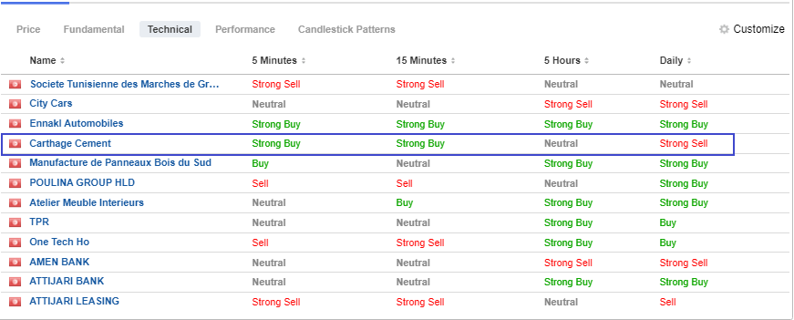

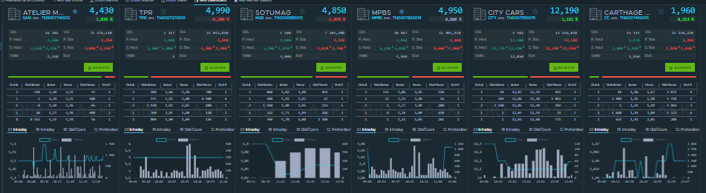

## Portfolio Rebalance

* In our investment strategy, we have decided to **refrain from investing** in **City Cars** due to its consistently **declining performance**. The ongoing trend of decreasing prices and deteriorating market conditions has led us to exercise caution and avoid exposure to this particular asset. By opting not to invest in City Cars, we aim to **mitigate potential losses and safeguard our portfolio against the uncertainties** associated with its declining performance. This decision aligns with our commitment to making prudent investment choices based on careful analysis of market dynamics and asset-specific trends.

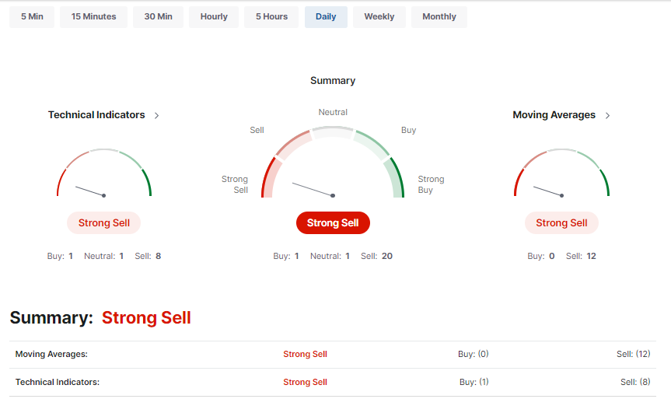

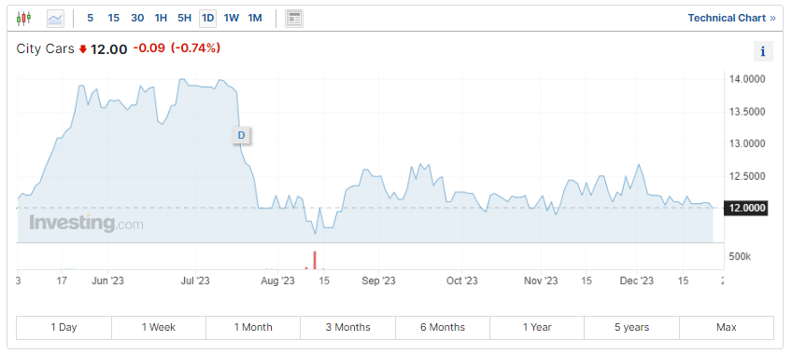

* Instead , we bought 3 stocks OTH on 12/20/2023 (8.49 per share)

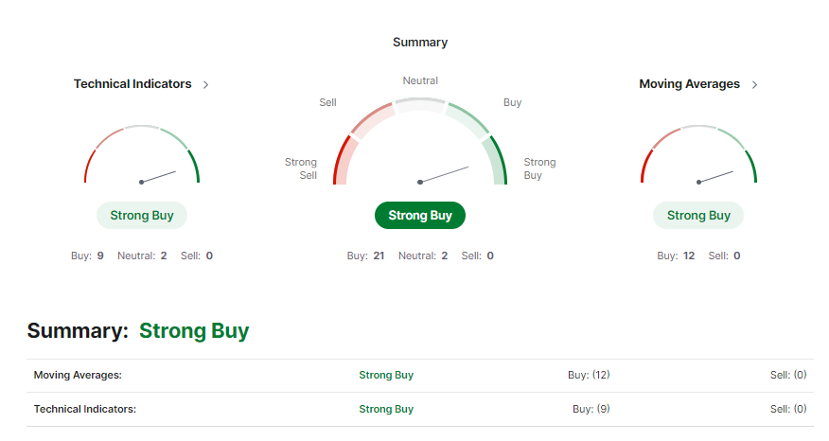

On **December 22, 2023**, after liquidating other stocks, we strategically allocated the remaining budget to enhance our portfolio's returns. We invested in 6 shares of BH Bank at 11.8 per share and 5 shares of Attijari Leasing at 16.7 per share, focusing on the robust financial sector, renowned for consistent performance in Tunisia. Additionally, we purchased 3 shares of Ennakl Automobile at 12 per share, anticipating potential growth in December. This targeted approach aims to **capitalize on the financial sector's stability with BH Bank and Attijari Leasing while also incorporating Ennakl for its growth prospects.**

The recent additions to our portfolio, namely BH Bank, Attijari Leasing, and Ennakl Automobile, are strategically chosen to boost returns and enhance overall performance. By concentrating on the financial sector, represented by BH Bank and Attijari Leasing, we aim to capitalize on its historical strength in Tunisia. Simultaneously, the inclusion of Ennakl Automobile, with its anticipated growth, further diversifies our holdings. The expectation is that these well-considered investments will contribute positively to the overall return of our portfolio, fostering an improved and more resilient performance in the market.

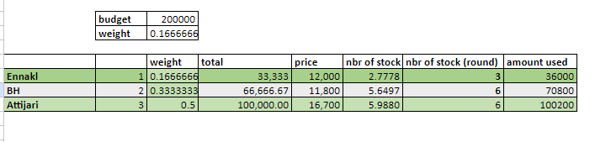

Following our thorough financial statement analysis (FSA) and technical assessment, **Attijari Leasing** emerged as the most favorable investment, securing a high coefficient of 3, signifying its strong potential for positive performance. However, due to the current bearish market conditions and the observable decrease in Attijari Leasing's stock price, a strategic decision was made to mitigate risk and align with budget constraints. Consequently, we opted to adjust the purchase plan, acquiring 5 stocks of Attijari Leasing instead of the initially planned 6. To diversify our portfolio, we also allocated resources to **BH Bank** with a coefficient of 2, purchasing 6 stocks, and **Ennakl** with a coefficient of 1, acquiring 3 stocks in the automobile sector.

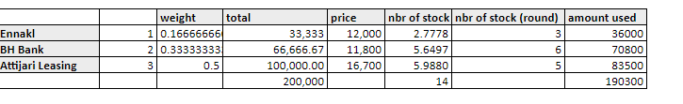

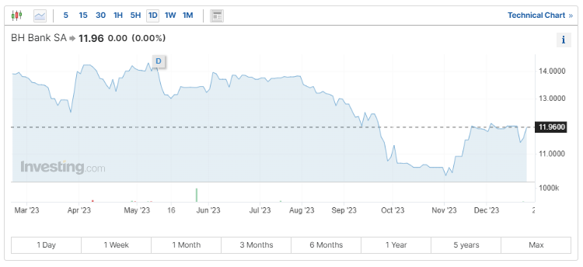

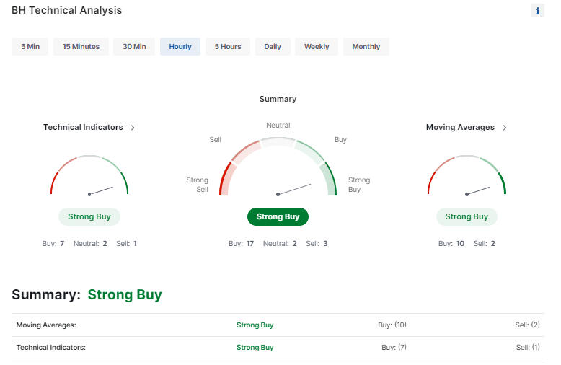

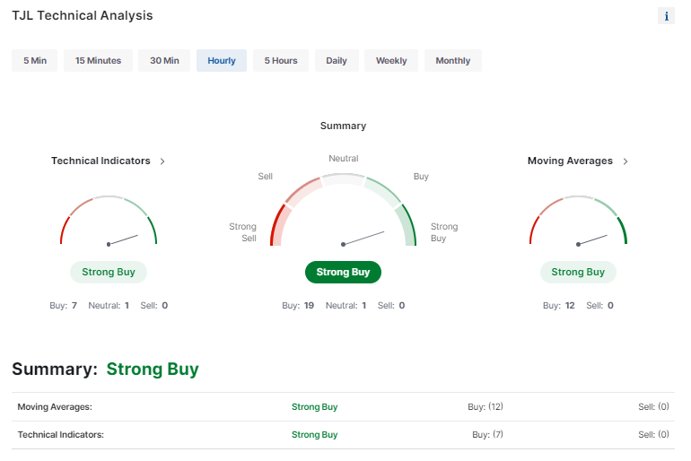

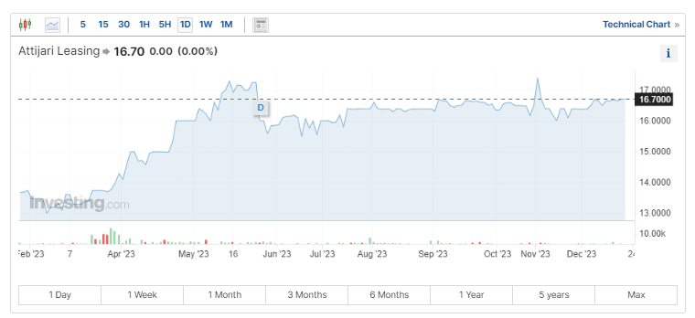

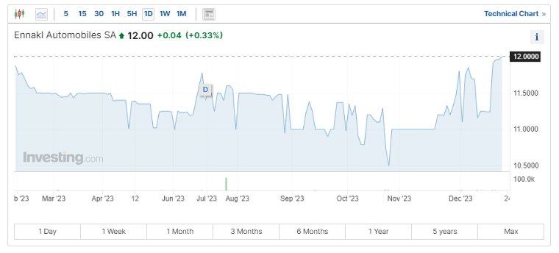

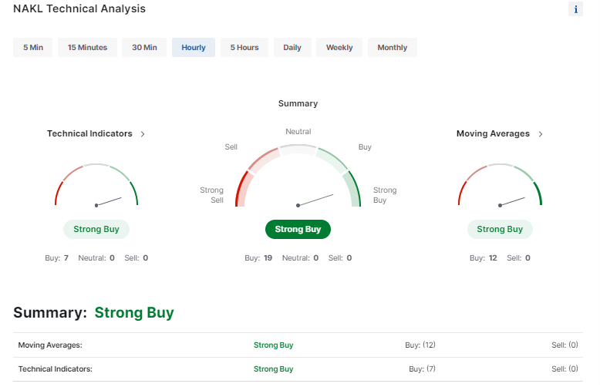

## Comparison to benchmarks

1. **To Tunindex**

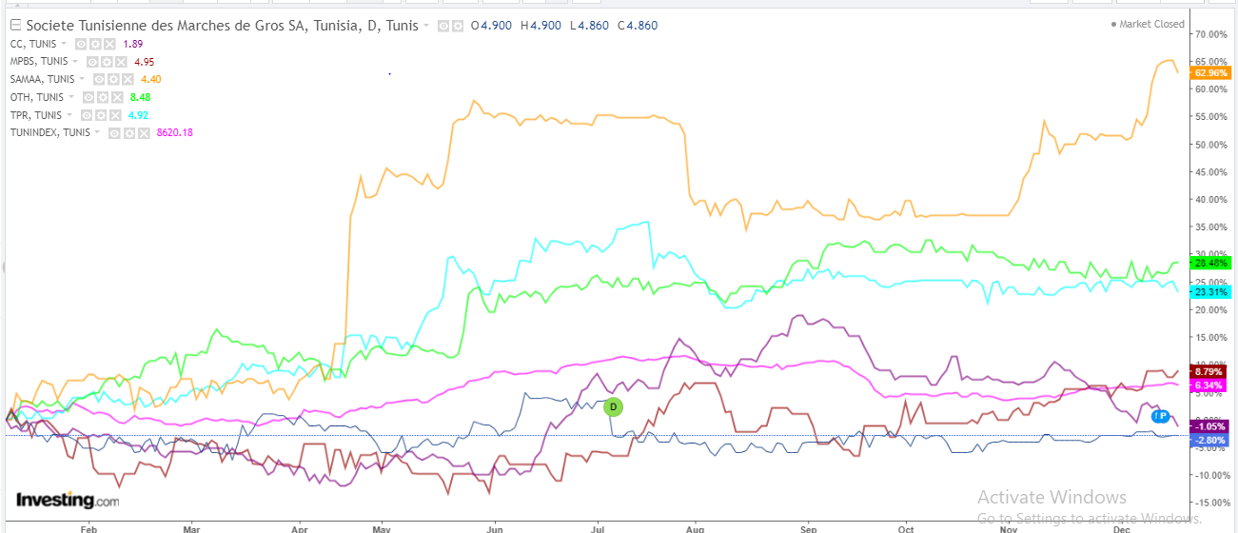

Published on investing.com, 19/12/2023 - 22:42 , Powered by TradingView

* The performance metrics reveal a compelling narrative of diverse outcomes among the mentioned entities in the market. Notably, SAM has emerged as a standout performer, showcasing a remarkable increase of 62.96%. This substantial growth underscores the company's ability to capitalize on market opportunities and generate robust returns . Similarly, OTH and TPR have demonstrated commendable results, with gains of 28.48% and 23.31%, respectively. These positive performances suggest effective strategic positioning and operational resilience in the face of market dynamics.
* MPBS, while showing a more moderate increase of 8.79%, still reflects a positive trajectory, contributing to the overall favorable sentiment. The collective outperformance of SAM, OTH, TPR, and MPBS against Tunindex implies that these companies have not only weathered market conditions effectively but have also surpassed the average market returns, thereby potentially offering attractive opportunities for capital appreciation.
* On the contrary, CC and SOTUMAG have faced challenges, with CC experiencing a slight decrease of -1.05%, and SOTUMAG recording a more pronounced decline of -2.8%. These downturns may indicate specific obstacles or industry-related factors impacting their performance negatively.
* In conclusion, the performance analysis provides a nuanced understanding of how **SAM, OTH, TPR, and MPBS** **have excelled,** while CC and SOTUMAG have encountered hurdles during the month of December.

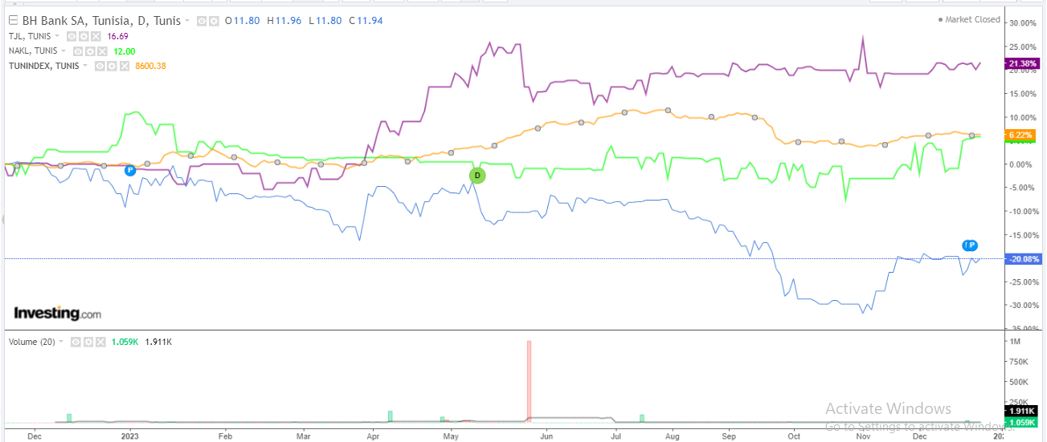

Published on investing.com, 26/12/2023 - 20:55 , Powered by TradingView

Attijari Leasing has experienced a notable variation of 21.38%, surpassing both the Tunindex, which has seen a variation of 6.22%, and Ennakl Automobile, which has a variation of 5.73%. However, BH Bank has shown a decline with a variation of -20.08%.

=> in conclusion only Attijari Leasing outperformed market by 26/12/2023

1. **To Sector**
2. **Industrial Goods & Services Industry**

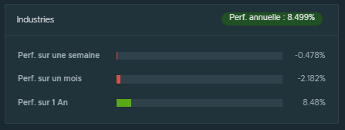 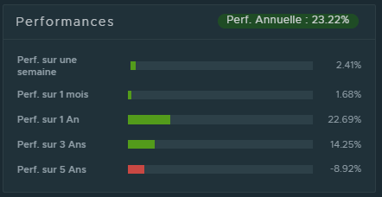MAC SA 19/12/2023

It appears that **One Tech Holding (OTH)** is standing out as a strong performer within the **Industrial Goods & Services Industry** . The latest week's performance data indicates that OTH has outperformed the industry sector, achieving a positive growth of 2.41%, while the industry sector as a whole experienced a decline of -0.478%. This noteworthy contrast underscores OTH's resilience and positive momentum relative to its industry peers during the last week

1. **Primary Materials Industry**

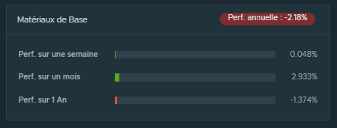 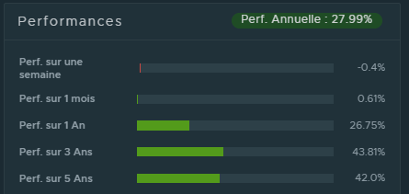19/12/2023

It appears that **TPR** has exhibited **underperformance** relative to the broader **primary materials industry** in the latest week. The data indicates that TPR recorded a decline of -0.4%, while the primary materials industry as a whole experienced a modest increase of 0.048% during the same period.

1. **Household & Personal Products Industry**

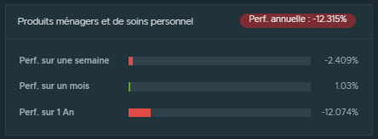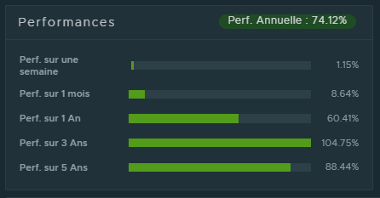19/12/2023

**SAM** has demonstrated a robust performance, **outperforming** the **Household & Personal Products Industry**. SAM achieved a positive growth of 1.15%, while the industry as a whole experienced a decline of -2.409% during the specified time frame.This positive differential suggests that SAM has exhibited resilience and strength relative to its industry peers.

1. **Building & Construction Industry**

**Carthage Cement : MPBS:**

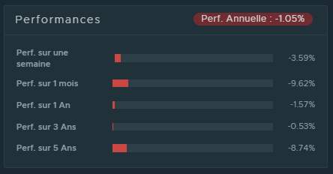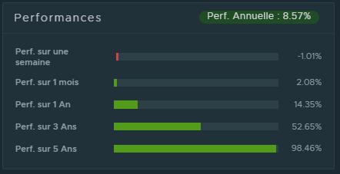

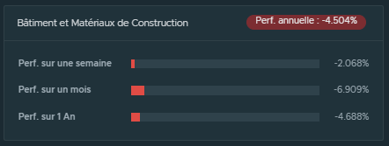19/12/2023

Both **CC and MPBS,** within the same sector, have experienced **negative variations** in their stock performance. In the case of CC, the stock recorded a decline of -3.59%, while the sector it belongs to experienced a slightly lower negative variation of -2.068%. Similarly, MPBS showed a negative variation of -1.01% within its sector. These negative variations may be indicative of challenges or market conditions impacting both individual companies and the broader sector.

1. **Services To Consumers Industry**

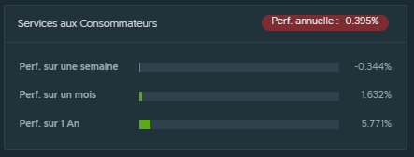 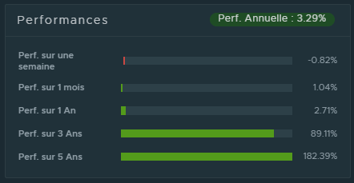19/12/2023

**SOTUMAG** has demonstrated **underperformance** relative to its sector, with a negative variation of -0.82%, while the sector itself experienced a lower negative variation of -0.334%. This indicates that SOTUMAG faced a more significant decline in its stock value compared to the average performance within its sector during the specified time frame.

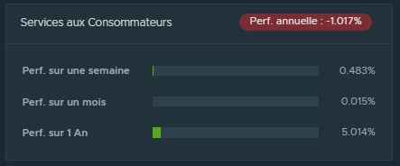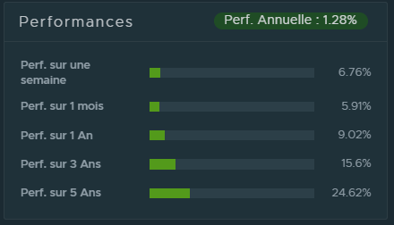

26/12/2023

**Ennakl Automobile**'s recent performance has been notably strong, **surpassing the Services to Consumers Industry by a substantial margin**. With a remarkable outperformance of 6.76%, Ennakl has demonstrated resilience and growth compared to the industry's more modest performance of 0.483% over the last week.

1. **Financial sector**

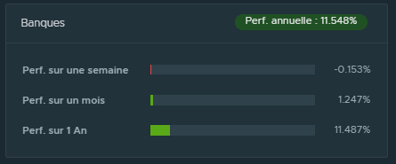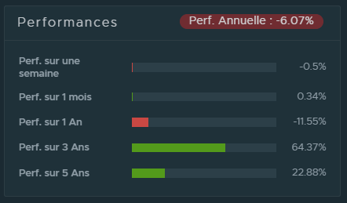

26/12/2023

**BH Bank** and the broader sector both have experienced **negative performance over the last week**. BH Bank specifically saw a decline of -0.5%, while the entire sector registered a negative performance of -0.153%.

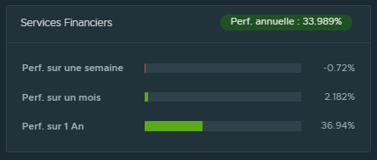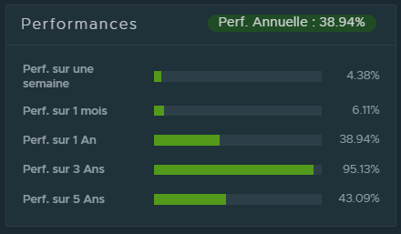

26/12/2023

**Attijari Leasing**'s recent performance **stands out positively** as it has outperformed the broader financial sector. With a notable increase of 4.38%, Attijari Leasing has demonstrated strength compared to the financial sector's overall decline of -0.72% over the specified time frame.

=> attijari leasing , Sam , Ennakl automobile , OTH outperform their own sector

## Money-Weighted Return VS Time-Weighted Return Strategy Explanation

For this project , the most suitable strategy to adopt is the **Money-Weighted Return (MWR)** for the following reasons :

1. **Active Portfolio Management**

* Our portfolio was actively managed and we have frequently contributed or withdrawn the funds. As MWR considers the timing and size of cash flows, it can provide insights into how the investment decisions impact overall returns.

Indeed , MWR, by factoring in the timing and magnitude of these cash flows, serves as a tool in understanding how our risk management decisions influence the overall performance of the portfolio. This nuanced perspective enables us to fine-tune our risk management strategies for optimal outcomes.

1. **Short-Term Goals**

* As the financial market project has short-term financial goals with a defined time frame, MWR is more suitable as it considers the actual return experienced by the investor, accounting for the impact of cash flows on the portfolio.

As we strategically position assets to capitalize on market opportunities and navigate potential risks, MWR's consideration of actual returns, coupled with its sensitivity to cash flow impacts, ensures a more accurate evaluation of our success in meeting short-term objectives.

### Flexibility in Decision-Making

* As our portfolio was balanced several times to adapt to current market conditions , MWR is considered more flexible than TWR as it accommodates varying contributions and withdrawals without isolating the impact of the cash flows.

### Performance Assessment in Real-world Context

* MWR is a performance metric that reflects the real-world experience of managing investments with active decision-making as it provides a more comprehensive and intuitive measure for investors who see their portfolios as dynamic and subject to changes in response to market conditions.

***Results***

| **Date** | **Cash Flows** | **Amount (DT)** |  | |  |  |
| --- | --- | --- | --- | --- | --- | --- |
| 12/11 | Cash Outflow | -116.644 |  |  |  |  |
| 12/12 | Cash Outflow | -48.782 |  |  |  |  |
| 12/13 | Cash Outflow | -0.07 |  |  |  |  |
| 12/14 | Cash Inflow | 0.82 |  |  |  |  |
| 12/15 | Cash Inflow | 0.12 | * **MWR = 4.314% ; *Formula : IRR(Amount(DT))*** | | | |
| 12/18 | Cash Outflow | -0.04 |  |  |  |  |
| 12/19 | Cash Outflow | -0.46 |  |  |  |  |
| 12/20 | Cash Inflow | 15.549 |  |  |  |  |
| 12/21 | Cash Inflow | 48.286 |  |  |  |  |
| 12/22 | Cash Inflow | 72.839 |  |  |  |  |
| 12/25 | Cash Inflow | 0.79 |  |  |  |  |
| 12/26 | Cash Inflow | 4.24 |  |  |  |  |
| 12/27 | Cash Inflow | 106.313 |  |  |  |  |

## Risk Analysis Ratios Explanation

For this project, the most appropriate ratios for assessing the tradeoff between risk and return were:

1. **Sharpe Ratio**

The Sharpe ratio compares the return of an investment with its risk. It's a mathematical expression of the insight that excess returns over a period of time may signify more volatility and risk, rather than investing skill.

* **Usually, any Sharpe ratio greater than 1.0 is considered acceptable to good by investors.**
* **A ratio higher than 2.0 is rated as very good.**
* **A ratio of 3.0 or higher is considered excellent.**
* **A ratio under 1.0 is considered sub-optimal.**

***The Sharpe Ratio* defines the risk in terms of standard deviation, which is a measure of total risk. Hence, it includes both *systematic* as well as *unsystematic risk*.**

| **SHARPE RATIO =** | |  | **-0.18** | **Bad** |
| --- | --- | --- | --- | --- |
| Expected Annual Portfolio Return (Rx) | | | -24.90% |  |
| Risk Free Rate (Rf) | | | 8.00% |  |
| Standard Deviation of Rx | | | 184.53% |  |

The negative value (-0.18) suggests that the portfolio's risk-adjusted return is below the risk-free rate. The portfolio's returns are not sufficiently compensating for the level of risk, and **the portfolio is underperforming** in terms of risk-adjusted returns.

The negative return, due to high taxes, likely contributes to the lower risk-adjusted performance.

1. **Treynor Ratio**

The Treynor ratio, also known as the **reward-to-volatility ratio**, is a performance metric for determining how much excess return was generated for each unit of risk taken on by a portfolio.

**If a portfolio has a negative beta, however, the ratio result is not meaningful.**

Our portfolio’s beta = **-0.000597 =>** The ratio in our case is not meaningful.

1. **Jensen’s Alpha**

The Jensen measure is calculated using the CAPM. The Jensen ratio calculates the excess return that a portfolio generates over its expected return. This measure of return is also known as alpha. **The higher the ratio, the better the risk-adjusted returns.**

**A portfolio with a consistently positive excess return will have a positive alpha, while a portfolio with a consistently negative excess return will have a negative alpha.**

**Alpha vs Sharpe ratio:** The numerator of the Sharpe ratio is indeed a quantitative measure of alpha.

| **Jensen’s Alpha =** | |  | **-32.90%** | **Bad** |
| --- | --- | --- | --- | --- |
| Expected Annual Portfolio Return (Rx) | | | -24.90% |  |
| Portfolio Return (CAPM) | | | 8.00% |  |
| Beta of Rx | | | -0.000597 |  |
| [Expected Market Return (Rm)](https://www.ilboursa.com/marches/cotation_PX1) | | | 6.12% |  |

A Jensen's Alpha of approximately -32.90% suggests that **the portfolio underperformed** relative to its expected returns based on the Capital Asset Pricing Model (CAPM). **The portfolio did not generate sufficient returns to compensate for its systematic risk, as measured by its beta.**

1. **Sortino Ratio**

This ratio is similar to the Sharpe Ratio, but it only penalizes negative returns, which makes it a better measure of downside risk.

* **A Sortino ratio greater than 1.0 is considered acceptable.**
* **A Sortino ratio higher than 2.0 is considered very good.**
* **A Sortino ratio of 3.0 or higher is considered excellent.**

**Sortino vs Sharpe ratio:** The Sharpe ratio indicates how well an equity investment is performing compared to a risk-free investment, taking into consideration the additional risk level involved with holding the equity investment. The Sortino ratio is a variation of the Sharpe ratio that only factors in downside risk.

| **Sortino RATIO =** | |  | **-0.28** | **Bad** |
| --- | --- | --- | --- | --- |
| Expected Annual Portfolio Return (Rx) | | | -24.90% |  |
| Risk Free Rate (Rf) | | | 8.00% |  |
| Downside Deviation = | | | 1.19 |  |

This negative value indicates that the **portfolio's expected return is not adequately compensating for the downside risk**, and the portfolio is experiencing more downside volatility than what would be expected based on the risk-free rate.

=> The portfolio's risk-adjusted return, specifically concerning downside risk, is unfavorable.

## KPIs & KRIs

1. **Total return**

Total return measures the overall change in value of the portfolio, including both capital gains and dividends. **Calculation:** **Total Return = (Ending Portfolio Value - Beginning Portfolio Value) / Beginning Portfolio Value**

| **Total return :** | **-0.39%** |
| --- | --- |

The negative total return indicates a decrease in the overall value of the portfolio.This could happen due to a variety of reasons, including market downturns, economic recessions, or poor performance of specific investments.

1. **Standard Deviation**

The standard deviation of a portfolio is a measure of the portfolio's total risk, taking into account the individual securities' risk as well as the correlations among them. It is a statistical measure that quantifies the amount of variation or dispersion of a set of values, in this case, the returns of the portfolio.

| **Standard deviation :** | **184.53%** |
| --- | --- |

A standard deviation of 184.5% means that the portfolio's returns have historically deviated, on average, by 184.5 percentage points from the mean return. This is a substantial level of variability and implies that the portfolio's performance has experienced significant fluctuations.

1. **Beta**

The beta of a portfolio is a measure of the portfolio's sensitivity to movements in the overall market. It is a key metric in the Capital Asset Pricing Model (CAPM), which is a widely used framework for assessing the expected return of an investment based on its risk relative to the market. **Calculation: Beta = Covariance (Portfolio Returns, Market Returns) / Variance (Market Returns)**

| **Average Beta (Portfolio) =** | | **-0.0005971** |
| --- | --- | --- |

* A portfolio with a negative beta is generally considered to be negatively correlated with the overall market.
* This negative correlation can be beneficial for diversification purposes, as it means the portfolio may act as a hedge against market downturns.

1. **Portfolio Turnover**

Reflects the frequency with which assets in the portfolio are bought and sold. High turnover may increase transaction costs.

**Calculation: Portfolio Turnover = (Total Purchases + Total Sales) / Average Portfolio Value**

| **Portfolio Turnover** | **291.56%** |
| --- | --- |

A portfolio turnover of 291% suggests a very high level of trading activity within the portfolio over the specified time period which justifies the transaction costs incurred.

**XVI . Attribution Analysis**

* **1st Portfolio**

| **Sector** | |  | **Weights** | | |  | **Performances** | | |  | **Portfolio Performance** | |  | **Whole Sector Performance** |
| --- | --- | --- | --- | --- | --- | --- | --- | --- | --- | --- | --- | --- | --- | --- |
|  | |  | Our portfolio | Whole Sector | Excess |  | Our portfolio | Whole Sector | Excess |  |  |  |  |  |
| Service to Consumers | |  | 0.3771 | 0.167 | 0.2101 |  | 0.0635 | -0.0344 | 0.0979 |  | 0.02394585 | |  | -0.0057448 |
| Building & Construction | |  | 0.2706 | 0.167 | 0.1036 |  | -0.046 | -0.0207 | -0.0253 |  | -0.0124476 | |  | -0.0034569 |
| Primary Materials | |  | 0.0439 | 0.2 | -0.1561 |  | -0.004 | 0.0048 | -0.0088 |  | -0.0001756 | |  | 0.00096 |
| Household & Personal Products | |  | 0.2084 | 0.071 | 0.1374 |  | 0.0115 | -0.0241 | 0.0356 |  | 0.0023966 | |  | -0.0017111 |
| Industrial Goods & Services | |  | 0.0548 | 0.167 | -0.1122 |  | 0.0241 | -0.0048 | 0.0289 |  | 0.00132068 | |  | -0.0008016 |
|  |  |  |  |  |  |  |  |  |  | **Total** | 0.01503993 | | **Total** | -0.0107544 |

***Attribution Analysis Results***

| **Sector** | |  | **Allocation Effect** |  | **Selection Effect** |  |  |
| --- | --- | --- | --- | --- | --- | --- | --- |
| Service to Consumers | |  | -0.00496794056 |  | 0.03691809 |  |  |
| Building & Construction | |  | -0.00103036416 |  | -0.00684618 |  | **Total value added** |
| Primary Materials | |  | -0.00242804184 |  | -0.00038632 |  | 0.02776023432 |
| Household & Personal Products | |  | -0.00183368544 |  | 0.00741904 |  |  |
| Industrial Goods & Services | |  | -0.00066808368 |  | 0.00158372 |  |  |
|  |  | **Total** | -0.01092811568 | **Total** | 0.03868835 |  |  |

***Conclusion***

* An allocation effect of -1.09% indicates that the allocation decisions, i.e the weights of the stocks, of our portfolio had a negative impact on its overall performance.
* A selection effect of 2.89% implies that the selection of stocks within each sector contributed positively to the overall portfolio's return .

This performance is strengthened mainly by the Household & personal products sectors which sectors that the stock chosen performed better than the benchmark.

* Combining these 2 effects have realized a total added value of 2.78% implying that the overall portfolio has overperformed the benchmark.

We can conclude that the stock selection is the source of the added value to our portfolio.

***Composite Performance Analysis***

The attribution analysis allowed us to determine how well each stock has performed in our portfolio.

The findings demonstrated that the Service to consumers sector (SOTUMAG) , Household and Personal products sector (SAM) , as well as Industrial Goods & Services (One Tech Holding) have shown a positive performance of 2.39% , 0.24% , and 0.13% respectively during the investment period.

However , the other sectors have contributed negatively to the portfolio with a decrease of 1.2% in the Building & Construction sector (Carthage Cement and MPBS) and a slight decrease of 0.002% in the Primary Materials sector (TPR).

The overall performance reached a level of 1.5% implying that during the investment period our portfolio has experienced an overall growth that was strengthened by the stocks of SOTUMAG , SAM , and OTH , and weakened by CC , MPBS , and TPR.

* **2nd Portfolio**

| **Sector** | |  | **Weights** | | |  | **Performances** | | |  | **Portfolio Performance** | |  | **Whole Sector Performance** |
| --- | --- | --- | --- | --- | --- | --- | --- | --- | --- | --- | --- | --- | --- | --- |
|  |  |  | Our portfolio | Whole Sector | Excess |  | Our portfolio | Whole Sector | Excess |  |  |  |  |  |
| Banks | |  | 0.167 | 0.071 | 0.096 |  | -0.005 | -0.00153 | -0.00347 |  | -0.000835 | |  | -0.00010863 |
| Financial Services | |  | 0.333 | 0.071 | 0.262 |  | 0.0438 | -0.0072 | 0.051 |  | 0.0145854 | |  | -0.0005112 |
| Service to Consumers | |  | 0.5 | 0.167 | 0.333 |  | 0 | 0.0048 | -0.0048 |  | 0 | |  | 0.0008016 |
|  |  |  |  |  |  |  |  |  |  | **Total** | 0.0137504 | | **Total** | 0.00018177 |

***Attribution Analysis Results***

| **Sector** | |  | **Allocation Effect** |  | **Selection Effect** |  |  |
| --- | --- | --- | --- | --- | --- | --- | --- |
| Banks | |  | -0.00016432992 |  | -0.00057949 |  |  |
| Financial Services | |  | -0.00193402374 |  | 0.016983 |  | **Total value added** |
| Service to Consumers | |  | 0.00153787059 |  | -0.0024 |  | 0.01344302693 |
|  |  | **Total** | -0.00056048307 | **Total** | 0.01400351 |  |  |

***Conclusion***

* A slightly negative allocation effect , which approximately 0 , may indicate that the allocation decisions made in the portfolio did not have any impact on its performance. In other words, the returns of the portfolio are solely attributed to the performance of individual stocks within the chosen sectors.
* A selection effect of 1.4% implies that the selection of stocks within each sector contributed positively to the overall portfolio's return .

This performance is strengthened mainly by the Financial Services sectors and the Service to Consumers sector which sectors that the stock chosen performed better than the benchmark.

* Combining these 2 effects have realized a total added value of 1.344% implying that the overall portfolio has overperformed the benchmark.

We can conclude that the stock selection is the source of the added value to our portfolio.

***Composite Performance Analysis***

The findings of the Attribution analysis showed that the Financial Services sector (Attijari Leasing) has realized a positive performance of 4.38% during the investment period.

However , the Banks sector (BH Bank) has contributed negatively to the portfolio with a decrease of 0.5% . This level was even greater than the sector which reached only 0.15% reduction , implying that BH Bank underperformed during the investment period.

For the Service to consumers sector (Ennakl) , it did not exercise any effect on the portfolio as the stock remained constant.

The overall performance reached a level of 4.76% implying that during the investment period our portfolio has experienced an overall growth that was strengthened by the stocks of Attijari Leasing, weakened by BH Bank.

**XVII . Conclusion**

In conclusion, this project represents a thorough exploration of the Tunisian stock market, marked by an exhaustive analysis of stock data encompassing macroeconomic, technical, and risk perspectives.

The tools utilized throughout this project have not only facilitated a more profound comprehension of the market but have also empowered us to tailor investment strategies more effectively. Recognizing that the financial landscape is ever-changing, the insights garnered from this project serve as a dynamic foundation for ongoing research and exploration in the stock market.

In essence, this endeavor has bridged theoretical concepts with real-world data, fostering a nuanced and practical understanding of the multifaceted nature of the financial market. The project not only contributes to academic inquiry but also equips us with applicable knowledge essential for navigating the complexities of the evolving financial landscape.

1. The ratios in this analysis were made in the third semester of 2023, unless there’s an indication of another date .